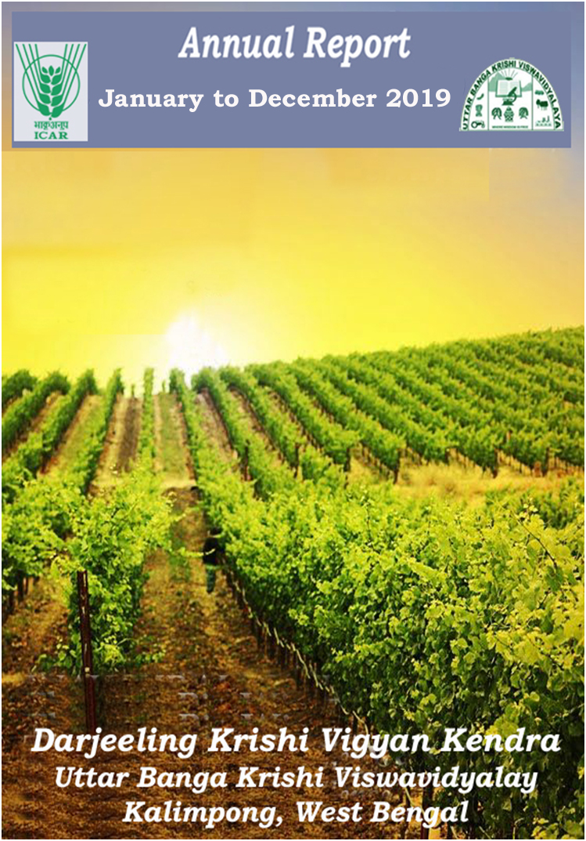

Edited by: Dr. M. W. Moktan

Contributed by : Mrs. Akriti Pradhan

: Dr. Pranab Barma

: Mrs. Snehalata Lama

: Dr. Ranajit Panda

: Dr. Subrata Manna

: Dr. Basu Deo Kharga

: Mr. Akash Deep Thapa

: Mr. Dinesh Kumar Diyali

Compiled by : Dr. Subrata Manna

Dr. Basu Deo Kharga

**PROFORMA FOR ANNUAL REPORT 2019 (January-December 2019)**

1. GENERAL INFORMATION ABOUT THE KVK

1.1. Name and address of KVK with phone, fax and e-mail

|  |  |  |  |
| --- | --- | --- | --- |
| Address | Telephone | | E mail |
|  | Office | FAX |  |
| Darjeeling KVK  Uttar Banga Krishi Viswavidyalaya  Kalimpong, Darjeeling, West Bengal - 734301 | 03552 256283 | 03552 256283 | [djkvk@yahoo.com](mailto:djkvk@yahoo.com)  djkvk93@gmail.com |

1.2 .Name and address of host organization with phone, fax and e-mail

|  |  |  |  |
| --- | --- | --- | --- |
| Address | Telephone | | E mail |
| Office | FAX |  |
| Dr. Prabhat Pal  Uttar Banga Krishi Viswavidyalaya  P.O Pundibari, Cooch Behar | 03582-270141/986 | 03582-270249/986 | dee_ubkv@gmail.com |

1.3. Name of Senior Scientist and Head with phone & mobile No.

|  |  |  |  |
| --- | --- | --- | --- |
| Name | Telephone / Contact | | |
|  | Residence | Mobile | Email |
| Dr. Mendel Wangchuk Moktan | 10½ Mile, Kalimpong  9434407412 | 9434407412 | mendelmw@gmail.com |

1.4. Year of sanction of KVK: 1993

1.5. Staff Position (**as on 1st January, 2019**)

|  |  |  |  |  |  |  |  |  |
| --- | --- | --- | --- | --- | --- | --- | --- | --- |
| **Sl.**  **No.** | **Sanctioned post** | **Name of the incumbent** | **Designation** | **Discipline** | **Pay**  **Scale with present basic** | **Date of joining** | **Permanent**  **/Temporary** | **Category (SC/ST/**  **OBC/**  **Others)** |
| 1 | Senior Scientist- cum- Head | Dr. Mendel Wangchuk Moktan | Senior Scientist- cum- Head | Agril. Extension | PB-4 | 10.12.2001 | Permanent | ST |
| 2 | Subject Matter  Specialist | Mrs Akriti Pradhan | SMS | Home Science | PB – 3 | 14/07/2014 | Permanent | OBC |
| 3 | Subject Matter  Specialist | Dr. Pranab Barma | SMS | Plant Protection | PB – 3 | 21/07/2014 | Permanent | SC |
| 4 | Subject Matter  Specialist | Mrs. Snehlata Lama | SMS | Horticulture | PB – 3 | 25/11/2014 | Permanent | ST |
| 5 | Subject Matter  Specialist | Dr. Ranajit Panda | SMS | Soil Science | PB-3 | 02/11/2018 | Permanent | General |
| 6 | Subject Matter  Specialist | Vacant | SMS | Agril Extension |  |  |  |  |
| 7 | Computer  Programmer | Dr. Subrata Manna | Programme Assistant (Computer) | Computer Science | PB – 3 | 30.01.2006 | Permanent | OBC |
| 8 | Programme Assistant | Dr. Basu Deo Kharga | Programme Assistant (Training) | Agril. Extension | PB – 3 | 20.06.2007 | Permanent | General |
| 9 | Farm Manager | Akash Deep Thapa | Farm Manager | Agril. Extension | PB – 3 | 02.07.2007 | Permanent | OBC |
| 10 | Assistant | Dinesh Kr.Diyali | Assistant | M.com. | PB – 2 | 30.01.2006 | Permanent | SC |
| 11 | Stenographer cum computer operator | Mr. Bhaskar Roy | Stenographer Gr III | B.A | PB-1 | 31/05/2019 | Permanent | SC |
| 12 | Driver | Ashok Tamang | Driver | HS | PB – 1 | 12.09.2007 | Permanent | ST |
| 13 | Driver | Harish Kr.Chhetri | Driver | HS | PB – 1 | 13.09.2007 | Permanent | General |
| 14 | Supporting staff | Mrs. Mingma Lhamu Lama | Supporting staff | HS | PB-1 | 31/10/2014 | Permanent | ST |
| 15 | Supporting staff | Sri Sandeep Thapa | Supporting staff | B.A. | PB-1 | 03/11/2014 | Permanent | OBC |

1.6. Total land with KVK (in ha):

|  |  |  |
| --- | --- | --- |
| S. No. | Item | Area (ha) |
| 1 | Under Buildings |  |
| 2. | Under Demonstration Units | 1.00 |
| 3. | Under Crops | 2.50 |
| 4. | Orchard/Agro-forestry | 1.88 |
| 5. | Others with details | 16.77 |
|  | Total | **22.4** |

*Total area should be matched with breakup*

1.7. Infrastructure Development:

A) Buildings and others

|  |  |  |  |  |  |  |  |  |  |
| --- | --- | --- | --- | --- | --- | --- | --- | --- | --- |
| S. No. | Name of infrastructure | Not yet started | Completed up to plinth level | Completed up to lintel level | Completed up to roof level | Totally completed | Plinth area (sq.m) | Under use or not* | Source of funding |
| 1. | Administrative  Building |  |  |  |  | 2004 | 293 | Yes | ICAR |
| 2. | Farmers Hostel |  |  |  |  | 2006 | 293 | Yes | ICAR |
| 3. | Staff Quarters (6) |  |  |  |  | 2009 | 400 | 4 out of 6 | ICAR |
| 4. | Piggery unit |  |  |  |  | 2012 | 14 | Yes | RKVY Project |
| 5 | Fencing |  |  |  |  | 2018 |  |  |  |
| 6 | Rain Water harvesting |  |  |  |  | 2009 | 75000 L | Yes | ICAR |
| 7 | Threshing floor |  |  |  |  | 2012 | 400 sq ft | Yes | RKVY Project |
| 8 | Farm godown |  |  |  |  | 2010 | 800 Sq ft | Yes | ICAR |
| 9. | Dairy unit |  |  |  |  | 2018 |  |  |  |
| 10. | Poultry unit |  |  |  |  | 2012 | 450 Sq ft | Yes | RKVY Project |
| 11. | Goatary unit |  |  |  |  | /2012 | 120 Sq ft | Yes | RKVY Project |
| 12. | Mushroom Lab |  |  |  |  | 2018 |  |  |  |
| 13. | Mushroom production unit |  |  |  |  | 2012 | 800 Sq ft | No | RKVY Project |
| 14. | Shade house |  |  |  |  | 2012 | 180 Sq ft | Yes | University |
| 15. | Soil test Lab |  |  |  |  | 2012 | 300 sq ft | No | RKVY Project |
| 16 | Others,Please Specify |  |  |  |  | 2018 | 293 | Yes | ICAR |
| 17 | Vermi Compost Unit |  |  |  |  | 2004 | 293 | Yes | ICAR |

B) Vehicles

|  |  |  |  |  |
| --- | --- | --- | --- | --- |
| Type of vehicle | Year of purchase | Cost (Rs.) | Total km. Run | Present status |
| Mahindra Max (4 wheel drive) | 2006 | 5.0 lacks | More than 2 Lakh | Condemned by MVI |
| Honda Unicon Bike | 2016 | 0.75 Lakh | 3733 | Good |
| Mahindra Gusto Scooty | 2016 | 0.60 Lakh | 6388 | Good |

C) Equipment & AV aids

|  |  |  |  |  |
| --- | --- | --- | --- | --- |
| **Name of equipment** | **Year of purchase** | **Cost (Rs.)** | **Present status** | **Source of fund** |
| **a. Lab equipment** | | | | |
| Spectrophotometer |  | 0.60 |  | ICAR |
| Flame Photometer |  | 0.50 |  | ICAR |
| PH Meter |  | 0.10 |  | ICAR |
| Conductivity bridge |  | 0.10 |  | ICAR |
| Physical balance |  | 0.10 |  | ICAR |
| Chemical balance |  | 1.00 |  | ICAR |
| Digestion unit |  |  |  | ICAR |
| Kjeldhal Distillation set |  | 0.60 |  | ICAR |
| Mechanical shaker |  | 0.50 |  | ICAR |
| Refrigerator |  | 0.20 |  | ICAR |
| Hot air oven |  | 0.15 |  | ICAR |
| Hot plate |  | 0.25 |  | ICAR |
| Grinder |  | 0.30 |  | ICAR |
| Water distillation unit (double) |  | 1.00 |  | ICAR |
| Chemical and Glass wares |  | 2.50 |  | ICAR |
| Soxlet Apparatus (Big &Small) |  | 0.50 |  | ICAR |
| Laboratory set up |  | 3.30 |  | ICAR |
| Soil and plant sample processing and storage facility |  | 0.50 |  | ICAR |
| **b. Farm machinery** | | | | |
| Power tiller | (2 nos) one from RRS, Hill Zone & another from Khoribari | One is in working condition another working but need some repairing | |  |
| Rotary power tiller | 2011 | 68500 | working | RKVY |
| Weed cutter | 2011 | 32800 | Working | RKVY |
| Mobile sprayer | 2011 | 32600 | Working | RKVY |
| Rocker sprayer | 2011 | 4800 | Working | RKVY |
| Branch cutter | 2011 | 61000 (2nos) | Working | RKVY |
| Paddy cutter | 2011 | 36000 | working | RKVY |
| Weigh machine | 2011 | 16640(2nos) | Working | RKVY |
| P.A. System | 2011 | 2860 | working | RKVY |
| **C. AV Aids** | | | | |
| Over Head Projector | 1995 | 9042 | Not good |  |
| Television | 2004 | 13500 | Good |  |
| DVD | 2006 | 4050 | Good |  |
| Camera | 1994 | 2350 | Not good |  |
| Digital Camera Sony F217 | 2004 | 64990 | Not good |  |
| LCD Projector | 2008 | 78000 | Good |  |
| LCD Projector | 2009 | 56000 | Not Good |  |
| Nikon SLR Camera | 2009 | 30000 | Not Good |  |
| Handy Cam | 2009 | 25000 | Not Good |  |
| Laptop | 2009 | 30000 | outdated |  |
| Laptop | 2011 | 30000 | Not Good |  |
| Netbook | 2011 | 25000 | Not Good |  |
| Ahuja Sound system for Conference Hall |  |  | Not Good |  |
| Canon Photo copier |  |  | Good |  |
| FAX Machine |  |  | Good |  |
| Laptop | 2011 | 44780 | Working |  |
| Desktop | 2011 | 40980 | Not Working |  |
| LCD Projector | 2011 | 54000 | Working |  |
| Printer | 2011 | 10900 | Not Working |  |
| UPS | 2011 | 1750 | Not working |  |

D) Farm implements / Lab equipments

|  |  |  |  |  |
| --- | --- | --- | --- | --- |
| **Name of equipment** | **Year of purchase** | **Cost (Rs.)** | **Present status** | **Source of fund** |
| Maize Sheller | 2011 | 1500 (10 pcs) | Working | ICAR |
| Secateurs | 2011 | 2100 (6pcs) | Working | RKVY |
| Tree pruner | 2011 | 1645 (1pc) | Working | RKVY |
| Hedge shear | 2011 | 1000 (1pc) | Working | RKVY |
| Pruning saw | 2011 | 400 (2pcs) | Working | RKVY |
| Garden tools | 2011 | 1200 (3 pcs) | Working | RKVY |
| Spade | 2011 | 3750 (12 pcs) | Working | RKVY |
| Rake | 2011 | 1344 (6 pcs) | Working | RKVY |
| Khurpa | 2011 | 900 (8 pcs) | Working | RKVY |
| Datri | 2011 | 375 (3pcs) | Working | RKVY |
| Knapsack sprayer | 2011 | 5100 (2 pcs) | Working | RKVY |
| Turmeric cutter machine | 2016 | 14000 ( 1 Pcs) | Working | TSP |
| Honey Extractor | 2016 | 6600 (2 pcs) | Working | TSP |
| Bee Hives | 2016 | 5400 ( 3 Pcs) | Working | TSP |
| Drier with 2 trays |  |  | Working | ICAR |
| Refrigerator LG |  |  | Not working | ICAR |
| Electronic weighing scale | 2018 | 5000 | Working | ICAR |
| Mixer grinder  (Morphy Richards) | 2018 | 4500 | Working | ICAR |
| Electric Kettel (Scarlet) | 2018 | 1500 | Working | ICAR |
| Hand Sealing Machine | 2018 | 2500 | Working | ICAR |
| Gas Stove | 2018 | 5500 | Working | ICAR |
| Kitchen Utensils (37 nos.) | 2018 | 16,500 | Working | ICAR |
| Cardamom harvesting knife (5 No.s) | 2017 | 600 | Working | ICAR |
| Spade and Fork (5 piece each) | 2018 | 9000 | Working | ICAR |

1.8. Details SAC meeting* conducted in the year : No SAC meeting has been conducted.

|  |  |  |  |  |  |
| --- | --- | --- | --- | --- | --- |
| Sl.No. | Date | Number of Participants | Salient Recommendations | Action taken | If not conducted, state reason |
|  |  |  |  |  |  |

*\* Salient recommendation of SAC in bullet form*

*Attach a copy of SAC proceedings along with list of participants*

2.a. District level data on agriculture, livestock and farming situation (2019)

|  |  |  |  |  |
| --- | --- | --- | --- | --- |
| **Sl. no.** | **Item** | **Information** | | |
| 1 | Major Farming system/enterprise | Hill and mountain farming system with horticulture base crop enterprise | | |
| 2 | Agro-climatic Zone | | | |
|  | Hill Zone | 1. Sloppy land – high soil erosion, shallow depth 2. Acidity problem 3. Low soil fertility – due to NPK and micro nutrient 4. Low Nitrogen release from organic matter due to soil acidity and low temperature | | |
|  | Tarai Zone | 1. High leaching loss of nutrient due to light texture soil 2. Low availability of P due to soil acidity 3. Bo and Mo deficiency | | |
| 3 | Agro ecological situation | 1. Due to sub-humid climate organic matter content moderate to high (2%) but decrease with depth 2. The eastern Himalayan region acidic to neutral range pH found | | |
| 4 | Soil type |  | | |
|  | Brown forest soil | 1. Slow release nutrients from organic matter due to acidity and low temperature 2. Micro nutrient deficiency 3. Leaching loss of nutrients due to high rainfall | | |
| 5 | Productivity of major 2-3 crops under cereals, pulses, oilseeds, vegetables, fruits and others | Crop | Productivity (q/ha) | |
| Rice | 16.98 | |
| Wheat | 13.18 | |
| Maize | 20.42 | |
| Gram | 10.65 | |
| Other Pulses | 6.19 | |
| Mustard | 3.01 | |
| Linseed | 2.05 | |
| Potato | 164.40 | |
| Tea | 18.89 | |
| Chilli (dry) | 7.5 | |
| Ginger | 35 | |
| Mandarin Orange | 92 | |
| Tomato | 160.79 | |
| Cabbage | 340.21 | |
| Cauliflower | 343.55 | |
| Radish | 135.04 | |
| Gladiolus | 146733 spikes | |
| 7 | Production of major livestock products like milk, egg, meat etc. | **Category** | | **Population** |
| **Cattle** | |  |
| *Crossbred* | | **277057** |
| *Indigenous* | |  |
| **Buffalo** | | **5520** |
| **Sheep** | |  |
| Crossbred | | **2649** |
| *Indigenous* | |  |
| **Goats** | | **187975** |
| **Pigs** | | **53875** |
| *Crossbred* | |  |
| *Indigenous* | |  |
| **Rabbits** | |  |
| **Poultry** | | **673026** |
| Hen | |  |
| *Desi* | |  |
| *Improved* | |  |
| Duck | |  |
| others | | **71593** |

2.b. Details of operational area / villages (2019)

|  |  |  |  |  |  |  |
| --- | --- | --- | --- | --- | --- | --- |
| **Sl.**  **No.** | **Name of Taluk** | **Name of the block** | **Name of the villages** | **Major crops**  **& enterprises** | **Major problems identified (crop-wise)** | **Identified Thrust Areas** |
| Horticulture | | | | | | |
| 01 | Kalimpong | Kalimpong -I | Lolay | Paddy, Vegetables, Maize, | Low productivity of paddy and vegetables | Labour intensive and Improper management practices. |
| Bong Busty | Ginger  Paddy, Vegetables, Maize, | Ginger Rhizome rot, low productivity of paddy and vegetables | Rhizome rot disease of ginger |
| Samalbong | Large Cardamom, Maize Potato Vegetables | Blight in Large cardamom, potato, low market price for vegetables | Blight in Large cardamom |
| Kalimpong-II | Sangsay | Large Cardamom  Vegetables  Ginger  Potato | Blight in Large cardamom and potato, low market price for vegetables Rhizome rot in ginger. | Rhizome rot in ginger, Blight of large cardamom. |
| Bidyang | Paddy, Vegetables, maize ,potato, Ginger | low productivity of paddy and vegetables | Rhizome rot in ginger, |
| Gorubathan | Rai gaon | Black pepper, Paddy , arecanut,and vegetables | low productivity of paddy and vegetables. | Labour intensive and Improper management practices. |
| Kurseong | Mirik | Duptin no 10  Zimba Gaon  Sadhu gaon  Rangamohan  Panighatta | Mandarin  Large cardamom  Vegetables  Ginger  Paddy ,Mustard , maize, | Decline in yield of Mandarin, Rhizome rot in ginger, Low production of vegetables ,Blight of large cardamom | Blight of large cardamom, fruit drop of mandarin , rhizome rot of ginger .  Labour intensive and Improper management practices of paddy . |
| Darjeeling | Bijanbari | Upper Relling Gaon  Lower Relling Gaon  Gumbatar | Mandarin  Vegetables  Large cardamom | Decline in yield of mandarin  Low production of vegetables and large cardamom | Blight of large cardamom, fruit drop of mandarin , |
|  | Sukhiapokhari | Dhajea busty  Pokhriabong | Ginger, Vegetables, Darjeeling Mandarin and Large Cardamom | Fruit drop in mandarin , Rhizome rot in ginger | Fruit drop in orange, Rhizome rot in ginger |
| Home Science | | | | | | |
|  | Kalimpong I | Block I | Dungra, Lower Echhey, Samalbong, Pemling, Bongbusty | Nutrition, Kitchen garden, Vermi compost, Mushroom Cultivation | Malnutrition of farmwomen, adolescents, children  Food security, Enterprise development | Poor intake of balanced diet  Unavailability of foods  Low purchasing capacity |
|  |  | Block II | Kaffer | Mushroom Cultivation | Enterprise development | Unemployment |

2. c. Details of village adoption programme:

Name of the villages adopted by PC and SMS (2019) for its development and action plan

|  |  |  |
| --- | --- | --- |
| ***Name of village*** | ***Block*** | ***Action taken for development*** |
| Lower Ecchey | Block I | Income and enterprise generating activities on Value addition, Mushroom cultivation, Kitchen gardening for nutrition security, Observation of important events like National Nutrition week, International Breast feeding week, Swach Bharat abhiyan |
| Sangsay | Block II | Income generation through Off season cultivation of vegetables in low cost polyhouse, Nutritional management of Darjeeling Mandarin, media preparation for the Commercial cultivation of Alstromeria flower. Strawberry cultivation, |

2.1 Priority thrust areas

|  |  |
| --- | --- |
| **S. No** | **Thrust area** |
| 1. |  |
| 2. | Mulching in Citrus orchard (to conserve soil moisture). |
| 3. | Unemployment of rural youths and school dropouts |
| 4. | Food insecurity and under-nutrition |
| 5. |  |
| 6. | Promotion of I.P.M. in Rice and Potato. |
| 7. |  |
| 8. | Entrepreneurship development of rural youth through floriculture, small scale piggery and production of vermi compost. |
| 9. |  |
| 10. | Production & Management of Maize. |
| 11. | Inadequate storage and marketing chain of local fruits and vegetables. |
| 12. | Unemployment of rural youths and school dropouts |
| 13 | Improper management of bio-waste |
| 14 | Food insecurity and under-nutrition |
|  | Management for the decline in yield of Darjeeling Mandarin orange. |
|  | Mulching in Citrus orchard (to conserve soil moisture). |
|  | Management of Gladiolus, Tuberose , Alstromeria (cut flowers) |
|  | Production management of Rice. |
|  | Production management of Potato, Ginger and Large Cardamom . |
|  | Production Management of Strawberry |
|  | Floriculture and Nursery raising . |
|  | Introduction of off season vegetables under plastic house. |
|  | Protected cultivation of vegeatables. |
|  |  |
|  |  |
|  |  |
|  |  |
|  |  |

3. TECHNICAL ACHIEVEMENTS

3.A. Details of target and achievement of mandatory activities by KVK during the year

|  |  |  |  |  |  |  |  |  |  |  |  |  |  |  |  |  |  |  |  |  |  |  |  |
| --- | --- | --- | --- | --- | --- | --- | --- | --- | --- | --- | --- | --- | --- | --- | --- | --- | --- | --- | --- | --- | --- | --- | --- |
| OFT | | | | | | | | | | | | FLD | | | | | | | | | | | |
| No. of technologies tested: | | | | | | | | | | | | No. of technologies demonstrated: | | | | | | | | | | | |
| Number of OFTs | | Number of farmers | | | | | | | | | | Number of FLDs | | Number of farmers | | | | | | | | | |
| Target | Achievement | Target | Achievement | | | | | | | | | Target | Achievement | Target | Achievement | | | | | | | | |
|  |  |  | SC | | ST | | Others | | Total | | |  |  |  | SC | | ST | | Others | | Total | | |
|  |  |  | M | F | M | F | M | F | M | F | T |  |  |  | M | F | M | F | M | F | M | F | T |
| Horticulture | | | | | | | | | | | | | | | | | | | | | | | |
| 2 | 2 | 2 | 1 | 0 | 3 | 4 | 3 | 1 | 7 | 5 | 12 | 4 | 2 | 20 | 0 | 0 | 11 | 4 | 4 | 1 | 15 | 5 | 20 |
| Home Science | | | | | | | | | | | | | | | | | | | | | | | |
| 2 | 0 |  |  |  |  |  |  |  |  |  |  | 4 | 2 | 16 | - | - | - | 7 | - | 12 | - | 19 | 19 |
|  |  |  |  |  |  |  |  |  |  |  |  |  |  |  |  |  |  |  |  |  |  |  |  |

|  |  |  |  |  |  |  |  |  |  |  |  |  |  |  |  |  |  |  |  |  |  |  |  |
| --- | --- | --- | --- | --- | --- | --- | --- | --- | --- | --- | --- | --- | --- | --- | --- | --- | --- | --- | --- | --- | --- | --- | --- |
| Training | | | | | | | | | | | | Extension activities | | | | | | | | | | | |
|  | | | | | | | | | | | |  | | | | | | | | | | | |
| Number of Courses | | Number of Participants | | | | | | | | | | Number of activities | | Number of participants | | | | | | | | | |
| Target | Achievement | Target | Achievement | | | | | | | | | Target | Achievement | Target | Achievement | | | | | | | | |
|  |  |  | SC | | ST | | Others | | Total | | |  |  |  | SC | | ST | | Others | | Total | | |
|  |  |  | M | F | M | F | M | F | M | F | T |  |  |  | M | F | M | F | M | F | M | F | T |
|  |  |  |  |  |  |  |  |  |  |  |  |  |  |  |  |  |  |  |  |  |  |  |  |
|  |  |  |  |  |  |  |  |  |  |  |  |  |  |  |  |  |  |  |  |  |  |  |  |
|  |  |  |  |  |  |  |  |  |  |  |  |  |  |  |  |  |  |  |  |  |  |  |  |
|  |  |  |  |  |  |  |  |  |  |  |  |  |  |  |  |  |  |  |  |  |  |  |  |
|  |  |  |  |  |  |  |  |  |  |  |  |  |  |  |  |  |  |  |  |  |  |  |  |

|  |  |  |  |  |  |  |  |  |  |  |  |  |  |  |  |  |  |  |  |  |  |
| --- | --- | --- | --- | --- | --- | --- | --- | --- | --- | --- | --- | --- | --- | --- | --- | --- | --- | --- | --- | --- | --- |
| Impact of capacity building | | | | | | | | | | | Impact of Extension activities | | | | | | | | | | |
|  | | | | | | | | | | |  | | | | | | | | | | |
| Number of Participants trained | | Number of Trainees got employment (self/ wage/ entrepreneur/ engaged as skilled manpower) | | | | | | | | | Number of Participants attended | | Number of participants got employment | | | | | | | | |
| Target | Achievement | SC | | ST | | Others | | Total | | | Target | Achievement | SC | | ST | | Others | | Total | | |
|  |  | M | F | M | F | M | F | M | F | T |  |  | M | F | M | F | M | F | M | F | T |
|  |  |  |  |  |  |  |  |  |  |  |  |  |  |  |  |  |  |  |  |  |  |
|  |  |  |  |  |  |  |  |  |  |  |  |  |  |  |  |  |  |  |  |  |  |
|  |  |  |  |  |  |  |  |  |  |  |  |  |  |  |  |  |  |  |  |  |  |
|  |  |  |  |  |  |  |  |  |  |  |  |  |  |  |  |  |  |  |  |  |  |

|  |  |  |  |
| --- | --- | --- | --- |
| Seed production (q) | | Planting material (in Lakh) | |
|  | |  | |
| Target | Achievement | Target | Achievement |
|  |  |  |  |

|  |  |  |  |
| --- | --- | --- | --- |
| Livestock strains and fish fingerlings produced (in lakh)* | | Soil, water, plant, manures samples tested (in lakh) | |
|  | |  | |
| Target | Achievement | Target | Achievement |
|  |  |  |  |

* * Give no. only in case of fish fingerlings

|  |  |  |  |  |  |  |  |
| --- | --- | --- | --- | --- | --- | --- | --- |
| Publication by KVKs | | | | | | | |
| Item | Number | No. circulated | No. of Research papers in NAAS rated Journals | Highest NAAS rating of any publication | Average NAAS rating of the publications | Details of awarded publication, if any | Details of Award given to the publication |
| Research paper | 11 |  |  | 5.5 | 3.5 |  |  |
| Seminar/conference/ symposia papers |  |  |  |  |  |  |  |
| Books |  |  |  |  |  |  |  |
| Bulletins |  |  |  |  |  |  |  |
| News letter | 5 |  |  |  |  |  |  |
| Popular Articles |  |  |  |  |  |  |  |
| Book Chapter |  |  |  |  |  |  |  |
| Extension Pamphlets/ literature | 5 | 850 |  |  |  |  |  |
| Technical reports | 15 |  |  |  |  |  |  |
| Electronic Publication (CD/DVD etc) | 2 | 25 |  |  |  |  |  |
| TOTAL | **34** | **875** |  |  |  |  |  |

1 Achievements on technologies assessed and refined

OFT-1 (Horticulture)

|  |  |  |
| --- | --- | --- |
| 1. | Title of On farm Trial | **Varietal Assessment of Strawberry in Kalimpong Hills** |
| 2. | Problem diagnosed | Poor quality ,small size and low berry yield |
| 3. | Details of technologies selected for assessment/refinement  (Mention either Assessed or Refined) | Farmers’ practice - use of local variety with FYM 10 tonnes/ha.  Tech. option I: use of Camarosa variety with FYM 25 t/ha and N:P:K 88:80:60 kg/ha  Tech. option II: use of Navella variety with FYM 25 t/ha and N:P:K 88:80:60 kg/ha  Tech. option III: use of Sweet Charlie variety with FYM 25 t/ha and N:P:K 88:80:60 kg/ha  Assessment |
| 4. | Source of Technology (ICAR/ AICRP/SAU/other, please specify) | COFARM ,North Bengal University |
| 5. | Production system and thematic area | Varietal Assessment Vegetable based production System |
| 6. | Performance of the Technology with performance indicators | Based on the berry yield, No of runners/plant, and comparative economics of different varieties compared to locally available variety |
| 7. | Final recommendation for micro level situation | Among the different Varieties , the Technology option II was recommended but further trial on commercial production against the |
| 8. | Constraints identified and feedback for research | Non-availability of quality materials and lack of awareness about the proper production technology. That’s why further research and training programmes have to be conducted to standardize the variety. |
| 9. | Process of farmers participation and their reaction | Farmers participated actively through phone calls, personal contacts, field days, etc. Farmers participated in this programme were highly interested in raising crops from the different variety and demanded a larger quantity and a regular supply of the different varieties for strawberry production. |

Thematic area: Vegetable based cropping systems.

Problem definition: Poor quality, small size and low berry yield

Technology assessed: Varietal assessment of Strawberry in Kalimpong Hills.

Results: Table:

|  |  |  |  |  |  |  |  |  |  |  |  |  |  |  |
| --- | --- | --- | --- | --- | --- | --- | --- | --- | --- | --- | --- | --- | --- | --- |
| **Technology option** | **No. of trials** | **Yield component** | | | | **Disease/ insect pest incidence (%)** | **Yield**  **(q/ha)** | | **Cost of cultivation**  **(Rs./ha)** | | **Gross return (Rs/ha)** | **Net return**  **(Rs./ha)** | **BC ratio** | |
| **No. of fruits per plant** | **No. of runners/ plant** | **Average weight of fruits(g)** | |
| Tech. option I: use of Camarosa variety with FYM 25 t/ha and N:P:K 88:80:60 kg/ha | 6 | 13.66 | 5.27 | 12.29 | |  | 67.15 | 9,18,000/- | | 13,03,900/- | | 3,85,900/- | | 1.42:1 |
| Tech. option II: use of Navella variety with FYM 25 t/ha and N:P:K 88:80:60 kg/ha | **15.88** | **7.14** | | **12.19** |  | **77.43** | **9,18,000/-** | | **16,31,100/-** | | **7,13,100/-** | | **1.77:1** |
| Tech. option III: use of Sweet Charlie variety with FYM 25 t/ha and N:P:K 88:80:60 kg/ha | 10.13 | 7.43 | | 12.75 |  | 51.68 | 9,18,000/- | | 14,08,400/- | | 4,90,400/- | | 1.53:1 |
| Farmers’ practice - use of local variety with FYM 10 tonnes/ha. | 9.58 | 5.23 | | 10.52 |  | 40.31 | 8,05,000/- | | 8,21,500/- | | 16,500/- | | 1.02;1 |

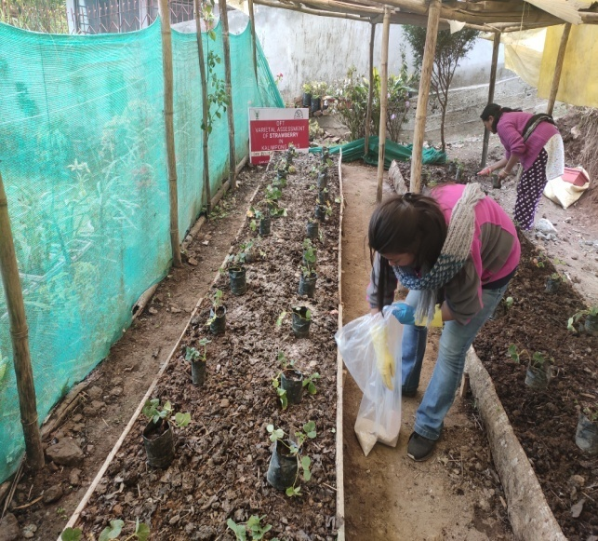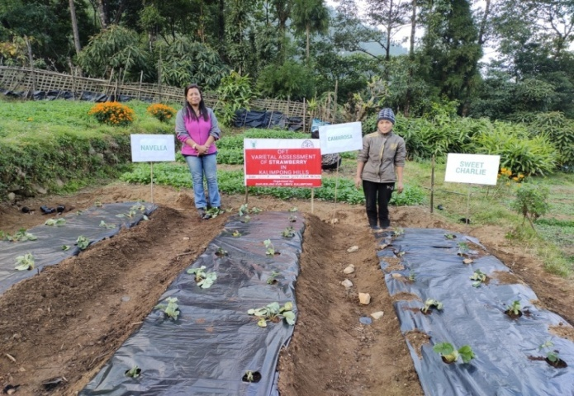

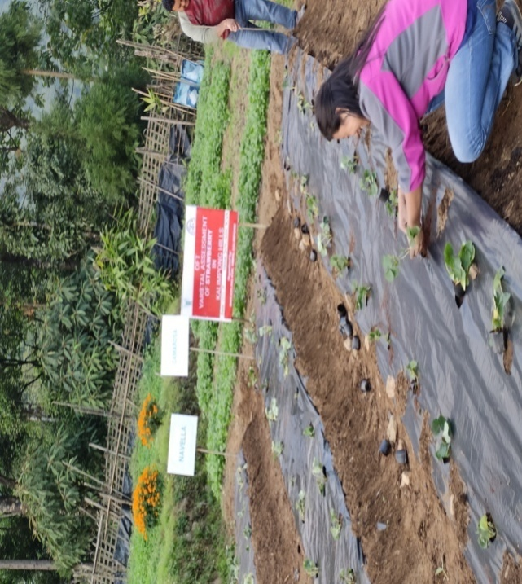

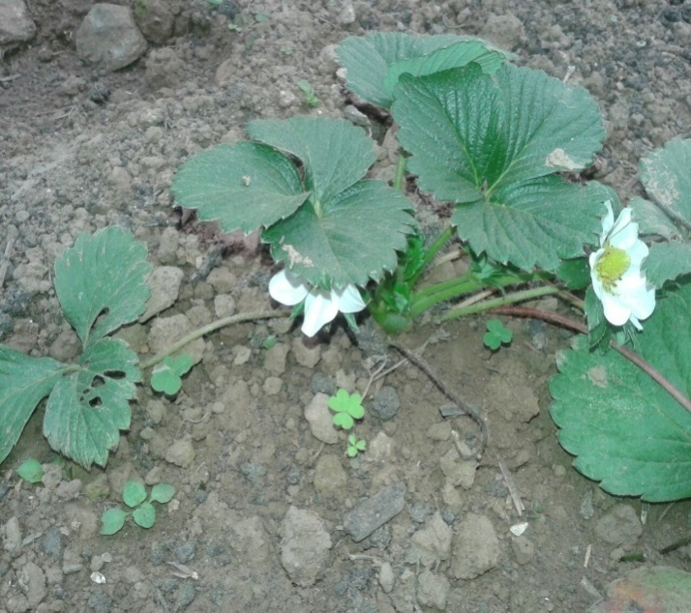

OFT-2

|  |  |  |
| --- | --- | --- |
| 1. | Title of On farm Trial | **Multi-Altitudinal Trial of Capsicum in Darjeeling and Kalimpong Hills** |
| 2. | Problem diagnosed | Low fruit set and small size of fruits. |
| 3. | Details of technologies selected for assessment/refinement  (Mention either Assessed or Refined) | Farmers’ practice – 1000-1250 M above sea level N:P:K@160:60:30 kg/ha FYM@25 t/ha  Tech. option I: 1251-1500 M above sea level N:P:K@160:60:30 kg/ha FYM@25 t/ha  Tech. option II:1501-1750 M above sea level N:P:K@160:60:30 kg/ha FYM@25 t/ha  Tech. option III:1751-2000 M above sea level N:P:K@160:60:30 kg/ha FYM@25 t/ha |
| 4. | Source of Technology (ICAR/ AICRP/SAU/other, please specify) | B.C.K.V |
| 5. | Production system and thematic area | Vegetable based cropping system |
| 6. | Performance of the Technology with performance indicators | Based on the fruit size, fruit yield and comparative economics of capsicum indifferent altitudes. |
| 7. | Final recommendation for micro level situation | Among the trials conducted at different altitudes , the Farmers practice (1000-125m AboveMSL)was recommended.It was also seen that the with the increase in the altitude the size of fruits as well as the number of fruits per plant decreased and in terms of the economic calculation Tech option II and Tech option III was a Failure so keeping in view of the result I would like to start my trial from the altitude of 500m Above MSL. |
| 8. | Constraints identified and feedback for research | Lack of awareness about the proper production technology. That’s why further research and training programmes have to be conducted inorder to find out the best altitude for growing capsicum. |
| 9. | Process of farmers participation and their reaction | Farmers participated actively through phone calls, personal contacts, field days, etc. Farmers participated in this programme were highly interested in raising crops from the different variety and demanded a larger quantity and a regular supply of the different varieties for strawberry production. |

**Results: Table**

|  |  |  |  |  |  |  |  |  |  |  |
| --- | --- | --- | --- | --- | --- | --- | --- | --- | --- | --- |
| **Technology option** | **No. of trials** | **Yield component** | | **Disease/ insect pest incidence (%)** | **Yield**  **(q/ha)** | **Cost of cultivation**  **(Rs./ha)** | **Gross return (Rs/ha)** | **Net return**  **(Rs./ha)** | **BC ratio** | |
| **No. of fruits per plant** | **Average weight of fruits(g)** |
| Farmers’practice:1000-1250 MSL N : P : K @ 160 :60:30 kg/ha FYM@25 t/ha | 6 | 20.8 | 35 |  | 172.90 | 75,750/- | 1,38,320/- | 62,570/- | | 1.82:1 |
| Tech. option I: 1251-1500M MSL N : P : K @ 160 :60:30 kg/ha FYM@25 t/ha | 20.2 | 33 |  | 158.31 | 75,750/- | 1,26,648/- | 50,898/- | | 1.67:1 |
| Tech. option II:1501-1750 M MSL N : P : K @ 160 :60:30 kg/ha FYM@25 t/ha | 18.1 | 25 |  | 104.07 | 75,750/- | 83,256/- | 7,506/- | | 1.09:1 |
| Tech. option III: 1751-2000 MSL N : P : K @ 160 :60:30 kg/ha FYM@25 t/ha | 15 | 18 |  | 64.125 | 75,750/- | 51,300/- | -24,245/- | | 0.6:1 |

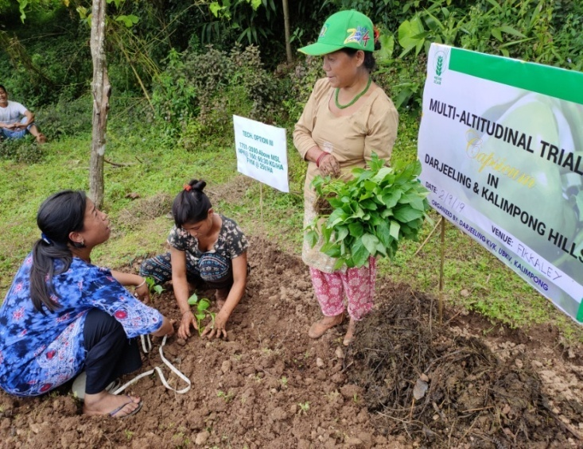 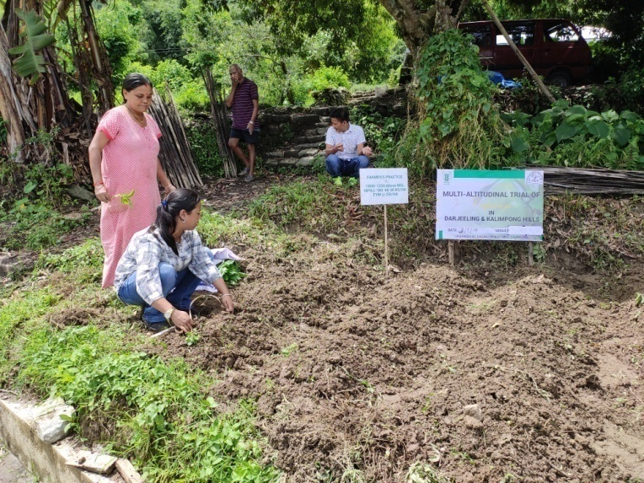

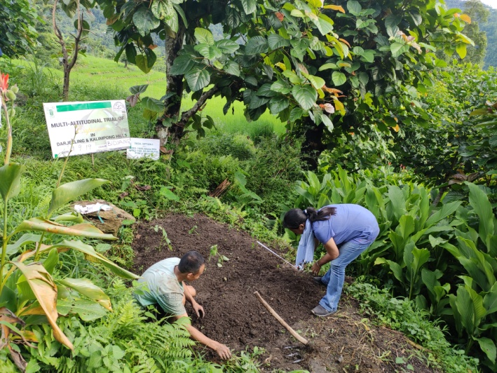 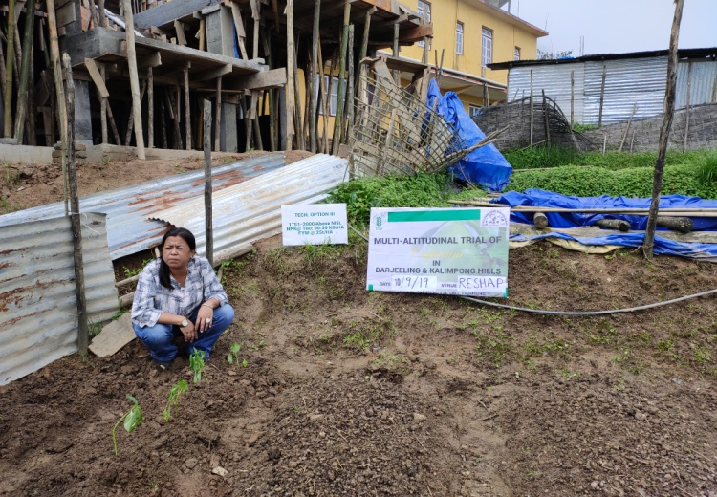

OFT-3 (Plant Protection)

|  |  |  |
| --- | --- | --- |
| 1. | Title of On farm Trial | Eco-friendly management of diamond back moth in cauliflower grown in Darjeeling Hills |
| 2. | Problem diagnosed | Poor yield |
| 3. | Details of technologies selected for assessment/refinement  (Mention either Assessed or Refined) | Assessed |
| 4. | Source of Technology (ICAR/ AICRP/SAU/other, please specify) | IPM schedule for vegetables, NHM, Ministry of Agriculture |
| 5. | Production system and thematic area | Vegetable based cropping system and Integrated pest management |
| 6. | Performance of the Technology with performance indicators | Pest incidence, Yield and BC ratio |
| 7. | Final recommendation for micro level situation | Sow Indian mustard as a trap crop and Installation of light trap was effectively control the diamond back moth in cauliflower. |
| 8. | Constraints identified and feedback for research | - |
| 9. | Process of farmers participation and their reaction | For selection of farmers a group meeting was organized from where a few farmers was selected considering the production system and farming situation as per action plan. Ultimately 8 no. of farmers were selected from primary list after in situ visit of the farmers’ field. |

*Thematic area: Integrated Pest Management*

Problem definition: Cauliflower crop are suffering from low yield due to the severe attack of diamond back moth and no proper management practices were followed.

Technology assessed: Tech. option I: Sow Indian mustard as a trap crop

Tech option II: T.O. I + Spray neem formulation Azadirachtin 1% @ 3ml/l of water

Tech. option III: T.O. I + Install light trap

Table:

|  |  |  |  |  |  |  |  |  |  |  |
| --- | --- | --- | --- | --- | --- | --- | --- | --- | --- | --- |
| Technology option | No. of trials | Yield component | | | Mean no. of larvae /plant | Yield  (q/ha) | Cost of cultivation  (Rs./ha) | Gross return (Rs/ha) | Net return  (Rs./ha) | BC ratio |
| No. of effective tillers/hill | No. of spikelet per panicle | Test wt. (100 grain wt.) |
| Farmers Practice | 3 | - | - | - | 6.3 (2.50) | 178 | 233350 | 326120 | 92770 | 1.39 |
| T1 | 3 | - | - | - | 2.3 (1.50) | 183 | 238750 | 366110 | 127360 | 1.53 |
| T2 | 3 | - | - | - | 2.8 (1.65) | 187 | 238950 | 374025 | 135075 | 1.56 |
| T3 | 3 | - | - | - | 1.5 (1.21) | 189 | 239150 | 378030 | 138880 | 1.58 |
| CD (p=0.05) | | | | | 0.39 | 5.99 |  |  |  |  |

**Interpretation:**All the selected technologies performed significantly better over farmers’ practice of which technology option3*i.e.* sowing of Indian mustard as a trap crop + installation of light trap @ 4/ha, resulted to produce highest yield (189q ha-1) as well as reduces the significant numbers of larval population (1.5 larvae plant-1) followed by technology option2 and technology option1.

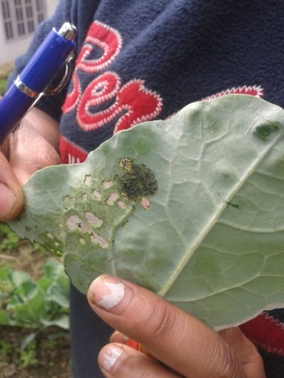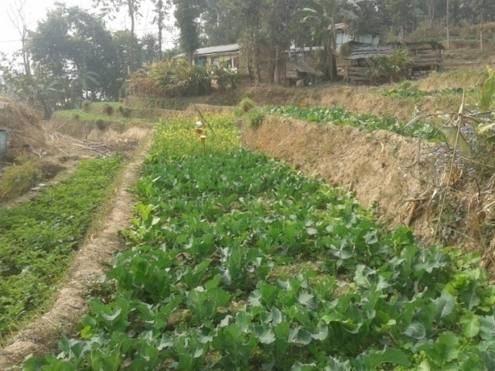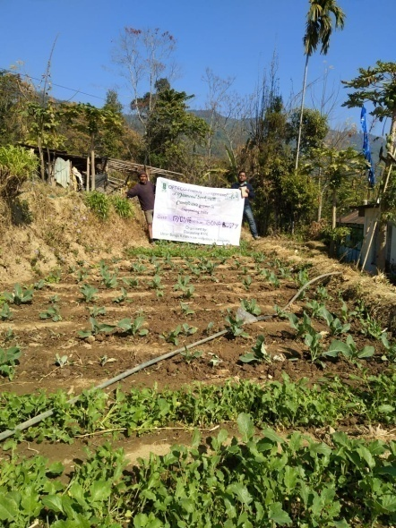

OFT-4 (Plant Protection)

|  |  |  |
| --- | --- | --- |
| 1. | Title of On farm Trial | IPM & Biological control of plant pathogensin tomato grown in Darjeeling Hills |
| 2. | Problem diagnosed | Poor yield due to high incidence of fruit borer and Late blight in tomato |
| 3. | Details of technologies selected for assessment/refinement  (Mention either Assessed or Refined) | Assessed |
| 4. | Source of Technology (ICAR/ AICRP/SAU/other, please specify) | Indian Institute of Vegetable Research |
| 5. | Production system and thematic area | Vegetable based cropping system and Integrated pest management & biological control |
| 6. | Performance of the Technology with performance indicators | Pest and disease incidence, Yield and BC ratio |
| 7. | Final recommendation for micro level situation | No recommendation can be made from the available result. |
| 8. | Constraints identified and feedback for research | - |
| 9. | Process of farmers participation and their reaction | For selection of farmers a group meeting was organized from where a few farmers was selected considering the production system and farming situation as per action plan. Ultimately 8 no. of farmers were selected from primary list after in situ visit of the farmers’ field. |

*Thematic area: Integrated Pest Management and Biological Control*

Problem definition: Tomato crop are suffering from low yield due to the severe attack of fruit borer and late blight disease infestation and no proper management practices were followed.

Technology assessed: Tech. option I: Management of *Helicoverpa armigera* by using sex pheromones traps in Tomato @ 4/ha to monitor the initial attack of pest at time of flowering

Tech option II: Soil application of neem cake @ 100g + Trichoderma@10g/ sq.m in nursery bed to reduce post emergence blight

Table:

|  |  |  |  |  |  |  |  |  |  |  |  |
| --- | --- | --- | --- | --- | --- | --- | --- | --- | --- | --- | --- |
| Technology option | No. of trials | Yield component | | | % Fruit borer damage /plant | Blight infestation (PDI) | Yield  (q/ha) | Cost of cultivation  (Rs./ha) | Gross return (Rs/ha) | Net return  (Rs./ha) | BC ratio |
| No. of effective tillers/hill | No. of spikelet per panicle | Test wt. (100 grain wt.) |
| Farmers Practice | 3 | - | - | - | 27.47 (3.00) | - | 20.57 | 7942 | 18510 | 10568 | 2.33 |
| T1 | 3 | - | - | - | 11.43 (1.93) | - | 28.73 | 8642 | 25860 | 17218 | 2.99 |
| T2 | 3 | - | - | - | 13.00 (2.06) | - | 26.10 | 8652 | 23490 | 14838 | 2.71 |
| CD (p=0.05) | | | | | NS | - | 3.64 | - | - | - | - |

**Interpretation:** Tomato fruit borer infestation recorded lowest value (11.43%) with technology option1 (Management of *Helicoverpa armigera* by using sex pheromones traps in Tomato @ 4/ha to monitor the initial attack of pest at time of flowering) followed by technology option2 (Soil application of neem cake @ 100g + Trichoderma@10g/ sq.m in nursery bed to reduce post emergence blight) and all were better over farmers’ practice but differences among the selected technologies were not significant. There is no blight infestation recorded in this trial period. In consonant highest yield was in technology option1 followed by technology option2.

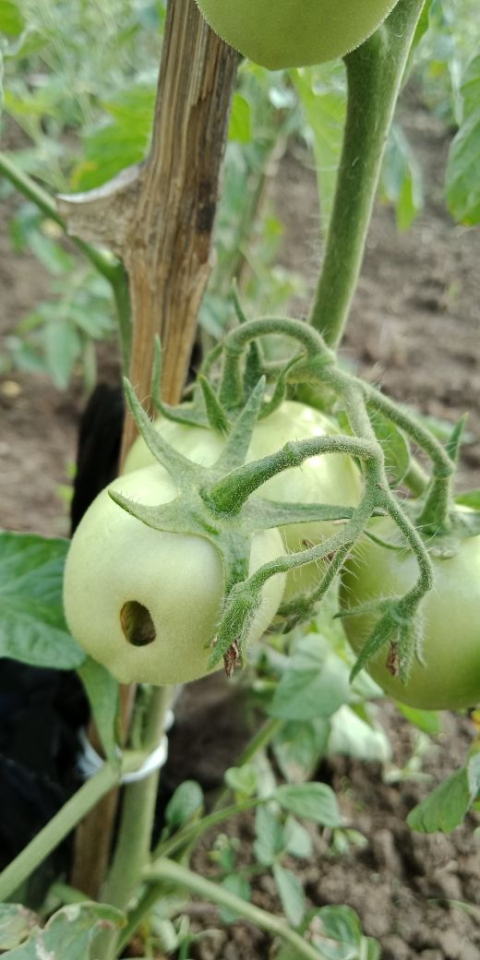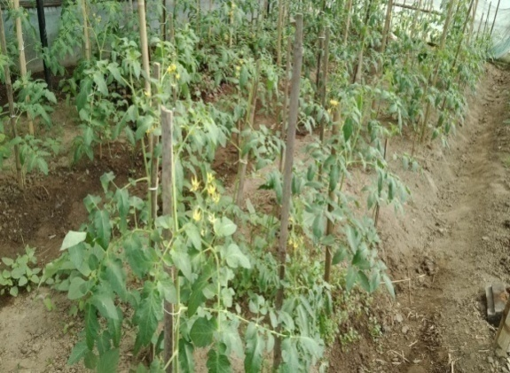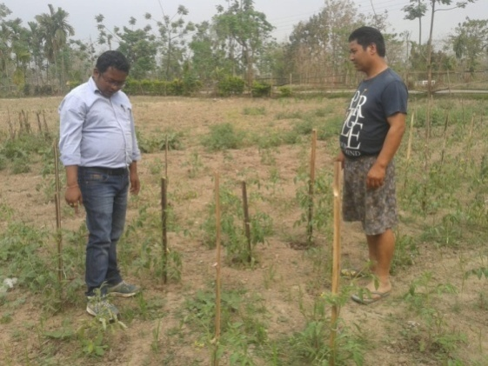

OFT-5 (Animal Science)

|  |  |  |
| --- | --- | --- |
| 1. | Title of On farm Trial | Assessment of different system of housing for poultry under backyard farming in hills. |
| 2. | Problem diagnosed | Low production and high mortality rate of poultry under backyard farming system in hills. |
| 3. | Details of technologies selected for assessment/refinement  (Mention either Assessed or Refined) | **Technology Assessed:**  **Farmers’ practice:** Poultry birds are kept in a very confined area  **Tech. option I:** Poultry birds kept in deep litter system  **Tech. option II:** Poultry birds kept in slat system  **Tech. option III:** Poultry birds kept in slat cum deep litter system |
| 4. | Source of Technology (ICAR/ AICRP/SAU/other, please specify) | ICAR-Central Avian Research Institute |
| 5. | Production system and thematic area | Backyard Poultry Farming System |
| 6. | Performance of the Technology with performance indicators | Growth rate, disease incidence and mortality rate |
| 7. | Final recommendation for micro level situation | The poultry birds kept in slat type of housing system had higher production performance due to higher growth rate, low morbidity and mortality rate in backyard poultry farming system in hill farming situation. |
| 8. | Constraints identified and feedback for research | No major constraints found in assessment of the trail. The farmers had positive response towards the slat type of poultry housing. This is due to low morbidity and mortality rate in poultry birds. |
| 9. | Process of farmers participation and their reaction | The farmers involved in OFT had genuine participation with high level of interaction and consultation between the farmers and the expert engaged in the trial. The farmers had high satisfaction that the technology can reduce the problem of low growth rate and high mortality rate in poultry under backyard farming system in hill farming situation. |

*Thematic area: Poultry Farming*

Problem definition: Low production and high mortality rate of poultry under backyard farming system in hills.

Technology assessed: Assessment of different system of housing for poultry under backyard farming in hills.

**Table: Data on parameter in relation to Technology demonstrated**

|  |  |  |  |  |  |  |  |  |  |
| --- | --- | --- | --- | --- | --- | --- | --- | --- | --- |
| **Tech. options** | Growth rate (@1 months) | | Growth rate (@2 months) | | Growth rate (@3 months) | | Disease incidence (%) | Mortality rate (%) | BCR |
| Male (Mean±SD) | Female (Mean±SD) | Male (Mean±SD) | Female (Mean±SD) | Male (Mean±SD) | Female (Mean±SD) |
| **Farmers’ practice** | 0.219 ± 0.15 | 0.207 ± 0.13 | 0.258 ± 0.09 | 0.250 ± 0.38 | 0.313 ± 0.12 | 0.308 ± 0.43 | 21.20 | 16.30 | 2.1:1 |
| **Tech. option I** | 0.237 ± 0.18 | 0.213 ± 0.07 | 0.288± 0.32 | 0.279 ± 0.16 | 0.377 ± 0.22 | 0.350 ± 0.05 | 14.10 | 11.40 | 3.2 |
| **Tech. option II** | 0.252 ± 0.27 | 0.221± 0.04 | 0.330 ± 0.31 | 0.310 ± 0.10 | 0.394 ± 0.45 | 0.366 ± 0.51 | 12.70 | 7.50 | 4.1:1 |
| **Tech. option III** | 0.239 ± 0.10 | 0.211± 0.08 | 0.323 ± 0.13 | 0.306 ± 0.28 | 0.381 ± 0.39 | 0.364 ± 0.19 | 13.80 | 8.50 | 3.6:1 |

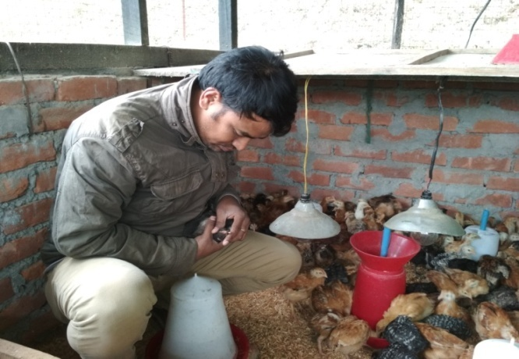**Results:** The results depicts that the Technology Option- II had higher growth rate and reduce disease incidence rate and mortality rate among other Technology Options and therefore it has higher B:C ratio. Therefore, it can be concluded that Technology Option II is better than the other two options and farmers’ practices. So, it can be recommended that poultry should be kept in slat housing system for this region.

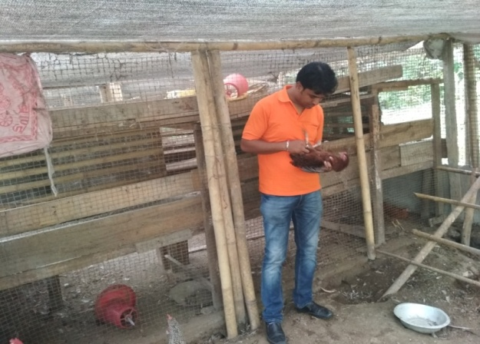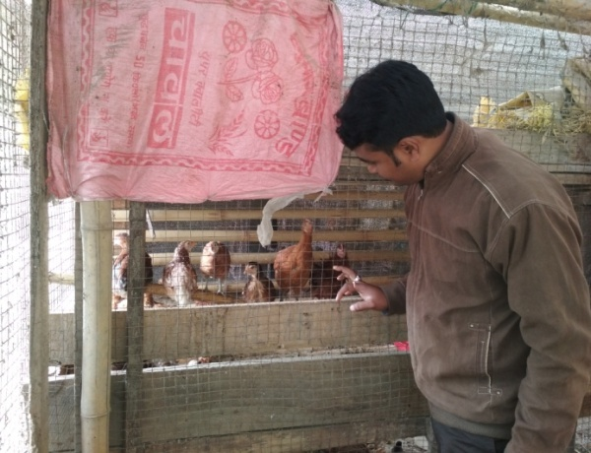

**OFT- 6 (Animal Science)**

|  |  |  |
| --- | --- | --- |
| 1. | Title of On farm Trial | Assessment of right heat sources for new born piglets during winter months to reduce mortality |
| 2. | Problem diagnosed | High mortality of piglet during winters months under backyard farming system |
| 3. | Details of technologies selected for assessment/refinement  (Mention either Assessed or Refined) | **Technology Assessed:**  **Farmers’ practice:** No heat sources are provide to newborn piglets during winter months under backyard farming system  **Tech. option I:** Providing heat with wood and coal to newborn piglets during winter months.  **Tech. option II:** Providing electric bulb to newborn piglets during winter months.  **Tech. option III:** Providing straw and gunny to newborn piglets during winter months. |
| 4. | Source of Technology (ICAR/ AICRP/SAU/other, please specify) | ICAR-NEH |
| 5. | Production system and thematic area | Backyard Pig Farming System |
| 6. | Performance of the Technology with performance indicators | Growth rate, disease incidence and piglet mortality |
| 7. | Final recommendation for micro level situation | The piglet provided heat during winter months with electric bulb had higher production performance due to higher growth rate, low morbidity and mortality rate in backyard pig farming system in hill farming situation. |
| 8. | Constraints identified and feedback for research | No major constraints found in assessment of the trail. The farmers had positive response towards the use of electric bulb during winter months. Through some of the farmers had reported power cut and they sometimes provided heat through firing wood. |
| 9. | Process of farmers participation and their reaction | The farmers involved in OFT had genuine participation with high level of interaction and consultation between the farmers and the expert engaged in the trial. The farmers had high satisfaction that the technology can reduce the problem of low growth rate and high mortality rate in pig during winter months under backyard farming system in hill farming situation. |

**Table: Data on parameter in relation to Technology demonstrated**

|  |  |  |  |  |  |  |  |  |  |
| --- | --- | --- | --- | --- | --- | --- | --- | --- | --- |
| **Techoption** | Growth rate (@1 months) | | Growth rate (@2 months) | | Growth rate (@3 months) | | Disease incidence (%) | Mortality rate (%) | BCR |
| Male (Mean±SD) | Female (Mean±SD) | Male (Mean±SD) | Female (Mean±SD) | Male (Mean±SD) | Female (Mean±SD) |
| **Farmers’ practice** | 2.501 ± 0.33 | 2.418 ± 0.65 | 4.321 ± 0.61 | 4.314± 0.92 | 6.572 ± 0.87 | 6.202 ± 0.39 | 24 | 14 | 3.3:1 |
| **Tech. option I** | 2.542 ± 0.28 | 2.517 ± 0.41 | 4.602 ± 0.84 | 4.303± 0.46 | 7.448 ± 0.44 | 7.305 ± 0.72 | 18 | 8 | 4.4:1 |
| **Tech. option II** | 2.547 ± 0.40 | 2.532 ± 0.53 | 4.834 ± 0.71 | 4.617 ± 1.01 | 7.584 ± 0.63 | 7.402 ± 0.96 | 14 | 5 | 5.2:1 |
| **Tech. option III** | 2.428 ± 0.74 | 2.414± 0.70 | 4.502 ± 0.92 | 4.215± 0.83 | 6.828 ± 0.78 | 6.418 ± 0.55 | 11 | 9 | 3.9:1 |

**Results:** The results shows that the Technology Option IIhad higher growth rate and lower disease incidence rate and mortality rate among other Technology Options and therefore it has higher B:C ratio. Therefore, it can be concluded that Technology Option II is better than the other two options and farmers’ practices. So, it can be recommended to the farmers of this region.

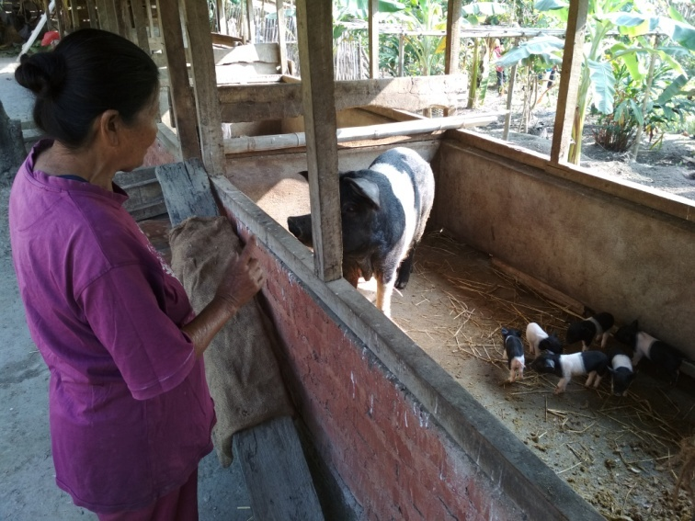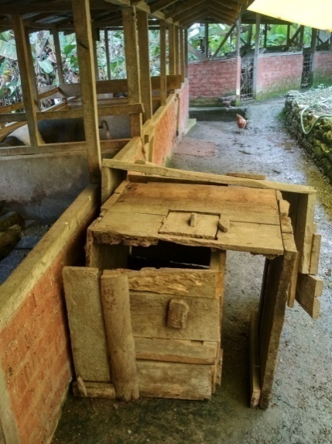

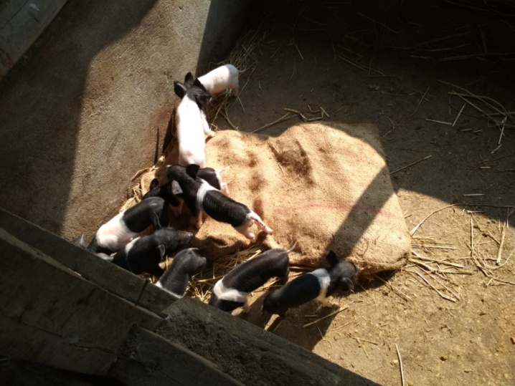

OFT-7 (Home Science) : NIL

|  |  |  |
| --- | --- | --- |
| 1. | Title of On farm Trial |  |
| 2. | Problem diagnosed |  |
| 3. | Details of technologies selected for assessment/refinement  (Mention either Assessed or Refined) |  |
| 4. | Source of Technology (ICAR/ AICRP/SAU/other, please specify) |  |
| 5. | Production system and thematic area |  |
| 6. | Performance of the Technology with performance indicators |  |
| 7. | Final recommendation for micro level situation |  |
| 8. | Constraints identified and feedback for research |  |
| 9. | Process of farmers participation and their reaction |  |

*Thematic area:*

|  |  |  |  |  |  |  |  |  |
| --- | --- | --- | --- | --- | --- | --- | --- | --- |
| **Technology option** | **No. of trials** | **Performance assessment parameters** | | | **Economic parameters** | | | **B C ratio** |
| **Self-life time** | **Shape/size** | **Colour** | **Input Cost** | **Gross return** | **Net return** |
|  |  |  |  |  |  |  |  |  |
|  |  |  |  |  |  |  |  |  |
|  |  |  |  |  |  |  |  |  |

**OFT 8 (Home Science): NIL**

|  |  |  |
| --- | --- | --- |
| 1. | Title of On farm Trial |  |
| 2. | Problem diagnosed |  |
| 3. | Details of technologies selected for assessment/refinement  (Mention either Assessed or Refined) |  |
| 4. | Source of Technology (ICAR/ AICRP/SAU/other, please specify) |  |
| 5. | Production system and thematic area |  |
| 6. | Performance of the Technology with performance indicators |  |
| 7. | Final recommendation for micro level situation |  |
| 8. | Constraints identified and feedback for research |  |
| 9. | Process of farmers participation and their reaction |  |

Thematic area

OFT-9 (Soil Science)

|  |  |
| --- | --- |
| Title | **Efficacy of Organic manure, Vermi-compost & bio-product to increase the productivity of Potato & Nutrient status of hilly region of West Bengal.** |
| Problem area | **Due to high acidity & low nutrient status cause less productivity.** |
| Production system | Vegetable based |
| Micro Farming situation | High land |
| Technology for testing | Performance of Organic Manure & bio-products |
| Source of technology | BCKV |
| Objectives | To increase the productivity of solanaceous (Potato) & Soil health management. |
| Hypothesis | Use of Organic Manure (FYM) + Trichoderma viridae + Vermicompost + Soil treatment with neem cakemay produce better result in production of potato & soil heath management. |
| Technology option | **Farmers’ practice:** No particular practice  **Technology option 1:** Application of *Trichoderma viridae* @ 5 gm/ kg of seed + 1350kg FYM/bigha in the mainfield 10 days before sowing of seeds.  **Technology option 2:** Seed treatment with *Trichoderma viridae* @ 5 gm/kg of seed + 700 kg Vermicompost/bigha in the main field 10 days before sowing  **Technology option 3:** Seed treatment with *Trichoderma viridae* @ 5 gm/kg of seed + Soil treatment with neem cake@ 66.5 kg/ bigha + 700kg vermicompost/ bigha 10 days before sowing. |
| Critical Inputs | *Farm Yeard Manure, Vermicompost, Neem cake, Trichoderma viridae* |
| Unit size | 0.13 ha |
| No. of replication | 4 |
| Cost/unit | 4,040/- |
| Total Cost | 16,160/- |
| Monitoring indicators | Production or Yield attributes farmers’ evaluation, Soil Nutrient status after harvesting. |

*Thematic area: Soil Health Management*

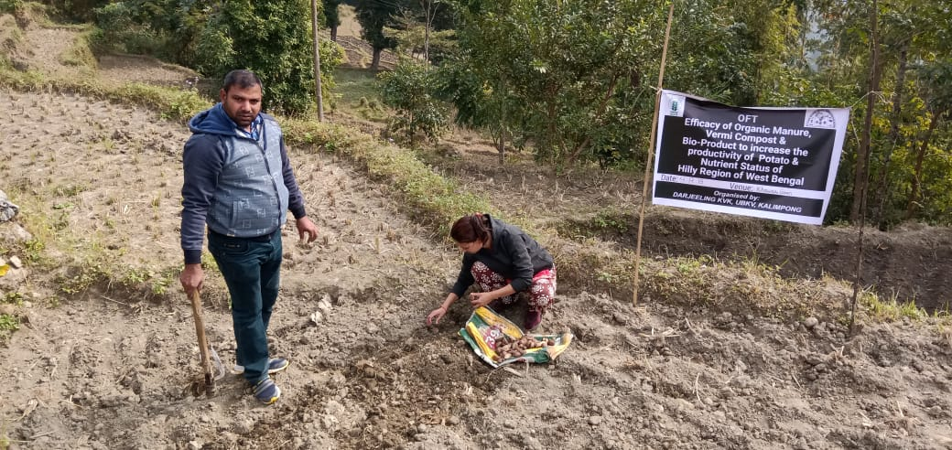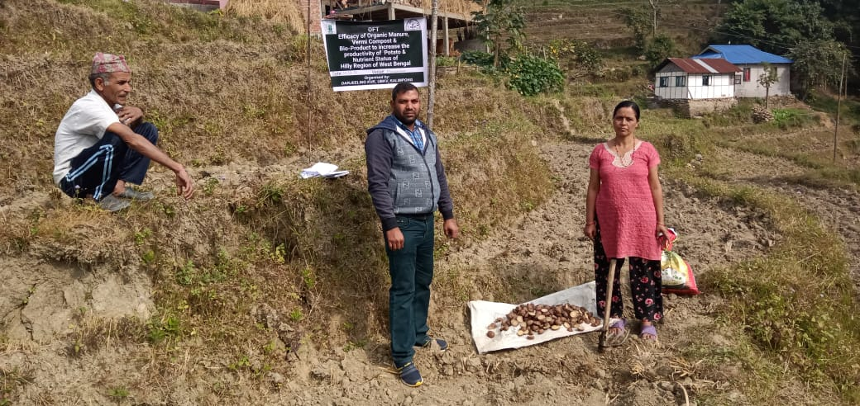

Problem definition: Potato crop is suffering from low yield due to the low nutrient status and no proper management practices were followed.

Table: Crop in field (Expected harvest in April 2020)

|  |  |  |  |  |  |  |  |  |  |  |  |
| --- | --- | --- | --- | --- | --- | --- | --- | --- | --- | --- | --- |
| Technology option | No. of trials | Yield component | | | % Fruit borer damage /plant | Blight infestation (PDI) | Yield  (q/ha) | Cost of cultivation  (Rs./ha) | Gross return (Rs/ha) | Net return  (Rs./ha) | BC ratio |
| No. of effective tillers/hill | No. of spikelet per panicle | Test wt. (100 grain wt.) |
| Farmers Practice |  |  |  |  |  |  |  |  |  |  |  |
| T1 |  |  |  |  |  |  |  |  |  |  |  |
| T2 |  |  |  |  |  |  |  |  |  |  |  |

**Interpretation:**

3.2 Achievements of Frontline Demonstrations

1. Details of FLDs conducted during the year

Crop category: Cereals

|  |  |  |  |  |  |  |  |  |  |  |  |  |  |  |  |
| --- | --- | --- | --- | --- | --- | --- | --- | --- | --- | --- | --- | --- | --- | --- | --- |
| Sl.  No. | Crop | Thematic area | Technology Demonstrated with detailed treatments | Area (ha) | | No. of farmers/  demonstration | | | | | | | | | Reasons for shortfall in achievement |
| Proposed | Actual | SC | | ST | | Others | | Total | | |
|  |  |  |  |  |  | M | F | M | F | M | F | M | F | T |
|  |  |  |  |  |  |  |  |  |  |  |  |  |  |  |  |

Details of farming situation

|  |  |  |  |  |  |  |  |  |  |  |  |
| --- | --- | --- | --- | --- | --- | --- | --- | --- | --- | --- | --- |
| Crop | Season | Farming situation (RF/Irrigated) | Soil type | Status of soil  (Kg/ha) | | | Previous crop | Sowing date | Harvest date | Seasonal rainfall (mm) | No. of rainy days |
| N | P2O5 | K2O |
|  |  |  |  |  |  |  |  |  |  |  |  |

Performance of FLD

|  |  |  |  |  |  |  |  |  |  |  |  |  |  |  |  |
| --- | --- | --- | --- | --- | --- | --- | --- | --- | --- | --- | --- | --- | --- | --- | --- |
| Crop | Thematic Area | Name of the technology demonstrated | No. of Farmers | Area  (ha) | Yield (q/ha) | | % Increase | *Economics of demonstration (Rs./ha) | | | | *Economics of check  (Rs./ha) | | | |
| Demo | Check | Gross  Cost | Gross  Return | Net Return | **  BCR | Gross  Cost | Gross  Return | Net Return | **  BCR |
|  |  |  |  |  |  |  |  |  |  |  |  |  |  |  |  |

Crop category: Oilseeds

|  |  |  |  |  |  |  |  |  |  |  |  |  |  |  |  |
| --- | --- | --- | --- | --- | --- | --- | --- | --- | --- | --- | --- | --- | --- | --- | --- |
| Sl.  No. | Crop | Thematic area | Technology Demonstrated with detailed treatments | Area (ha) | | No. of farmers/  demonstration | | | | | | | | | Reasons for shortfall in achievement |
| Proposed | Actual | SC | | ST | | Others | | Total | | |
|  |  |  |  |  |  | M | F | M | F | M | F | M | F | T |
|  |  |  |  |  |  |  |  |  |  |  |  |  |  |  |  |

Details of farming situation

|  |  |  |  |  |  |  |  |  |  |  |  |
| --- | --- | --- | --- | --- | --- | --- | --- | --- | --- | --- | --- |
| Crop | Season | Farming situation (RF/Irrigated) | Soil type | Status of soil  (Kg/ha) | | | Previous crop | Sowing date | Harvest date | Seasonal rainfall (mm) | No. of rainy days |
| N | P2O5 | K2O |
|  |  |  |  |  |  |  |  |  |  |  |  |

Performance of FLD

|  |  |  |  |  |  |  |  |  |  |  |  |  |  |  |  |
| --- | --- | --- | --- | --- | --- | --- | --- | --- | --- | --- | --- | --- | --- | --- | --- |
| Crop | Thematic Area | Name of the technology demonstrated | No. of Farmers | Area  (ha) | Yield (q/ha) | | % Increase | *Economics of demonstration (Rs./ha) | | | | *Economics of check  (Rs./ha) | | | |
| Demo | Check | Gross  Cost | Gross  Return | Net Return | **  BCR | Gross  Cost | Gross  Return | Net Return | **  BCR |
|  |  |  |  |  |  |  |  |  |  |  |  |  |  |  |  |

Pulses   
Frontline demonstration on pulse crops

|  |  |  |  |  |  |  |  |  |  |  |  |  |  |  |  |
| --- | --- | --- | --- | --- | --- | --- | --- | --- | --- | --- | --- | --- | --- | --- | --- |
| Crop | Thematic Area | Name of the technology demonstrated | No. of Farmers | Area  (ha) | Yield (q/ha) | | % Increase | *Economics of demonstration (Rs./ha) | | | | *Economics of check  (Rs./ha) | | | |
| Demo | Check | Gross  Cost | Gross  Return | Net Return | **  BCR | Gross  Cost | Gross  Return | Net Return | **  BCR |
|  |  |  |  |  |  |  |  |  |  |  |  |  |  |  |  |
|  |  |  |  |  |  | | | | | | | | | | |
|  |  |  |  |  |  |  |  |  |  |  |  |  |  |  |  |

* Economics to be worked out based on total cost of production per unit area and not on critical inputs alone.

** BCR= GROSS RETURN/GROSS COST

Crop category: Vegetables

|  |  |  |  |  |  |  |  |  |  |  |  |  |  |  |  |
| --- | --- | --- | --- | --- | --- | --- | --- | --- | --- | --- | --- | --- | --- | --- | --- |
| Sl.  No. | Crop | Thematic area | Technology Demonstrated with detailed treatments | Area (ha) | | No. of farmers/  demonstration | | | | | | | | | Reasons for shortfall in achievement |
| Proposed | Actual | SC | | ST | | Others | | Total | | |
|  |  |  |  |  |  | M | F | M | F | M | F | M | F | T |
|  |  |  |  |  |  |  |  |  |  |  |  |  |  |  |  |

Details of farming situation

|  |  |  |  |  |  |  |  |  |  |  |  |
| --- | --- | --- | --- | --- | --- | --- | --- | --- | --- | --- | --- |
| Crop | Season | Farming situation (RF/Irrigated) | Soil type | Status of soil  (Kg/ha) | | | Previous crop | Sowing date | Harvest date | Seasonal rainfall (mm) | No. of rainy days |
| N | P2O5 | K2O |
|  |  |  |  |  |  |  |  |  |  |  |  |

Performance of FLD

|  |  |  |  |  |  |  |  |  |  |  |  |  |  |  |  |
| --- | --- | --- | --- | --- | --- | --- | --- | --- | --- | --- | --- | --- | --- | --- | --- |
| Crop | Thematic Area | Name of the technology demonstrated | No. of Farmers | Area  (ha) | Yield (q/ha) | | % Increase | *Economics of demonstration (Rs./ha) | | | | *Economics of check  (Rs./ha) | | | |
| Demo | Check | Gross  Cost | Gross  Return | Net Return | **  BCR | Gross  Cost | Gross  Return | Net Return | **  BCR |
|  |  |  |  |  |  |  |  |  |  |  |  |  |  |  |  |

Crop category: Fruit Crop

|  |  |  |  |  |  |  |  |  |  |  |  |  |  |  |  |
| --- | --- | --- | --- | --- | --- | --- | --- | --- | --- | --- | --- | --- | --- | --- | --- |
| Sl.  No. | Crop | Thematic area | Technology Demonstrated with detailed treatments | Area (ha) | | No. of farmers/  demonstration | | | | | | | | | Reasons for shortfall in achievement |
| Proposed | Actual | SC | | ST | | Others | | Total | | |
| M | F | M | F | M | F | M | F | T |
| 1 | Mandarin | Nutrient Management | N:P:K@300:250:300 g B50g,Z250g,Vermicompost12.5kg,PigManure 6.25kg and FYM 25 kg/tree | 1 ha | 1 ha |  |  |  |  |  |  |  |  |  |  |

Details of farming situation

|  |  |  |  |  |  |  |  |  |  |  |  |
| --- | --- | --- | --- | --- | --- | --- | --- | --- | --- | --- | --- |
| Crop | Season | Farming situation (RF/Irrigated) | Soil type | Status of soil  (Kg/ha) | | | Previous crop | Sowing date | Harvest date | Seasonal rainfall (mm) | No. of rainy days |
| N | P2O5 | K2O |
|  |  |  |  |  |  |  |  |  |  |  |  |

Performance of FLD

|  |  |  |  |  |  |  |  |  |  |  |  |  |  |  |  |
| --- | --- | --- | --- | --- | --- | --- | --- | --- | --- | --- | --- | --- | --- | --- | --- |
| **Crop** | **Thematic area** | **Name of the technology demonstrated** | **No. of Farmer** | **Area**  **(ha)** | **Yield (q/ha)** | | **% change in yield** | **\*Economics of demonstration (Rs./ha)** | | | | **\*Economics of check**  **(Rs./ha)** | | | |
| Demons  ration | Check | Gross  Cost | Gross  Return | Net Return | **  BCR | Gross  Cost | Gross  Return | Net Return | **  BCR |
| Mandarin | Crop production | Nutrient Mnagement |  | 1 | 590 | 260 | 55 | 2,35,500 | 5,82,920 | 3,47,420 | 2.4:1 | 1,45,500 | 2,56,880 | 1,11,380 | 1.76 |

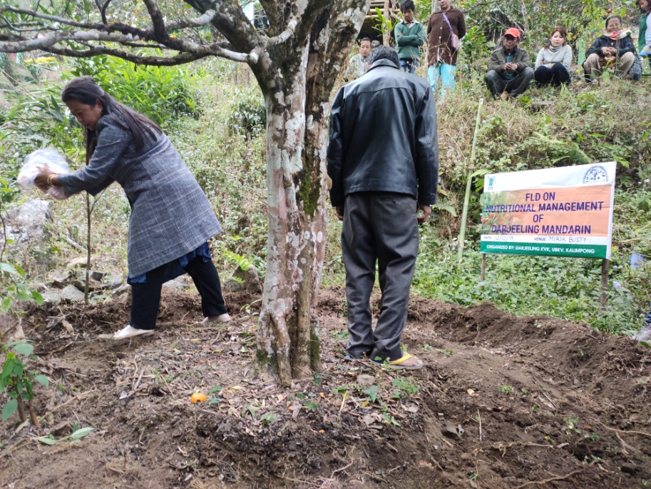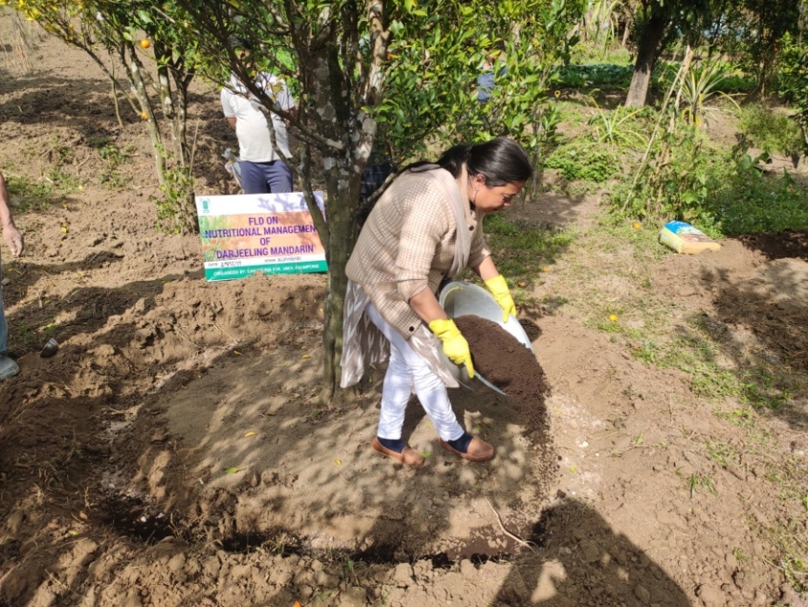

Crop category: Spices Crop

|  |  |  |  |  |  |  |  |  |  |  |  |  |  |  |  |
| --- | --- | --- | --- | --- | --- | --- | --- | --- | --- | --- | --- | --- | --- | --- | --- |
| Sl.  No. | Crop | Thematic area | Technology Demonstrated with detailed treatments | Area (ha) | | No. of farmers/  demonstration | | | | | | | | | Reasons for shortfall in achievement |
| Proposed | Actual | SC | | ST | | Others | | Total | | |
| M | F | M | F | M | F | M | F | T |
| 1 | Black Pepper | Plant Propagation | Serpentine method of Black pepper propagation | 100 plants | 100 plants |  |  |  |  |  |  |  |  |  |  |

Details of farming situation : Potted crop

|  |  |  |  |  |  |  |  |  |  |  |  |
| --- | --- | --- | --- | --- | --- | --- | --- | --- | --- | --- | --- |
| Crop | Season | Farming situation (RF/Irrigated) | Soil type | Status of soil  (Kg/ha) | | | Previous crop | Sowing date | Harvest date | Seasonal rainfall (mm) | No. of rainy days |
| N | P2O5 | K2O |
|  |  |  |  |  |  |  |  |  |  |  |  |

Performance of FLD (Crop in Field : Expected result in July 2020)

|  |  |  |  |  |  |  |  |  |  |  |  |  |  |  |  |
| --- | --- | --- | --- | --- | --- | --- | --- | --- | --- | --- | --- | --- | --- | --- | --- |
| **Crop** | **Thematic area** | **Name of the technology demonstrated** | **No. of Farmer** | **Area**  **(ha)** | **Yield (q/ha)** | | **% change in yield** | **\*Economics of demonstration (Rs./ha)** | | | | **\*Economics of check**  **(Rs./ha)** | | | |
| Demons  ration | Check | Gross  Cost | Gross  Return | Net Return | **  BCR | Gross  Cost | Gross  Return | Net Return | **  BCR |
|  |  |  |  |  |  |  |  |  |  |  |  |  |  |  |  |

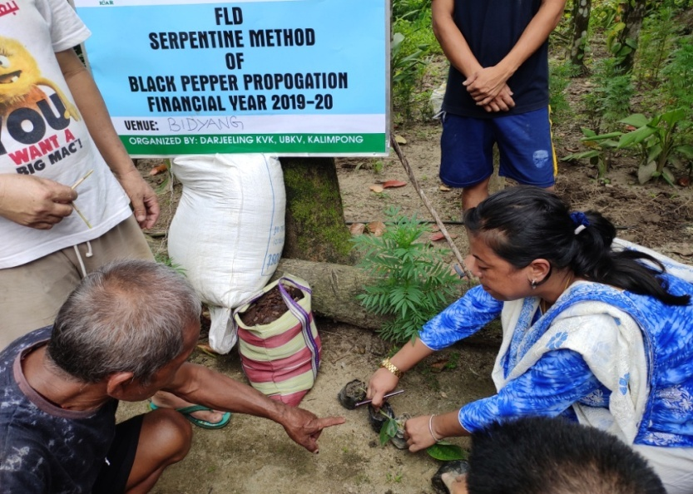 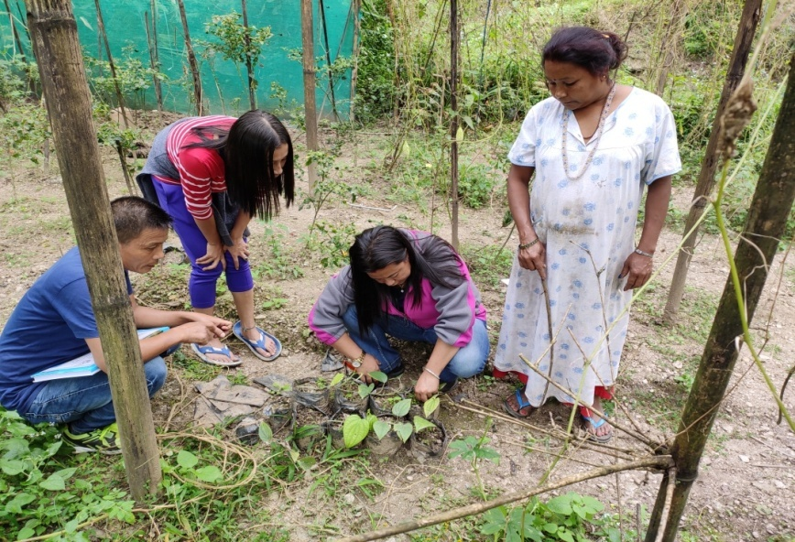

Crop category: Flower

|  |  |  |  |  |  |  |  |  |  |  |  |  |  |  |  |
| --- | --- | --- | --- | --- | --- | --- | --- | --- | --- | --- | --- | --- | --- | --- | --- |
| Sl.  No. | Crop | Thematic area | Technology Demonstrated with detailed treatments | Area (ha) | | No. of farmers/  demonstration | | | | | | | | | Reasons for shortfall in achievement |
| Proposed | Actual | SC | | ST | | Others | | Total | | |
| M | F | M | F | M | F | M | F | T |
|  |  |  |  |  |  |  |  |  |  |  |  |  |  |  |  |

Details of farming situation

|  |  |  |  |  |  |  |  |  |  |  |  |
| --- | --- | --- | --- | --- | --- | --- | --- | --- | --- | --- | --- |
| Crop | Season | Farming situation (RF/Irrigated) | Soil type | Status of soil  (Kg/ha) | | | Previous crop | Sowing date | Harvest date | Seasonal rainfall (mm) | No. of rainy days |
| N | P2O5 | K2O |
|  |  |  |  |  |  |  |  |  |  |  |  |

Performance of FLD

|  |  |  |  |  |  |  |  |  |  |  |  |  |  |  |  |
| --- | --- | --- | --- | --- | --- | --- | --- | --- | --- | --- | --- | --- | --- | --- | --- |
| **Crop** | **Thematic area** | **Name of the technology demonstrated** | **No. of Farmer** | **Area**  **(ha)** | **Yield (q/ha)** | | **% change in yield** | **\*Economics of demonstration (Rs./ha)** | | | | **\*Economics of check**  **(Rs./ha)** | | | |
| Demons  ration | Check | Gross  Cost | Gross  Return | Net Return | **  BCR | Gross  Cost | Gross  Return | Net Return | **  BCR |
|  |  |  |  |  |  |  |  |  |  |  |  |  |  |  |  |

Livestock

|  |  |  |  |  |  |  |  |  |  |  |  |  |  |  |  |
| --- | --- | --- | --- | --- | --- | --- | --- | --- | --- | --- | --- | --- | --- | --- | --- |
| Sl.  No. | Crop | Thematic area | Technology Demonstrated with detailed treatments | Area (ha) | | No. of farmers/  demonstration | | | | | | | | | Reasons for shortfall in achievement |
| Proposed | Actual | SC | | ST | | Others | | Total | | |
|  |  |  |  |  |  | M | F | M | F | M | F | M | F | T |
| 1. | Dairy | Production performance | Area specific mineral mixture | 20 | 20 | 5 | 0 | 4 | 5 | 0 | 6 | 9 | 11 | 20 |  |
| 2 | Poultry | Production performance | Grading up of local poultry by RIR cock | 30 | 30 | 0 | 5 | 0 | 13 | 0 | 12 | 0 | 30 | 30 |  |
| 3 | Piggery | Production performance | Grading up of local pig breeds by Hampshire pig | 30 | 30 | 0 | 13 | 0 | 17 | 0 | 0 | 0 | 30 | 30 |  |
| 4 | Piggery | Mortality check | Iron supplementation to new born piglet | 100 | 84 | 0 | 0 | 0 | 12 | 0 | 0 | 0 | 12 | 0 | Litter size during farrowing was low |

Performance of FLD

|  |  |  |  |  |  |  |  |  |  |  |  |  |  |  |  |  |  |
| --- | --- | --- | --- | --- | --- | --- | --- | --- | --- | --- | --- | --- | --- | --- | --- | --- | --- |
| Category | Thematic  area | Name of the technology demonstrated | No. of Farmer | No.of units | Major parameters | | % change in major parameter | Other parameter | | *Economics of demonstration (Rs.) | | | | *Economics of check  (Rs.) | | | |
| Demons  ration | Check | Demons  ration | Check | Gross  Cost | Gross  Return | Net Return | **  BCR | Gross  Cost | Gross  Return | Net Return | **  BCR |
| Dairy | Production performance | Area specific mineral mixture | 20 | 20 | Milk Production | Milk Production | 19 | -- | -- | 12370 | 41400 | 32030 | 3.34:1 | 10850 | 34600 | 23750 | 3.19:1 |
| Cow |  |  |  |  |  |  |  |  |  |  |  |  |  |  |  |  |  |
| Buffalo |  |  |  |  |  |  |  |  |  |  |  |  |  |  |  |  |  |
| Poultry | Production performance | Grading up of local poultry breeds by RIR cock | 30 | 30 | Egg production | Egg production | 22 | Weight gain | Weight gain | 5750 | 22350 | 16600 | 3.88:1 | 4950 | 15570 | 10620 | 3.14:1 |
| Rabbitry |  |  |  |  |  |  |  |  |  |  |  |  |  |  |  |  |  |
| Piggery | Production performance | Grading up of local pig breeds by Hampshire pig | 10 | 10 | Growth rate | Growth rate | 12 | Litter size | Litter size | 14180 | 48500 | 28150 | 3.42:1 | 9640 | 34200 | 16560 | 3.16:1 |
| Piggery | Piglet Anaemia | Iron Supplementation to new born piglet | 12 | 84 | Mortality rate | Mortality rate | 3 | -- | -- | 1580 | 4250 | 2670 | 2.68:1 | Mortality due to piglet anaemia is fully on chance factor. Supplementation of iron to new born piglet is a prophylactic measures | | | |
| Sheep and goat |  |  |  |  |  |  |  |  |  |  |  |  |  |  |  |  |  |
| Duckery |  |  |  |  |  |  |  |  |  |  |  |  |  |  |  |  |  |
| Others (pl.specify) |  |  |  |  |  |  |  |  |  |  |  |  |  |  |  |  |  |
| Total |  |  |  |  |  |  |  |  |  |  |  |  |  |  |  |  |  |

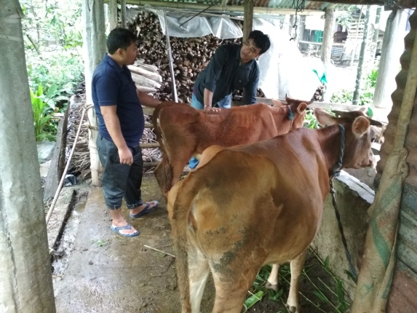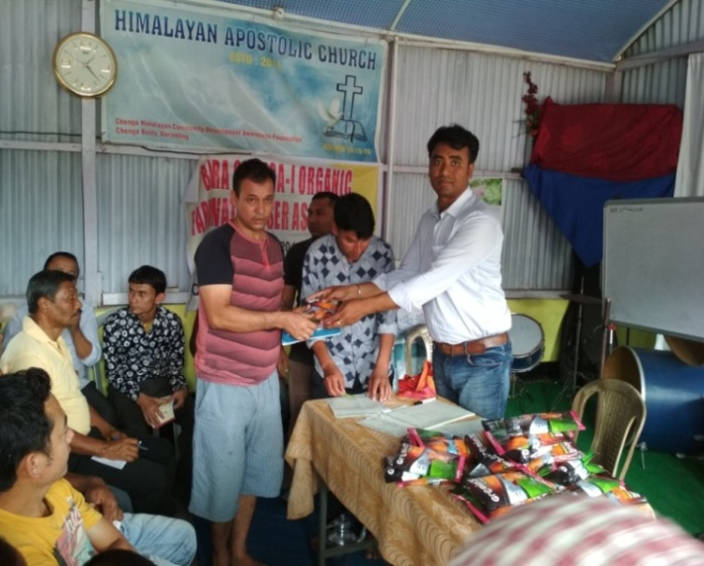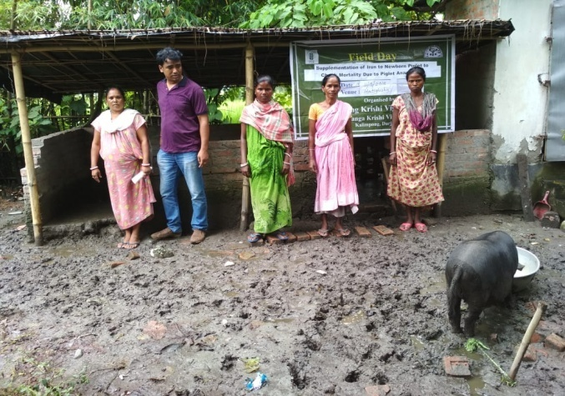

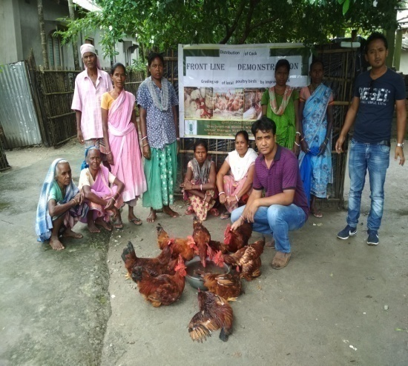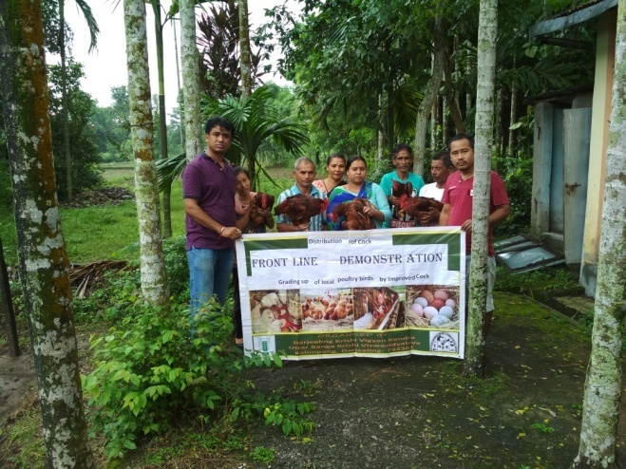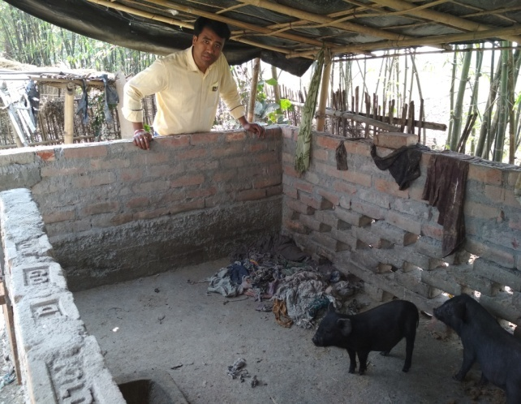

Fisheries

|  |  |  |  |  |  |  |  |  |  |  |  |  |  |  |  |  |  |  |
| --- | --- | --- | --- | --- | --- | --- | --- | --- | --- | --- | --- | --- | --- | --- | --- | --- | --- | --- |
| Category | Thematic area | | Name of the technology demonstrated | No. of Farmer | No.of units | Major parameters | | % change in major parameter | Other parameter | | *Economics of demonstration (Rs.) | | | | *Economics of check  (Rs.) | | | |
| Demons  ration | Check | Demons  ration | Check | Gross  Cost | Gross  Return | Net Return | **  BCR | Gross  Cost | Gross  Return | Net Return | **  BCR |
| Common carps |  | |  |  |  |  |  |  |  |  |  |  |  |  |  |  |  |  |
| Mussels |  | |  |  |  |  |  |  |  |  |  |  |  |  |  |  |  |  |
|  |  | |  |  |  |  |  |  |  |  |  |  |  |  |  |  |  |  |
| Ornamental fishes |  | |  |  |  |  |  |  |  |  |  |  |  |  |  |  |  |  |
| Others (pl.specify) |  | |  |  |  |  |  |  |  |  |  |  |  |  |  |  |  |  |
|  |  | |  |  |  |  |  |  |  |  |  |  |  |  |  |  |  |  |
|  | | Total | |  |  |  | | | | | | | | | | | | |

* Economics to be worked out based on total cost of production per unit area and not on critical inputs alone.

** BCR= GROSS RETURN/GROSS COST

Other Enterprise

|  |  |  |  |  |  |  |  |  |  |  |  |  |  |  |  |  |  |  |
| --- | --- | --- | --- | --- | --- | --- | --- | --- | --- | --- | --- | --- | --- | --- | --- | --- | --- | --- |
| Sl.  No. | Crop | Thematic area | Technology Demonstrated with detailed treatments | Area (ha) / Qty | | No. of farmers/  demonstration | | | | | | | | | | | | Reasons for shortfall in achievement |
| Proposed | Actual | ***SC*** | | ***ST*** | | | ***Others*** | | | ***Total*** | | | |  |
|  |  |  |  |  |  | ***M*** | ***F*** | | ***M*** | ***F*** | | ***M*** | ***F*** | | ***M*** | ***F*** | ***T*** |  |
| 1 | Vermi compost | Enterprise development | Use of vermibeds for more production and yield of vermi compost | 4 Units | 3 Units | 0 | 0 | | 0 | 1 | | 0 | 2 | | 0 | 3 | 3 |  |
| 2 | fruits and vegetables processing | Value addition | Preservation of seasonal fruits and vegetables by different techniques such as :drying, pickling, sugar cookery (Jam, squash, juice), Candies, preparation of chips and papads | 20 Kg | 20 Kg | 0 | 1 | | 0 | 5 | | 0 | 9 | | 0 | 15 | 15 |  |
| 3 | Kitchen gardening | Nutrition | High yielding seed varieties for green leafy vegetables, roots, cucurbits and chillies | 25 unit | 25 Unit | 0 | 0 | | 0 | 4 | | 0 | 21 | | 0 | 0 | 25 |  |

Performance of FLD

|  |  |  |  |  |  |  |  |  |  |  |  |  |  |  |  |  |
| --- | --- | --- | --- | --- | --- | --- | --- | --- | --- | --- | --- | --- | --- | --- | --- | --- |
| Category | Name of the technology demonstrated | No. of Farmer | No.of units | Major parameters | | % change in major parameter | Other parameter | | *Economics of demonstration (Rs.) or Rs./unit | | | | *Economics of check  (Rs.) or Rs./unit | | | |
| Demons  ration | Check | Demons  ration | Check | Gross  Cost | Gross  Return | Net Return | **  BCR | Gross  Cost | Gross  Return | Net Return | **  BCR |
| Oyster mushroom | Enterprise development |  |  |  |  |  |  |  |  |  |  |  |  |  |  |  |
| Button mushroom |  |  |  |  |  |  |  |  |  |  |  |  |  |  |  |  |
| Vermicompost | Vermi Sp. | 6 | 3 | Production of vermi compost | Production of vermi compost | - | - | - | 3000 | 12000 | 9000 | 4:1 | 3000 | 8000 | 5000 | 2.6:1 |
| Sericulture |  |  |  |  |  |  |  |  |  |  |  |  |  |  |  |  |
| Apiculture |  |  |  |  |  |  |  |  |  |  |  |  |  |  |  |  |
| fruits and vegetables processing |  |  |  | Ginger Candy  4 Kg @ Rs 80-/ per kg | Fresh Ginger | - | - | - | 600 | 1950 | 1350 | 3.25:1 | 320 | 480 | 160 | 1.5:1 |
|  |  |  | Round Chilli pickle  3 Kg @ Rs 150/- per Kg | Fresh Round Chilli | - | - | - | 750 | 1800 | 1050 | 2.4:1 | 450 | 600 | 150 | 1.33:1 |
|  |  |  | Rice Papad  2 Kg @ Rs 25/- per Kg | Rice | - | - | - | 75 | 300 | 225 | 4:1 | 50 | 60 | 10 | 1.2:1 |
|  |  |  | Mushroom Pickle  5 Kg @ 80/- per Kg | Fresh Mushroom | - | - | - | 1050 | 3250 | 2200 | 3.09:1 | 400 | 600 | 200 | 1.5:1 |
|  |  |  | Strawberry jam  2.5 Kg @ Rs. 200/- per Kg | Fresh Strawberry | - | - | - | 650 | 1500 | 550 | 2.3:1 | 500 | 750 | 250 | 1.5:1 |
| Kitchen gardening |  |  | 13 | Vegetable production | Vegetable production | - | - | - | 1500/- | 6000/- | 4500/- | 4:1 | Kitchen garden production is for household purpose and self consumption.  Its purpose is to fulfill the nutritional and food security of a family.  Hence economics of check cannot be calculated. | | | |
| Total | |  |  |  | | | | | | | | | | | | |

* Economics to be worked out based on total cost of production per unit area and not on critical inputs alone.

** BCR= GROSS RETURN/GROSS COST

FLD on Value Addition

FLD on Vermi Compost

FLD on Kitchen Garden

1. Details of FLDs conducted during the year

**FLD 1: Kitchen Gardening for nutrition and food safety**

|  |  |  |
| --- | --- | --- |
| 1. | Problem Area | Poor nutritional status and health of rural women and adolescents  Low purchasing capacity of nutritious vegetables |
| 2. | Important cause | * Poor purchasing capacity * Lack of knowledge on importance of nutrition and health |
| 3. | Technology for demonstration | Multiple vegetables in crop rotation |
| 4. | Unit of demonstration | 3 |
| 5. | Monitoring indicator | * Availability of more varieties of vegetables leading to improved intake of good quality foods * Improved health status * Reduced incidences of deficiencies and illnesses |
| 6. | Proposed block of demonstration | Kalimpong I & II |
| 7. | Inputs | Season based vegetables |
| 8. | No. of demonstration | 5 (No. of crops) |
| 9. | Total cost of demonstration | 10,000 |

|  |  |  |  |  |  |  |  |  |  |
| --- | --- | --- | --- | --- | --- | --- | --- | --- | --- |
| **Sl.**  **No.** | **Crop** | **Thematic area** | **Technology Demonstrated with detailed treatments** | **No. of demonstrations** | | **No. of farmers** | | | **Reasons for shortfall in achievement** |
| **Proposed** | **Actual** | **SC/ST** | **Others** | **Total** |
| **1.** | Season based vegetables | Food and nutritional security | Kitchen gardening | 5 | 5 | 5 | 5 | 10 | -- |

|  |  |  |  |  |  |  |  |  |  |  |  |
| --- | --- | --- | --- | --- | --- | --- | --- | --- | --- | --- | --- |
| Crop | No. of units | Major parameters | | *Economics of demonstration (Rs.) | | | | *Economics of check (Rs.) | | | |
| Demons  tration | Check | Gross  Cost | Gross  Return | Net Return | **  BCR | Gross  Cost | Gross  Return | Net Return | **  BCR |
| Vegetables | 3 | Vegetable production | Vegetable production | 10000 | 32000 | 22000 | 2.2:1 | 10000 | 25000 | 15000 | 1.5:1 |

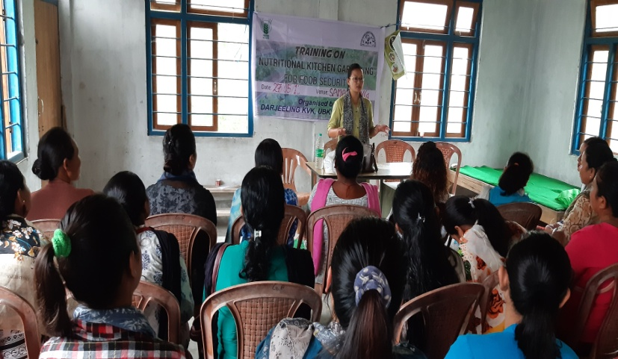 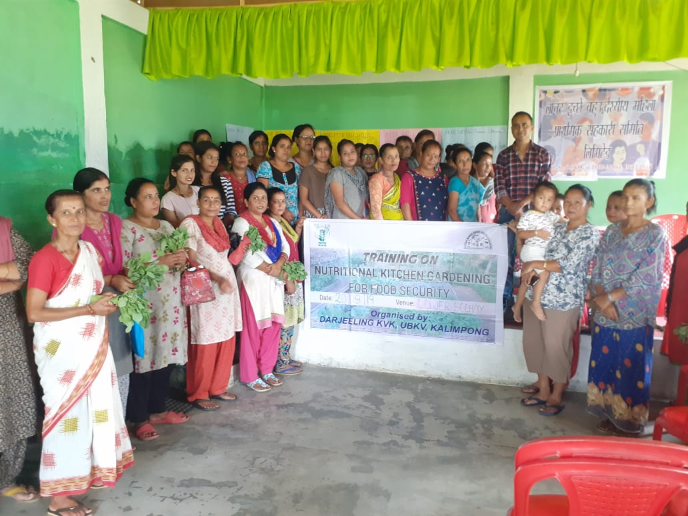

**FLD 2: Preparation of low cost weaning mixes for rural infants**

|  |  |  |
| --- | --- | --- |
| 1. | Problem Area | Malnutrition and poor health status among rural infants |
| 2. | Important cause | * Poor purchasing capacity * Lack of knowledge on techniques of preparing low cost locally available foods |
| 3. | Technology for demonstration | Techniques and various recipes to prepare low cost nutrient rich supplements from locally available food |
| 4. | Unit of demonstration | 4 |
| 5. | Monitoring indicator | * Preparation and usage of low cost nutrient rich supplements * Overall improved health status * Reduced incidences of deficiencies and illnesses |
| 6. | Proposed block of demonstration | Kalimpong I & II |
| 7. | Inputs | Low cost cereals and pulses, GLVs, tubers |
| 8. | No. of demonstration | 4 |
| 9. | Total cost of demonstration | 10,000 |

|  |  |  |  |  |  |  |  |  |  |
| --- | --- | --- | --- | --- | --- | --- | --- | --- | --- |
| **Sl.**  **No.** | **Crop** | **Thematic area** | **Technology Demonstrated with detailed treatments** | **No. of demonstrations** | | **No. of farmers** | | | **Reasons for shortfall in achievement** |
| **Proposed** | **Actual** | **SC/ST** | **Others** | **Total** |
| **1.** | Low cost cereals and pulses, GLV’s, tubers | Nutrition | Techniques and recipes to prepare low cost nutrient rich supplements | 4 | 1 | 5 | 3 | 8 | -- |

|  |  |  |  |  |  |  |  |  |  |  |  |
| --- | --- | --- | --- | --- | --- | --- | --- | --- | --- | --- | --- |
| Crop | No. of units | Major parameters | | *Economics of demonstration (Rs.) | | | | *Economics of check (Rs.) | | | |
| Demonstration | Check | Gross  Cost | Gross  Return | Net Return | **  BCR | Gross  Cost | Gross  Return | Net Return | **  BCR |
|  |  |  |  |  |  |  |  |  |  |  |  |

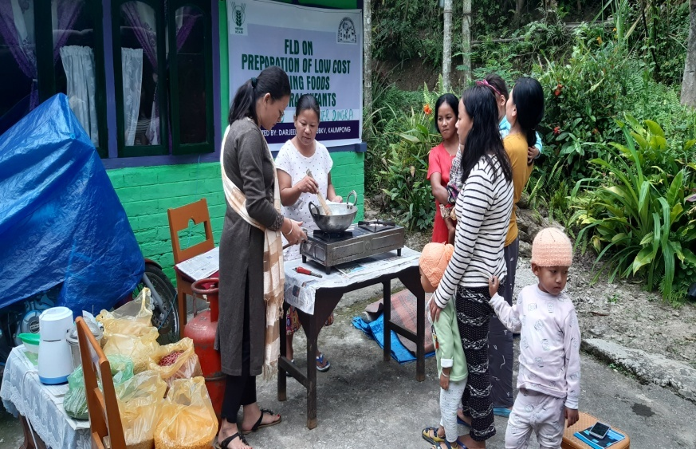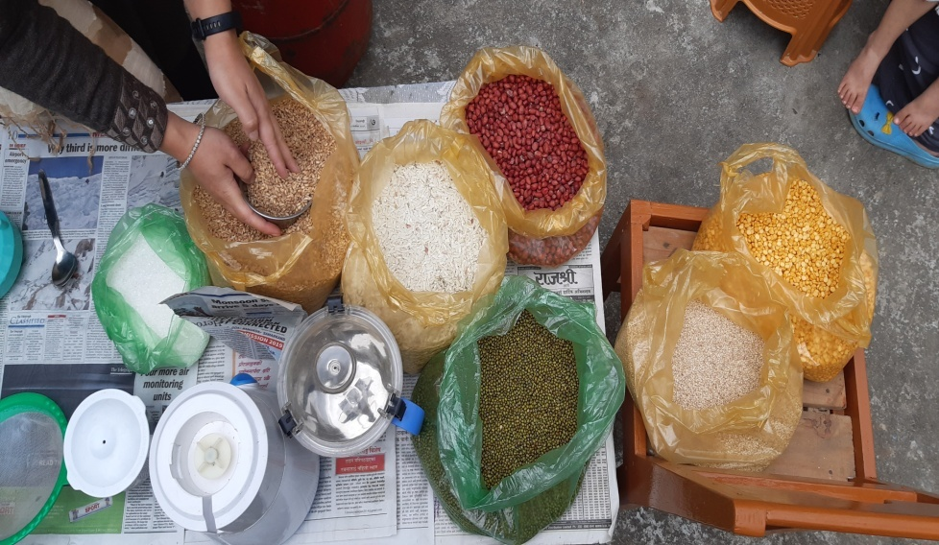

Women empowerment

|  |  |  |  |  |  |
| --- | --- | --- | --- | --- | --- |
| Category | Name of technology | No. of demonstrations | Observations | | Remarks |
| Demonstration | Check |
| Farm Women | Mushroom cultivation, value addition | Mushroom cultivation- 2  Value addition- 1 | Self employment  Income generation | Unemployed and dependent, inactive SHG | Skill development |
| Pregnant women | Awareness on balanced diet, nutrition and health care during pregnancy | 4 | Improvement of knowledge | Lack of knowledge | Knowledge level enhanced |
| Adolescent Girl | Balanced diet, food groups, food pyramid | 1 | Improvement of knowledge | Anaemic  Poor health  Intake of imbalance diet | Awareness on various foods groups , nutritional content of different foods, use of food pyramid |
| Other women | Preparation of vermin compost | 1 | Skill enhancement | Unskilled | Additional income generations |
| Children |  |  |  |  |  |
| Neonatal |  |  |  |  |  |
| Infants | Low cost weaning supplements | 1 | Intake of low cost weaning supplements | Consumption of commercially available supplements | Improvement in health status & cost effective and can be prepared locally at home level. |

Farm implements and machinery

|  |  |  |  |  |  |  |  |  |  |  |  |  |  |  |  |
| --- | --- | --- | --- | --- | --- | --- | --- | --- | --- | --- | --- | --- | --- | --- | --- |
| Name of the implement | Crop | Name of the technology demonstrated | No. of Farmer | Area (ha) | Filed observation (output/man hour) | | % change in major parameter | Labor reduction (man days) | | | | Cost reduction (Rs./ha or Rs./Unit) | | | |
| Demons  ration | Check |  |  |  |  |  |  |  |  |
|  |  |  |  |  |  |  |  |  |  |  |  |  |  |  |  |

**\* Economics to be worked out based on total cost of production per unit area and not on critical inputs alone.**

**\*\* BCR= GROSS RETURN/GROSS COST**

Demonstration details on crop hybrids

|  |  |  |  |  |  |  |  |  |  |  |
| --- | --- | --- | --- | --- | --- | --- | --- | --- | --- | --- |
| Crop | Name of the Hybrid | No. of  farmers | Area  (ha) | Yield (kg/ha) / major parameter | | | Economics (Rs./ha) | | | |
| Cereals |  |  |  | Demo | Local check | % change | Gross  Cost | Gross  Return | Net  Return | BCR |
|  |  |  |  |  |  |  |  |  |  |  |
| Bajra |  |  |  |  |  |  |  |  |  |  |
| Maize |  |  |  |  |  |  |  |  |  |  |
| Paddy |  |  |  |  |  |  |  |  |  |  |
| Sorghum |  |  |  |  |  |  |  |  |  |  |
| Wheat |  |  |  |  |  |  |  |  |  |  |
| Others (Pl. specify) |  |  |  |  |  |  |  |  |  |  |
| Total |  |  |  |  |  |  |  |  |  |  |
| Oilseeds |  |  |  |  |  |  |  |  |  |  |
| Castor |  |  |  |  |  |  |  |  |  |  |
| Mustard |  |  |  |  |  |  |  |  |  |  |
| Safflower |  |  |  |  |  |  |  |  |  |  |
| Sesame |  |  |  |  |  |  |  |  |  |  |
| Sunflower |  |  |  |  |  |  |  |  |  |  |
| Groundnut |  |  |  |  |  |  |  |  |  |  |
| Soybean |  |  |  |  |  |  |  |  |  |  |
| Others (Pl. specify) |  |  |  |  |  |  |  |  |  |  |
| Total |  |  |  |  |  |  |  |  |  |  |
| Pulses |  |  |  |  |  |  |  |  |  |  |
| Greengram |  |  |  |  |  |  |  |  |  |  |
| Blackgram |  |  |  |  |  |  |  |  |  |  |
| Bengalgram |  |  |  |  |  |  |  |  |  |  |
| Redgram |  |  |  |  |  |  |  |  |  |  |
| Others (Pl. specify) |  |  |  |  |  |  |  |  |  |  |
| Total |  |  |  |  |  |  |  |  |  |  |
| Vegetable crops |  |  |  |  |  |  |  |  |  |  |
| Bottle gourd |  |  |  |  |  |  |  |  |  |  |
| Capsicum |  |  |  |  |  |  |  |  |  |  |
| Cucumber |  |  |  |  |  |  |  |  |  |  |
| Tomato |  |  |  |  |  |  |  |  |  |  |
| Brinjal |  |  |  |  |  |  |  |  |  |  |
| Okra |  |  |  |  |  |  |  |  |  |  |
| Onion |  |  |  |  |  |  |  |  |  |  |
| Potato |  |  |  |  |  |  |  |  |  |  |
| Field bean |  |  |  |  |  |  |  |  |  |  |
| Others (Pl. specify) |  |  |  |  |  |  |  |  |  |  |
| Total |  |  |  |  |  |  |  |  |  |  |
| Commercial crops |  |  |  |  |  |  |  |  |  |  |
| Cotton |  |  |  |  |  |  |  |  |  |  |
| Coconut |  |  |  |  |  |  |  |  |  |  |
| Others (Pl. specify) |  |  |  |  |  |  |  |  |  |  |
|  |  |  |  |  |  |  |  |  |  |  |
| Total |  |  |  |  |  |  |  |  |  |  |
| Fodder crops |  |  |  |  |  |  |  |  |  |  |
| Napier (Fodder) |  |  |  |  |  |  |  |  |  |  |
| Maize (Fodder) |  |  |  |  |  |  |  |  |  |  |
| Sorghum (Fodder) |  |  |  |  |  |  |  |  |  |  |
| Others (Pl. specify) |  |  |  |  |  |  |  |  |  |  |
| Total |  |  |  |  |  |  |  |  |  |  |

Technical Feedback on the demonstrated technologies

|  |  |  |
| --- | --- | --- |
| ***Sl. No*** | ***Crop/ Enterprise*** | ***Feed Back*** |
| 1 | Kitchen garden | Good qualitative and quantitative output of vegetable crops.  Increase in intake of freshly grown vegetable crops leading to good health and food security. Helpful in home budget. |
| 2 | Low cost supplementation |  |
| 3 |  |  |
| 4 |  |  |
| 5 |  |  |
| 6 |  |  |
| 7 | Darjeeling Mandarin | Application of Balanced nutrition in Darjeeling Mandarin increased the number of fruits per tree which ultimately increase the crop production per unit area. |
| 8 | Black pepper | -- |

Extension and Training activities under FLD

|  |  |  |  |  |  |
| --- | --- | --- | --- | --- | --- |
| ***Sl.No.*** | ***Activity*** | ***Date*** | ***No. of activities organized*** | ***Number of participants*** | ***Remarks*** |
| Home Science | | | | | |
| 1. | Farmers Training |  |  |  |  |
| 2. | Training for extension functionaries |  |  |  |  |
| 3. |  |  |  |  |  |
| 4. |  |  |  |  |  |
| Horticulture | | | | | |
| 1 | Field days |  |  |  |  |
| 2 | Farmers Training | 28/8/19  09/8/19 | 3 | 22 | Package and practice of Black pepper cultivation |
| 3 | Media coverage |  |  |  |  |
| 4 | Training for extension functionaries |  |  |  |  |
|  |  |  |  |  |  |
|  |  |  |  |  |  |
|  |  |  |  |  |  |
|  |  |  |  |  |  |

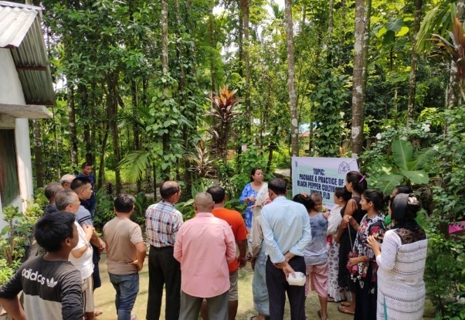

**Performance of the demonstration under CFLD on Pulse and Oilseed Crops during Kharif 2019 and Rabi 2019:**

1. Technical Parameters:

|  |  |  |  |  |  |  |  |  |  |  |  |  |  |  |  |
| --- | --- | --- | --- | --- | --- | --- | --- | --- | --- | --- | --- | --- | --- | --- | --- |
| **Sl.**  **No.** | **Crop demonstrated** | **Existing (Farmer's) variety name** | **Existing yield**  **(q/ha)** | **Yield gap (Kg/ha)**  **w.r.to** | | | **Name of Variety + Technology**  **demonstrated** | **Number of farmers** | **Area in ha** | **Yield obtained (q/ha)** | | | **Yield gap minimized**  **(%)** | | |
| **District**  **yield (D)** | **State**  **yield (S)** | **Potential**  **yield (P)** |
| **Max.** | **Min.** | **Av.** | **D** | **S** | **P** |
| 1. | Green gram | Local (Paheli ) | 13.8 | 553 | 609 |  | Pusa Vishal | 25 | 10 | 20.9 | 16.5 | 18.19 | 69.59 | 66.52 |  |
| 2. | Black gram | Local | 4.6 | 482 | 580 |  | VBN (Bg) 5 | 51 | 20 | 7.1 | 4.5 | 5.56 | 13.3 |  |  |
| 3. | Rapeseed/Mustard | Standing Crop. | | | | | | | | | | | | | |
| 4. | Field Pea | Standing Crop. | | | | | | | | | | | | | |

1. Economic parameters

|  |  |  |  |  |  |  |  |  |  |
| --- | --- | --- | --- | --- | --- | --- | --- | --- | --- |
| **Sl.**  **No.** | **Variety demonstrated & Technology demonstrated** | **Farmer’s Existing plot** | | | | **Demonstration plot** | | | |
| **Gross Cost**  **(Rs/ha)** | **Gross return**  **(Rs/ha)** | **Net Return**  **(Rs/ha)** | **B:C**  **ratio** | **Gross Cost**  **(Rs/ha)** | **Gross return**  **(Rs/ha)** | **Net Return**  **(Rs/ha)** | **B:C**  **ratio** |
| 01 | Green Gram Pusa Vishal | 39,000/- | 55,200/- | 16,200/- | 1.41:1 | 42,500/- | 72,760/- | 30,260/- | 1.7:1 |
| 02 | Black Gram  VBN (Bg) 5 | 17,500/- | 20,700/- | 3,200/- | 1.18:1 | 18900/- | 25,020/- | 6,120/- | 1.32:1 |

1. Socio-economic impact parameters

|  |  |  |  |  |  |  |  |  |
| --- | --- | --- | --- | --- | --- | --- | --- | --- |
| **Sl.**  **No.** | **Crop and variety**  **Demonstrated** | **Total Produce**  **Obtained (kg)** | **Produce sold**  **(Kg/household)** | **Selling**  **Rate**  **(Rs/Kg)** | **Produce used for own sowing (Kg)** | **Produce distributed to other farmers (Kg)** | **Purpose for which income gained was utilized** | **Employment Generated (Mandays/house hold)** |
| 01 | Green gram  Pusa Vishal | 18190 | 120 | 140 | 10 | 11 | Household activity and Children education | 9 |
| 02. | Black Gram | 11,120 | 45 | 45 | 17 | 8 | Household activity and Children education | 6 |

1. Oilseed Farmers’ perception of the intervention demonstrated

|  |  |  |  |  |  |  |  |
| --- | --- | --- | --- | --- | --- | --- | --- |
| **Sl.**  **No.** | **Technologies demonstrated**  **(with name)** | **Farmers' Perception parameters** | | | | | |
| **Suitability to their farming system** | **Likings**  **(Preference)** | **Affordability** | **Any negative effect** | **Is Technology acceptable to all in the group/village** | **Suggestions, for change/improvement, if any** |
|  |  |  |  |  |  |  |  |

1. Specific Characteristics of Technology and Performance

|  |  |  |  |
| --- | --- | --- | --- |
| **Specific Characteristic** | **Performance** | **Performance of Technology vis-a vis Local Check** | **Farmers Feedback** |
| Green gram: High seed yield | Pod foermation and size of pod is good . | Line sowing of seeds | Farmers actively participated in the programme . |
| Black Gram Moderately resistance Yellow Mosaic | Maturity of pods takes 70-75 days and pod formation ids higher | Line sowing of the variety gave higher yield compared to local check. | Farmers actively participated in the programme . |

1. Extension activities under FLD conducted: Black Gram

|  |  |  |  |
| --- | --- | --- | --- |
| **Sl. No.** | **Extension Activities organized** | **Date and place of activity** | **Number of farmer attended** |
| 1 | Training | Tumlabong 26/8/2019 | 20 |
| Chenga 28/8/2019 | 25 |
| Yok 30/8/2019 | 25 |
| 2 | Demonstration | Tumlabong 9/9/2019 | 20 |
| 3 | Field visit | Tumlabong 25/9/2019 | 10 |
| Chenga 25/10/2019 | 15 |
| Yok 04/11/2019 | 10 |

1. Extension activities under FLD conducted: Green Gram

|  |  |  |  |
| --- | --- | --- | --- |
| **Sl. No.** | **Extension Activities organized** | **Date and place of activity** | **Number of farmer attended** |
| 1 | Training | Yogda 15/3/2019 | 25 |
| 2 | Training cum Demonstration | Naxalbari 25/3/2019 | 25 |
| 3 | Field visit | Yogda 25/6/2019 | 15 |
| Phasidewa 8/7/2019 | 10 |

1. Sequential good quality photographs (as per crop stages i.e. growth & development)
2. Farmers' training photographs
3. Quality Action Photographs of field visits/field days and technology demonstrated.

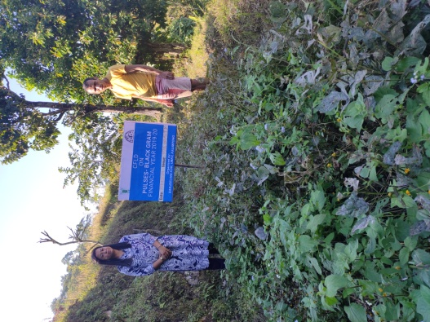PHOTOGRAPHS OF CFLD BLACK GRAM:

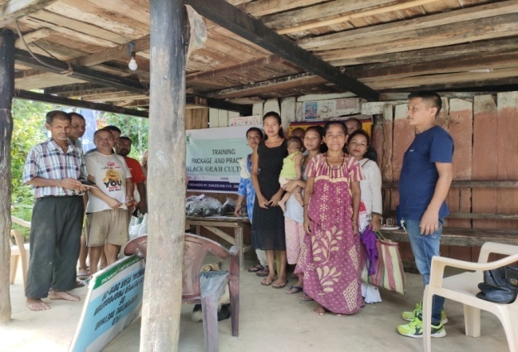

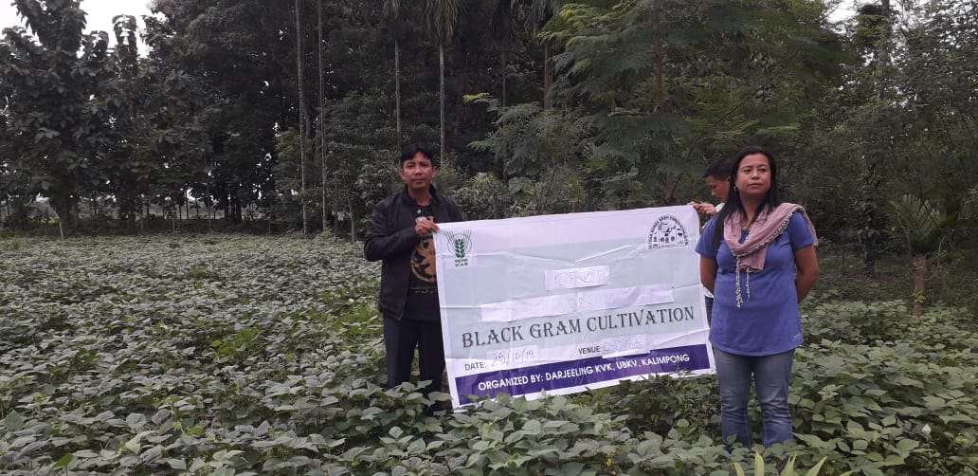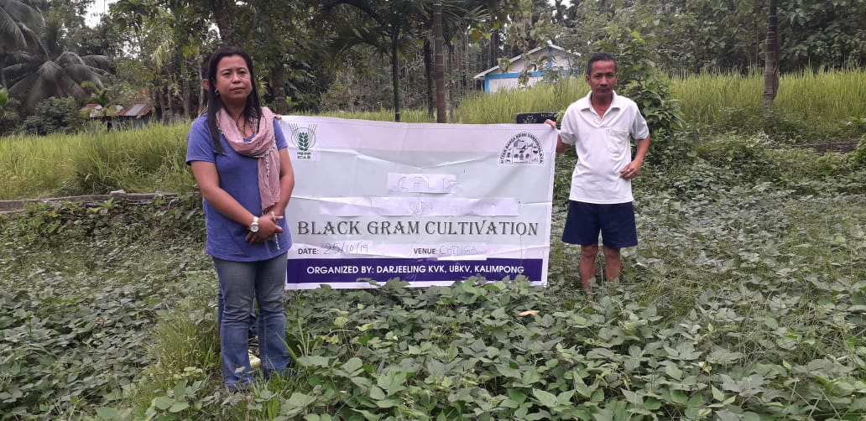

PHOTOGRAPHS OF CFLD GREEN GRAM:

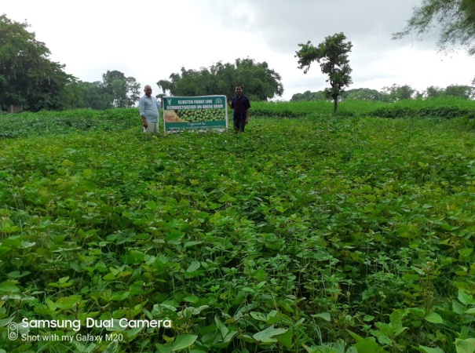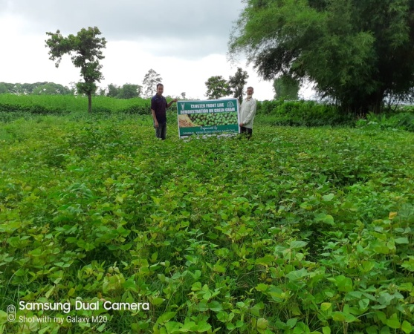

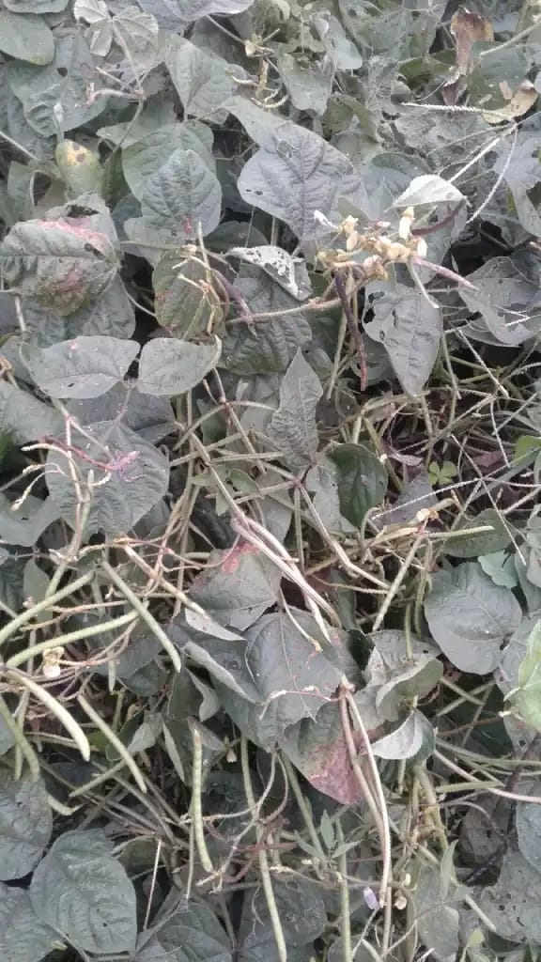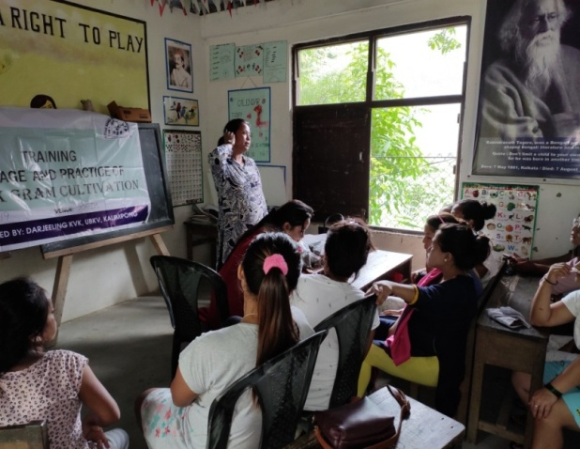

**J. Details of budget utilization**

|  |  |  |  |  |
| --- | --- | --- | --- | --- |
| Crop  (provide crop wise information ) | Items | Budget  Received  (Rs.) | Budget  Utilization  (Rs.) | Balance  (Rs.) |
|  | i) Critical input |  |  |  |
| ii) TA/DA/POL etc. for monitoring |  |  |  |
| iii) Extension Activities (Field day) |  |  |  |
| iv)Publication of literature |  |  |  |
|  | Total |  |  |  |

* 1. **Achievements on Training (Including the sponsored and FLD training programmes):**

1. **Farmers and farm women (on campus)**

| Thematic Area | No. of Courses | No. of Participants | | | | | | | | | | Grand Total | | |
| --- | --- | --- | --- | --- | --- | --- | --- | --- | --- | --- | --- | --- | --- | --- |
| Other | | | SC | | | | ST | | |
|  | M | F | T | M | F | | T | M | F | T | M | F | T |
| **I. Crop Production** |  |  |  |  |  |  | |  |  |  |  |  |  |  |
| Weed Management |  |  |  |  |  |  | |  |  |  |  |  |  |  |
| Resource Conservation Technologies |  |  |  |  |  |  | |  |  |  |  |  |  |  |
| Cropping Systems |  |  |  |  |  |  | |  |  |  |  |  |  |  |
| Crop Diversification |  |  |  |  |  |  | |  |  |  |  |  |  |  |
| Integrated Farming |  |  |  |  |  |  | |  |  |  |  |  |  |  |
| Water management |  |  |  |  |  |  | |  |  |  |  |  |  |  |
| Seed production |  |  |  |  |  |  | |  |  |  |  |  |  |  |
| Nursery management |  |  |  |  |  |  | |  |  |  |  |  |  |  |
| Integrated Crop Management |  |  |  |  |  |  | |  |  |  |  |  |  |  |
| Fodder production |  |  |  |  |  |  | |  |  |  |  |  |  |  |
| Production of organic inputs |  |  |  |  |  |  | |  |  |  |  |  |  |  |
| Others, (cultivation of crops ) |  |  |  |  |  |  | |  |  |  |  |  |  |  |
| **II. Horticulture** |  |  |  |  |  |  | |  |  |  |  |  |  |  |
| **a) Vegetable Crops** |  |  |  |  |  |  | |  |  |  |  |  |  |  |
| Integrated nutrient management |  |  |  |  |  |  | |  |  |  |  |  |  |  |
| Water management |  |  |  |  |  |  | |  |  |  |  |  |  |  |
| Enterprise development |  |  |  |  |  |  | |  |  |  |  |  |  |  |
| Skill development |  |  |  |  |  |  | |  |  |  |  |  |  |  |
| Yield increment |  |  |  |  |  |  | |  |  |  |  |  |  |  |
| Production of low volume and high value crops |  |  |  |  |  |  | |  |  |  |  |  |  |  |
| Off-season vegetables |  |  |  |  |  |  | |  |  |  |  |  |  |  |
| Nursery raising |  |  |  |  |  |  | |  |  |  |  |  |  |  |
| Export potential vegetables |  |  |  |  |  |  | |  |  |  |  |  |  |  |
| Grading and standardization |  |  |  |  |  |  | |  |  |  |  |  |  |  |
| Protective cultivation (Green Houses, Shade Net etc.) |  |  |  |  |  |  | |  |  |  |  |  |  |  |
| Others, if any (Cultivation of Vegetable) |  |  |  |  |  |  | |  |  |  |  |  |  |  |
| Training and Pruning |  |  |  |  |  |  | |  |  |  |  |  |  |  |
| **b) Fruits** |  |  |  |  |  |  | |  |  |  |  |  |  |  |
| Layout and Management of Orchards |  |  |  |  |  |  | |  |  |  |  |  |  |  |
| Cultivation of Fruit |  |  |  |  |  |  | |  |  |  |  |  |  |  |
| Management of young plants/orchards |  |  |  |  |  |  | |  |  |  |  |  |  |  |
| Rejuvenation of old orchards |  |  |  |  |  |  | |  |  |  |  |  |  |  |
| Export potential fruits |  |  |  |  |  |  | |  |  |  |  |  |  |  |
| Micro irrigation systems of orchards |  |  |  |  |  |  | |  |  |  |  |  |  |  |
| Plant propagation techniques |  |  |  |  |  |  | |  |  |  |  |  |  |  |
| Others, if any(INM) |  |  |  |  |  |  | |  |  |  |  |  |  |  |
| **c) Ornamental Plants** |  |  |  |  |  |  | |  |  |  |  |  |  |  |
| Nursery Management |  |  |  |  |  |  | |  |  |  |  |  |  |  |
| Management of potted plants |  |  |  |  |  |  | |  |  |  |  |  |  |  |
| Export potential of ornamental plants |  |  |  |  |  |  | |  |  |  |  |  |  |  |
| Propagation techniques of Ornamental Plants |  |  |  |  |  |  | |  |  |  |  |  |  |  |
| Others, if any |  |  |  |  |  |  | |  |  |  |  |  |  |  |
| **d) Plantation crops** |  |  |  |  |  |  | |  |  |  |  |  |  |  |
| Production and Management technology |  |  |  |  |  |  | |  |  |  |  |  |  |  |
| Processing and value addition |  |  |  |  |  |  | |  |  |  |  |  |  |  |
| Others, if any |  |  |  |  |  |  | |  |  |  |  |  |  |  |
| **e) Tuber crops** |  |  |  |  |  |  | |  |  |  |  |  |  |  |
| Production and Management technology |  |  |  |  |  |  | |  |  |  |  |  |  |  |
| Processing and value addition |  |  |  |  |  |  | |  |  |  |  |  |  |  |
| Others, if any |  |  |  |  |  |  | |  |  |  |  |  |  |  |
| **f) Spices** |  |  |  |  |  |  | |  |  |  |  |  |  |  |
| Production and Management technology |  |  |  |  |  |  | |  |  |  |  |  |  |  |
| Processing and value addition |  |  |  |  |  |  | |  |  |  |  |  |  |  |
| Others, if any |  |  |  |  |  |  | |  |  |  |  |  |  |  |
| **g) Medicinal and Aromatic Plants** |  |  |  |  |  |  | |  |  |  |  |  |  |  |
| Nursery management |  |  |  |  |  |  | |  |  |  |  |  |  |  |
| Production and management technology |  |  |  |  |  |  | |  |  |  |  |  |  |  |
| Post harvest technology and value addition |  |  |  |  |  |  | |  |  |  |  |  |  |  |
| Others, if any |  |  |  |  |  |  | |  |  |  |  |  |  |  |
| **III. Soil Health and Fertility Management** |  |  |  |  |  |  | |  |  |  |  |  |  |  |
| Soil fertility management |  |  |  |  |  |  | |  |  |  |  |  |  |  |
| Soil and Water Conservation |  |  |  |  |  |  | |  |  |  |  |  |  |  |
| Integrated Nutrient Management |  |  |  |  |  |  | |  |  |  |  |  |  |  |
| Production and use of organic inputs | 2 | 22 | 13 | 35 | 2 | 1 | | 3 | 4 | 8 | 12 | 28 | 22 | 50 |
| Management of Problematic soils | 1 | 16 | 8 | 24 | 0 | 0 | | 0 | 0 | 1 | 1 | 16 | 9 | 25 |
| Micro nutrient deficiency in crops |  |  |  |  |  |  | |  |  |  |  |  |  |  |
| Nutrient Use Efficiency |  |  |  |  |  |  | |  |  |  |  |  |  |  |
| Soil and Water Testing | 3 | 25 | 16 | 41 | 27 | 6 | | 33 | 5 | 13 | 18 | 57 | 35 | 92 |
| Others, if any |  |  |  |  |  |  | |  |  |  |  |  |  |  |
| **IV. Livestock Production and Management** |  |  |  |  |  |  | |  |  |  |  |  |  |  |
| Dairy Management | 1 | 9 | 2 | 11 | 4 | 1 | | 5 | 6 | 3 | 9 | 19 | 6 | 25 |
| Poultry Management | 2 | 14 | 2 | 16 | 8 | 3 | | 11 | 10 | 3 | 13 | 32 | 8 | 40 |
| Piggery Management |  |  |  |  |  |  | |  |  |  |  |  |  |  |
| Rabbit Management |  |  |  |  |  |  | |  |  |  |  |  |  |  |
| Disease Management |  |  |  |  |  |  | |  |  |  |  |  |  |  |
| Feed management |  |  |  |  |  |  | |  |  |  |  |  |  |  |
| Production of quality animal products | 1 | 14 | 6 | 20 | 5 | 2 | | 7 | 3 | 4 | 7 | 22 | 12 | 34 |
| Others, if any Goat farming |  |  |  |  |  |  | |  |  |  |  |  |  |  |
| **V. Home Science/Women empowerment** |  |  |  |  |  |  | |  |  |  |  |  |  |  |
| Household food security by kitchen gardening and nutrition gardening |  |  |  |  |  |  | |  |  |  |  |  |  |  |
| Design and development of low/minimum cost diet |  |  |  |  |  |  | |  |  |  |  |  |  |  |
| Designing and development for high nutrient efficiency diet |  |  |  |  |  |  | |  |  |  |  |  |  |  |
| Minimization of nutrient loss in processing |  |  |  |  |  |  | |  |  |  |  |  |  |  |
| Gender mainstreaming through SHGs |  |  |  |  |  |  | |  |  |  |  |  |  |  |
| Storage loss minimization techniques |  |  |  |  |  |  | |  |  |  |  |  |  |  |
| Enterprise development |  |  |  |  |  |  | |  |  |  |  |  |  |  |
| Value addition |  |  |  |  |  |  | |  |  |  |  |  |  |  |
| Income generation activities for empowerment of rural Women |  |  |  |  |  |  | |  |  |  |  |  |  |  |
| Location specific drudgery reduction technologies |  |  |  |  |  |  | |  |  |  |  |  |  |  |
| Rural Crafts |  |  |  |  |  |  | |  |  |  |  |  |  |  |
| Capacity building |  |  |  |  |  |  | |  |  |  |  |  |  |  |
| Women and child care |  |  |  |  |  |  | |  |  |  |  |  |  |  |
| Others, if any (Home Economics) |  |  |  |  |  |  | |  |  |  |  |  |  |  |
| **VI.Agril. Engineering** |  |  |  |  |  |  | |  |  |  |  |  |  |  |
| Installation and maintenance of micro irrigation systems |  |  |  |  |  |  | |  |  |  |  |  |  |  |
| Use of Plastics in farming practices |  |  |  |  |  |  | |  |  |  |  |  |  |  |
| Production of small tools and implements |  |  |  |  |  |  | |  |  |  |  |  |  |  |
| Repair and maintenance of farm machinery and implements |  |  |  |  |  |  | |  |  |  |  |  |  |  |
| Small scale processing and value addition |  |  |  |  |  |  | |  |  |  |  |  |  |  |
| Post Harvest Technology |  |  |  |  |  |  | |  |  |  |  |  |  |  |
| Others, if any |  |  |  |  |  |  | |  |  |  |  |  |  |  |
| **VII. Plant Protection** |  |  |  |  |  |  | |  |  |  |  |  |  |  |
| Integrated Pest Management | 1 | 6 | 14 | 20 | 5 | 5 | | 10 | 0 | 2 | 2 | 11 | 21 | 32 |
| Integrated Disease Management | 1 | 9 | 0 | 9 | 0 | 0 | | 0 | 0 | 0 | 0 | 9 | 0 | 9 |
| Bio-control of pests and diseases |  |  |  |  |  |  | |  |  |  |  |  |  |  |
| Production of bio control agents and bio pesticides |  |  |  |  |  | |  |  |  |  |  |  |  |  |
| Others, if any |  |  |  |  |  | |  |  |  |  |  |  |  |  |
| **VIII. Fisheries** |  |  |  |  |  | |  |  |  |  |  |  |  |  |
| Integrated fish farming |  |  |  |  |  | |  |  |  |  |  |  |  |  |
| Carp breeding and hatchery management |  |  |  |  |  | |  |  |  |  |  |  |  |  |
| Carp fry and fingerling rearing |  |  |  |  |  | |  |  |  |  |  |  |  |  |
| Composite fish culture & fish disease |  |  |  |  |  | |  |  |  |  |  |  |  |  |
| Fish feed preparation & its application to fish pond, like nursery, rearing & stocking pond |  |  |  |  |  | |  |  |  |  |  |  |  |  |
| Hatchery management and culture of freshwater prawn |  |  |  |  |  | |  |  |  |  |  |  |  |  |
| Breeding and culture of ornamental fishes |  |  |  |  |  | |  |  |  |  |  |  |  |  |
| Portable plastic carp hatchery |  |  |  |  |  | |  |  |  |  |  |  |  |  |
| Pen culture of fish and prawn |  |  |  |  |  | |  |  |  |  |  |  |  |  |
| Shrimp farming |  |  |  |  |  | |  |  |  |  |  |  |  |  |
| Edible oyster farming |  |  |  |  |  | |  |  |  |  |  |  |  |  |
| Pearl culture |  |  |  |  |  | |  |  |  |  |  |  |  |  |
| Fish processing and value addition |  |  |  |  |  | |  |  |  |  |  |  |  |  |
| Others, if any |  |  |  |  |  | |  |  |  |  |  |  |  |  |
| **IX. Production of Inputs at site** |  |  |  |  |  | |  |  |  |  |  |  |  |  |
| Seed Production |  |  |  |  |  | |  |  |  |  |  |  |  |  |
| Planting material production |  |  |  |  |  | |  |  |  |  |  |  |  |  |
| Bio-agents production |  |  |  |  |  | |  |  |  |  |  |  |  |  |
| Bio-pesticides production |  |  |  |  |  | |  |  |  |  |  |  |  |  |
| Bio-fertilizer production |  |  |  |  |  | |  |  |  |  |  |  |  |  |
| Vermi-compost production |  |  |  |  |  | |  |  |  |  |  |  |  |  |
| Organic manures production |  |  |  |  |  | |  |  |  |  |  |  |  |  |
| Production of fry and fingerlings |  |  |  |  |  | |  |  |  |  |  |  |  |  |
| Production of Bee-colonies and wax sheets |  |  |  |  |  | |  |  |  |  |  |  |  |  |
| Small tools and implements |  |  |  |  |  | |  |  |  |  |  |  |  |  |
| Production of livestock feed and fodder |  |  |  |  |  | |  |  |  |  |  |  |  |  |
| Production of Fish feed |  |  |  |  |  | |  |  |  |  |  |  |  |  |
| Others, if any |  |  |  |  |  | |  |  |  |  |  |  |  |  |
| **X. Capacity Building and Group Dynamics** |  |  |  |  |  | |  |  |  |  |  |  |  |  |
| Leadership development |  |  |  |  |  | |  |  |  |  |  |  |  |  |
| Group dynamics |  |  |  |  |  | |  |  |  |  |  |  |  |  |
| Formation and Management of SHGs |  |  |  |  |  | |  |  |  |  |  |  |  |  |
| Mobilization of social capital |  |  |  |  |  | |  |  |  |  |  |  |  |  |
| Entrepreneurial development of farmers/youths |  |  |  |  |  | |  |  |  |  |  |  |  |  |
| WTO and IPR issues |  |  |  |  |  | |  |  |  |  |  |  |  |  |
| Others, if any |  |  |  |  |  | |  |  |  |  |  |  |  |  |
| XI Agro-forestry |  |  |  |  |  | |  |  |  |  |  |  |  |  |
| Production technologies |  |  |  |  |  | |  |  |  |  |  |  |  |  |
| Nursery management |  |  |  |  |  | |  |  |  |  |  |  |  |  |
| Integrated Farming Systems |  |  |  |  |  | |  |  |  |  |  |  |  |  |
| **XII. Others (Pl. Specify)** |  |  |  |  |  | |  |  |  |  |  |  |  |  |
| **TOTAL** | **12** | **115** | **61** | **176** | **51** | | **18** | **0** | **69** | **28** | **34** | **62** | **194** | **113** |

**B) Rural Youth (on campus)**

| Thematic Area | No. of Courses | No. of Participants | | | | | | | | | | Grand Total | | |
| --- | --- | --- | --- | --- | --- | --- | --- | --- | --- | --- | --- | --- | --- | --- |
| Other | | | SC | | | | ST | | |
|  | M | F | T | M | F | | T | M | F | T | M | F | T |
| Mushroom Production | 2 | 38 | 3 | 41 | 5 | | 0 | 5 | 9 | 6 | 15 | 52 | 9 | 61 |
| Bee-keeping | 3 | 38 | 4 | 42 | 6 | | 0 | 6 | 13 | 0 | 13 | 57 | 4 | 61 |
| Integrated farming |  |  |  |  |  | |  |  |  |  |  |  |  |  |
| Seed production |  |  |  |  |  | |  |  |  |  |  |  |  |  |
| Production of organic inputs | 1 | 19 | 0 | 19 | 6 | | 0 | 6 | 0 | 0 | 0 | 25 | 0 | 25 |
| Integrated Farming |  |  |  |  |  | |  |  |  |  |  |  |  |  |
| Planting material production |  |  |  |  |  | |  |  |  |  |  |  |  |  |
| Vermi-culture | 1 | 21 | 4 | 25 | 7 | | 2 | 9 | 3 | 0 | 3 | 31 | 6 | 37 |
| Sericulture |  |  |  |  |  | |  |  |  |  |  |  |  |  |
| Protected cultivation of vegetable crops |  |  |  |  |  | |  |  |  |  |  |  |  |  |
| Commercial fruit production |  |  |  |  |  | |  |  |  |  |  |  |  |  |
| Repair and maintenance of farm machinery and implements |  |  |  |  |  | |  |  |  |  |  |  |  |  |
| Nursery Management of Horticulture crops |  |  |  |  |  | |  |  |  |  |  |  |  |  |
| Training and pruning of orchards |  |  |  |  |  | |  |  |  |  |  |  |  |  |
| Value addition |  |  |  |  |  | |  |  |  |  |  |  |  |  |
| Production of quality animal products |  |  |  |  |  | |  |  |  |  |  |  |  |  |
| Dairying |  |  |  |  |  | |  |  |  |  |  |  |  |  |
| Sheep and goat rearing |  |  |  |  |  | |  |  |  |  |  |  |  |  |
| Quail farming |  |  |  |  |  | |  |  |  |  |  |  |  |  |
| Piggery |  |  |  |  |  | |  |  |  |  |  |  |  |  |
| Rabbit farming |  |  |  |  |  | |  |  |  |  |  |  |  |  |
| Poultry production |  |  |  |  |  | |  |  |  |  |  |  |  |  |
| Ornamental fisheries |  |  |  |  |  | |  |  |  |  |  |  |  |  |
| Enterprise development |  |  |  |  |  | |  |  |  |  |  |  |  |  |
| Para vets |  |  |  |  |  | |  |  |  |  |  |  |  |  |
| Para extension workers |  |  |  |  |  | |  |  |  |  |  |  |  |  |
| Composite fish culture |  |  |  |  |  | |  |  |  |  |  |  |  |  |
| Freshwater prawn culture |  |  |  |  |  | |  |  |  |  |  |  |  |  |
| Shrimp farming |  |  |  |  |  | |  |  |  |  |  |  |  |  |
| Pearl culture |  |  |  |  |  | |  |  |  |  |  |  |  |  |
| Cold water fisheries |  |  |  |  |  | |  |  |  |  |  |  |  |  |
| Fish harvest and processing technology |  |  |  |  |  | |  |  |  |  |  |  |  |  |
| Fry and fingerling rearing |  |  |  |  |  | |  |  |  |  |  |  |  |  |
| Small scale processing |  |  |  |  |  | |  |  |  |  |  |  |  |  |
| Post Harvest Technology |  |  |  |  |  | |  |  |  |  |  |  |  |  |
| Tailoring and Stitching |  |  |  |  |  | |  |  |  |  |  |  |  |  |
| Rural Crafts |  |  |  |  |  | |  |  |  |  |  |  |  |  |
| **TOTAL** | **7** | **116** | **11** | **127** | **24** | | **0** | **24** | **25** | **6** | **31** | **165** | **19** | **184** |

**C) Extension Personnel (on campus)**

| Thematic Area | No. of Courses | No. of Participants | | | | | | | | | | Grand Total | | |
| --- | --- | --- | --- | --- | --- | --- | --- | --- | --- | --- | --- | --- | --- | --- |
| Other | | | SC | | | | ST | | |
|  | M | F | T | M | F | | T | M | F | T | M | F | T |
| Productivity enhancement in field crops |  |  |  |  |  | |  |  |  |  |  |  |  |  |
| Value addition |  |  |  |  |  | |  |  |  |  |  |  |  |  |
| Integrated Pest Management |  |  |  |  |  | |  |  |  |  |  |  |  |  |
| Integrated Nutrient management |  |  |  |  |  | |  |  |  |  |  |  |  |  |
| Rejuvenation of old orchards |  |  |  |  |  | |  |  |  |  |  |  |  |  |
| Protected cultivation technology |  |  |  |  |  | |  |  |  |  |  |  |  |  |
| Formation and Management of SHGs | 1 | 0 | 48 | 48 | 0 | | 4 | 4 | 0 | 11 | 11 | 0 | 63 | 63 |
| Group Dynamics and farmers organization |  |  |  |  |  | |  |  |  |  |  |  |  |  |
| Information networking among farmers |  |  |  |  |  | |  |  |  |  |  |  |  |  |
| Capacity building for ICT application |  |  |  |  |  | |  |  |  |  |  |  |  |  |
| Care and maintenance of farm machinery and implements |  |  |  |  |  | |  |  |  |  |  |  |  |  |
| WTO and IPR issues |  |  |  |  |  | |  |  |  |  |  |  |  |  |
| Management in farm animals |  |  |  |  |  | |  |  |  |  |  |  |  |  |
| Livestock feed and fodder production |  |  |  |  |  | |  |  |  |  |  |  |  |  |
| Household food security | 1 | 0 | 8 | 8 | 0 | | 10 | 10 | 0 | 0 | 0 | 0 | 18 | 18 |
| Women and Child care |  |  |  |  |  | |  |  |  |  |  |  |  |  |
| Low cost and nutrient efficient diet designing | 1 | 0 | 12 | 12 | 0 | | 0 | 0 | 0 | 6 | 6 | 0 | 18 | 18 |
| Production and use of organic inputs |  |  |  |  |  | |  |  |  |  |  |  |  |  |
| Gender mainstreaming through SHGs |  |  |  |  |  | |  |  |  |  |  |  |  |  |
| **TOTAL** | **3** | **0** | **68** | **68** | **0** | | **14** | **14** | **0** | **17** | **17** | **0** | **99** | **99** |

**D) Farmers and farm women (off campus)**

| Thematic Area | No. of Courses | No. of Participants | | | | | | | | | | Grand Total | | |
| --- | --- | --- | --- | --- | --- | --- | --- | --- | --- | --- | --- | --- | --- | --- |
| Other | | | SC | | | | ST | | |
|  | M | F | T | M | F | | T | M | F | T | M | F | T |
| **I. Crop Production** |  |  |  |  |  |  | |  |  |  |  |  |  |  |
| Weed Management |  |  |  |  |  |  | |  |  |  |  |  |  |  |
| Resource Conservation Technologies |  |  |  |  |  |  | |  |  |  |  |  |  |  |
| Cropping Systems | 2 | 9 | 27 | 36 | 0 | 0 | | 0 | 4 | 11 | 15 | 13 | 38 | 51 |
| Crop Diversification |  |  |  |  |  |  | |  |  |  |  |  |  |  |
| Integrated Farming |  |  |  |  |  |  | |  |  |  |  |  |  |  |
| Water management |  |  |  |  |  |  | |  |  |  |  |  |  |  |
| Seed production |  |  |  |  |  |  | |  |  |  |  |  |  |  |
| Nursery management |  |  |  |  |  |  | |  |  |  |  |  |  |  |
| Integrated Crop Management |  |  |  |  |  |  | |  |  |  |  |  |  |  |
| Fodder production |  |  |  |  |  |  | |  |  |  |  |  |  |  |
| Production of organic inputs |  |  |  |  |  |  | |  |  |  |  |  |  |  |
| Others, (cultivation of crops ) |  |  |  |  |  |  | |  |  |  |  |  |  |  |
| **II. Horticulture** |  |  |  |  |  |  | |  |  |  |  |  |  |  |
| **a) Vegetable Crops** |  |  |  |  |  |  | |  |  |  |  |  |  |  |
| Integrated nutrient management |  |  |  |  |  |  | |  |  |  |  |  |  |  |
| Water management |  |  |  |  |  |  | |  |  |  |  |  |  |  |
| Enterprise development |  |  |  |  |  |  | |  |  |  |  |  |  |  |
| Skill development |  |  |  |  |  |  | |  |  |  |  |  |  |  |
| Yield increment |  |  |  |  |  |  | |  |  |  |  |  |  |  |
| Production of low volume and high value crops | 1 | 18 | 6 | 24 | 0 | 0 | | 0 | 12 | 4 | 16 | 30 | 10 | 40 |
| Off-season vegetables | 1 | 11 | 5 | 16 | 4 | 4 | | 8 | 8 | 1 | 9 | 23 | 10 | 33 |
| Nursery raising | 1 | 3 | 14 | 17 | 0 | 0 | | 0 | 0 | 4 | 4 | 3 | 18 | 21 |
| Export potential vegetables |  |  |  |  |  |  | |  |  |  |  |  |  |  |
| Grading and standardization |  |  |  |  |  |  | |  |  |  |  |  |  |  |
| Protective cultivation (Green Houses, Shade Net etc.) | 1 | 11 | 2 | 13 | 0 | 0 | | 0 | 12 | 1 | 13 | 23 | 3 | 26 |
| Others, if any (Cultivation of Vegetable) |  |  |  |  |  |  | |  |  |  |  |  |  |  |
| Training and Pruning |  |  |  |  |  |  | |  |  |  |  |  |  |  |
| **b) Fruits** |  |  |  |  |  |  | |  |  |  |  |  |  |  |
| Layout and Management of Orchards |  |  |  |  |  |  | |  |  |  |  |  |  |  |
| Cultivation of Fruit | 1 | 0 | 13 | 13 | 0 | 1 | | 1 | 0 | 26 | 26 | 0 | 40 | 40 |
| Management of young plants/orchards |  |  |  |  |  |  | |  |  |  |  |  |  |  |
| Rejuvenation of old orchards |  |  |  |  |  |  | |  |  |  |  |  |  |  |
| Export potential fruits |  |  |  |  |  |  | |  |  |  |  |  |  |  |
| Micro irrigation systems of orchards |  |  |  |  |  |  | |  |  |  |  |  |  |  |
| Plant propagation techniques |  |  |  |  |  |  | |  |  |  |  |  |  |  |
| Others, if any(Post harvest Management) | 1 | 3 | 0 | 3 | 25 | 0 | | 25 | 2 | 0 | 2 | 30 | 0 | 30 |
| **c) Ornamental Plants** |  |  |  |  |  |  | |  |  |  |  |  |  |  |
| Nursery Management |  |  |  |  |  |  | |  |  |  |  |  |  |  |
| Management of potted plants |  |  |  |  |  |  | |  |  |  |  |  |  |  |
| Export potential of ornamental plants |  |  |  |  |  |  | |  |  |  |  |  |  |  |
| Propagation techniques of Ornamental Plants |  |  |  |  |  |  | |  |  |  |  |  |  |  |
| Others, if any |  |  |  |  |  |  | |  |  |  |  |  |  |  |
| **d) Plantation crops** |  |  |  |  |  |  | |  |  |  |  |  |  |  |
| Production and Management technology |  |  |  |  |  |  | |  |  |  |  |  |  |  |
| Processing and value addition |  |  |  |  |  |  | |  |  |  |  |  |  |  |
| Others, if any |  |  |  |  |  |  | |  |  |  |  |  |  |  |
| **e) Tuber crops** |  |  |  |  |  |  | |  |  |  |  |  |  |  |
| Production and Management technology |  |  |  |  |  |  | |  |  |  |  |  |  |  |
| Processing and value addition |  |  |  |  |  |  | |  |  |  |  |  |  |  |
| Others, if any |  |  |  |  |  |  | |  |  |  |  |  |  |  |
| **f) Spices** |  |  |  |  |  |  | |  |  |  |  |  |  |  |
| Production and Management technology | 3 | 21 | 9 | 30 | 1 | 2 | | 3 | 2 | 2 | 4 | 24 | 13 | 37 |
| Processing and value addition |  |  |  |  |  |  | |  |  |  |  |  |  |  |
| Others, if any |  |  |  |  |  |  | |  |  |  |  |  |  |  |
| **g) Medicinal and Aromatic Plants** |  |  |  |  |  |  | |  |  |  |  |  |  |  |
| Nursery management |  |  |  |  |  |  | |  |  |  |  |  |  |  |
| Production and management technology |  |  |  |  |  |  | |  |  |  |  |  |  |  |
| Post harvest technology and value addition |  |  |  |  |  |  | |  |  |  |  |  |  |  |
| Others, if any |  |  |  |  |  |  | |  |  |  |  |  |  |  |
| **III. Soil Health and Fertility Management** |  |  |  |  |  |  | |  |  |  |  |  |  |  |
| Soil fertility management |  |  |  |  |  |  | |  |  |  |  |  |  |  |
| Soil and Water Conservation |  |  |  |  |  |  | |  |  |  |  |  |  |  |
| Integrated Nutrient Management | 1 | 12 | 12 | 24 | 1 | 3 | | 4 | 1 | 9 | 10 | 14 | 24 | 38 |
| Production and use of organic inputs | 2 | 14 | 35 | 49 | 4 | 6 | | 10 | 6 | 7 | 13 | 24 | 48 | 72 |
| Management of Problematic soils |  |  |  |  |  |  | |  |  |  |  |  |  |  |
| Micro nutrient deficiency in crops |  |  |  |  |  |  | |  |  |  |  |  |  |  |
| Nutrient Use Efficiency |  |  |  |  |  |  | |  |  |  |  |  |  |  |
| Soil and Water Testing | 1 | 19 | 1 | 20 | 12 | 0 | | 12 | 0 | 0 | 0 | 31 | 1 | 32 |
| Others, if any |  |  |  |  |  |  | |  |  |  |  |  |  |  |
| **IV. Livestock Production and Management** |  |  |  |  |  |  | |  |  |  |  |  |  |  |
| Dairy Management | 2 | 18 | 21 | 39 | 10 | 9 | | 19 | 2 | 8 | 10 | 30 | 38 | 68 |
| Poultry Management | 2 | 4 | 8 | 12 | 15 | 7 | | 22 | 11 | 11 | 22 | 30 | 26 | 56 |
| Piggery Management |  |  |  |  |  |  | |  |  |  |  |  |  |  |
| Rabbit Management |  |  |  |  |  |  | |  |  |  |  |  |  |  |
| Disease Management | 1 | 4 | 8 | 12 | 4 | 2 | | 6 | 7 | 3 | 10 | 15 | 13 | 28 |
| Feed management |  |  |  |  |  |  | |  |  |  |  |  |  |  |
| Production of quality animal products |  |  |  |  |  |  | |  |  |  |  |  |  |  |
| Others, if any Goat farming |  |  |  |  |  |  | |  |  |  |  |  |  |  |
| **V. Home Science/Women empowerment** |  |  |  |  |  |  | |  |  |  |  |  |  |  |
| Household food security by kitchen gardening and nutrition gardening | 1 | 0 | 9 | 9 | 0 | 2 | | 2 | 0 | 17 | 17 | 0 | 28 | 28 |
| Design and development of low/minimum cost diet |  |  |  |  |  |  | |  |  |  |  |  |  |  |
| Designing and development for high nutrient efficiency diet |  |  |  |  |  |  | |  |  |  |  |  |  |  |
| Minimization of nutrient loss in processing |  |  |  |  |  |  | |  |  |  |  |  |  |  |
| Gender mainstreaming through SHGs |  |  |  |  |  |  | |  |  |  |  |  |  |  |
| Storage loss minimization techniques |  |  |  |  |  |  | |  |  |  |  |  |  |  |
| Enterprise development |  |  |  |  |  |  | |  |  |  |  |  |  |  |
| Value addition |  |  |  |  |  |  | |  |  |  |  |  |  |  |
| Income generation activities for empowerment of rural Women |  |  |  |  |  |  | |  |  |  |  |  |  |  |
| Location specific drudgery reduction technologies |  |  |  |  |  |  | |  |  |  |  |  |  |  |
| Rural Crafts |  |  |  |  |  |  | |  |  |  |  |  |  |  |
| Capacity building |  |  |  |  |  |  | |  |  |  |  |  |  |  |
| Women and child care | 1 | 0 | 6 | 6 | 0 | 0 | | 0 | 0 | 9 | 9 | 0 | 15 | 15 |
| Others, if any |  |  |  |  |  |  | |  |  |  |  |  |  |  |
| **VI.Agril. Engineering** |  |  |  |  |  |  | |  |  |  |  |  |  |  |
| Installation and maintenance of micro irrigation systems |  |  |  |  |  |  | |  |  |  |  |  |  |  |
| Use of Plastics in farming practices |  |  |  |  |  |  | |  |  |  |  |  |  |  |
| Production of small tools and implements |  |  |  |  |  |  | |  |  |  |  |  |  |  |
| Repair and maintenance of farm machinery and implements |  |  |  |  |  |  | |  |  |  |  |  |  |  |
| Small scale processing and value addition |  |  |  |  |  |  | |  |  |  |  |  |  |  |
| Post Harvest Technology |  |  |  |  |  |  | |  |  |  |  |  |  |  |
| Others, if any |  |  |  |  |  |  | |  |  |  |  |  |  |  |
| **VII. Plant Protection** |  |  |  |  |  |  | |  |  |  |  |  |  |  |
| Integrated Pest Management | 2 | 40 | 3 | 43 | 10 | 0 | | 10 | 7 | 0 | 7 | 57 | 3 | 60 |
| Integrated Disease Management | 2 | 16 | 0 | 16 | 16 | 4 | | 20 | 3 | 4 | 7 | 35 | 8 | 43 |
| Bio-control of pests and diseases |  |  |  |  |  |  | |  |  |  |  |  |  |  |
| Production of bio control agents and bio pesticides |  |  |  |  |  | |  |  |  |  |  |  |  |  |
| Others, if any |  |  |  |  |  | |  |  |  |  |  |  |  |  |
| **VIII. Fisheries** |  |  |  |  |  | |  |  |  |  |  |  |  |  |
| Integrated fish farming |  |  |  |  |  | |  |  |  |  |  |  |  |  |
| Carp breeding and hatchery management |  |  |  |  |  | |  |  |  |  |  |  |  |  |
| Carp fry and fingerling rearing |  |  |  |  |  | |  |  |  |  |  |  |  |  |
| Composite fish culture & fish disease |  |  |  |  |  | |  |  |  |  |  |  |  |  |
| Fish feed preparation & its application to fish pond, like nursery, rearing & stocking pond |  |  |  |  |  | |  |  |  |  |  |  |  |  |
| Hatchery management and culture of freshwater prawn |  |  |  |  |  | |  |  |  |  |  |  |  |  |
| Breeding and culture of ornamental fishes |  |  |  |  |  | |  |  |  |  |  |  |  |  |
| Portable plastic carp hatchery |  |  |  |  |  | |  |  |  |  |  |  |  |  |
| Pen culture of fish and prawn |  |  |  |  |  | |  |  |  |  |  |  |  |  |
| Shrimp farming |  |  |  |  |  | |  |  |  |  |  |  |  |  |
| Edible oyster farming |  |  |  |  |  | |  |  |  |  |  |  |  |  |
| Pearl culture |  |  |  |  |  | |  |  |  |  |  |  |  |  |
| Fish processing and value addition |  |  |  |  |  | |  |  |  |  |  |  |  |  |
| Others, if any |  |  |  |  |  | |  |  |  |  |  |  |  |  |
| **IX. Production of Inputs at site** |  |  |  |  |  | |  |  |  |  |  |  |  |  |
| Seed Production |  |  |  |  |  | |  |  |  |  |  |  |  |  |
| Planting material production |  |  |  |  |  | |  |  |  |  |  |  |  |  |
| Bio-agents production |  |  |  |  |  | |  |  |  |  |  |  |  |  |
| Bio-pesticides production |  |  |  |  |  | |  |  |  |  |  |  |  |  |
| Bio-fertilizer production |  |  |  |  |  | |  |  |  |  |  |  |  |  |
| Vermi-compost production |  |  |  |  |  | |  |  |  |  |  |  |  |  |
| Organic manures production |  |  |  |  |  | |  |  |  |  |  |  |  |  |
| Production of fry and fingerlings |  |  |  |  |  | |  |  |  |  |  |  |  |  |
| Production of Bee-colonies and wax sheets |  |  |  |  |  | |  |  |  |  |  |  |  |  |
| Small tools and implements |  |  |  |  |  | |  |  |  |  |  |  |  |  |
| Production of livestock feed and fodder |  |  |  |  |  | |  |  |  |  |  |  |  |  |
| Production of Fish feed |  |  |  |  |  | |  |  |  |  |  |  |  |  |
| Others, if any |  |  |  |  |  | |  |  |  |  |  |  |  |  |
| **X. Capacity Building and Group Dynamics** |  |  |  |  |  | |  |  |  |  |  |  |  |  |
| Leadership development |  |  |  |  |  | |  |  |  |  |  |  |  |  |
| Group dynamics |  |  |  |  |  | |  |  |  |  |  |  |  |  |
| Formation and Management of SHGs |  |  |  |  |  | |  |  |  |  |  |  |  |  |
| Mobilization of social capital |  |  |  |  |  | |  |  |  |  |  |  |  |  |
| Entrepreneurial development of farmers/youths |  |  |  |  |  | |  |  |  |  |  |  |  |  |
| WTO and IPR issues |  |  |  |  |  | |  |  |  |  |  |  |  |  |
| Others, if any |  |  |  |  |  | |  |  |  |  |  |  |  |  |
| XI Agro-forestry |  |  |  |  |  | |  |  |  |  |  |  |  |  |
| Production technologies |  |  |  |  |  | |  |  |  |  |  |  |  |  |
| Nursery management |  |  |  |  |  | |  |  |  |  |  |  |  |  |
| Integrated Farming Systems |  |  |  |  |  | |  |  |  |  |  |  |  |  |
| **XII. Others (Pl. Specify)** |  |  |  |  |  | |  |  |  |  |  |  |  |  |
| **TOTAL** | **26** | **203** | **179** | **382** | **102** | | **40** | **142** | **77** | **117** | **194** | **382** | **336** | **718** |

**E) RURAL YOUTH (Off Campus)**

| Thematic Area | No. of Courses | No. of Participants | | | | | | | | | | Grand Total | | |
| --- | --- | --- | --- | --- | --- | --- | --- | --- | --- | --- | --- | --- | --- | --- |
| Other | | | SC | | | | ST | | |
|  | M | F | T | M | F | | T | M | F | T | M | F | T |
| Mushroom Production | 1 | 1 | 3 | 4 | 0 | | 0 | 0 | 5 | 21 | 26 | 6 | 24 | 30 |
| Bee-keeping | 1 | 14 | 0 | 14 | 5 | | 0 | 5 | 3 | 0 | 3 | 22 | 0 | 22 |
| Integrated farming |  |  |  |  |  | |  |  |  |  |  |  |  |  |
| Seed production |  |  |  |  |  | |  |  |  |  |  |  |  |  |
| Production of organic inputs |  |  |  |  |  | |  |  |  |  |  |  |  |  |
| Integrated Farming |  |  |  |  |  | |  |  |  |  |  |  |  |  |
| Planting material production | 1 | 3 | 0 | 3 | 0 | | 1 | 1 | 7 | 3 | 10 | 10 | 4 | 14 |
| Vermi-culture |  |  |  |  |  | |  |  |  |  |  |  |  |  |
| Sericulture |  |  |  |  |  | |  |  |  |  |  |  |  |  |
| Protected cultivation of vegetable crops | 1 | 0 | 14 | 14 | 0 | | 0 | 0 | 0 | 6 | 6 | 0 | 20 | 20 |
| Commercial fruit production |  |  |  |  |  | |  |  |  |  |  |  |  |  |
| Repair and maintenance of farm machinery and implements |  |  |  |  |  | |  |  |  |  |  |  |  |  |
| Nursery Management of Horticulture crops |  |  |  |  |  | |  |  |  |  |  |  |  |  |
| Training and pruning of orchards |  |  |  |  |  | |  |  |  |  |  |  |  |  |
| Value addition | 1 | 4 | 10 | 14 | 0 | | 0 | 0 | 0 | 5 | 5 | 4 | 15 | 19 |
| Production of quality animal products |  |  |  |  |  | |  |  |  |  |  |  |  |  |
| Dairying |  |  |  |  |  | |  |  |  |  |  |  |  |  |
| Sheep and goat rearing |  |  |  |  |  | |  |  |  |  |  |  |  |  |
| Quail farming |  |  |  |  |  | |  |  |  |  |  |  |  |  |
| Piggery |  |  |  |  |  | |  |  |  |  |  |  |  |  |
| Rabbit farming |  |  |  |  |  | |  |  |  |  |  |  |  |  |
| Poultry production | 1 | 0 | 23 | 23 | 0 | | 8 | 8 | 0 | 0 | 0 | 0 | 31 | 31 |
| Ornamental fisheries |  |  |  |  |  | |  |  |  |  |  |  |  |  |
| Para vets |  |  |  |  |  | |  |  |  |  |  |  |  |  |
| Para extension workers |  |  |  |  |  | |  |  |  |  |  |  |  |  |
| Composite fish culture |  |  |  |  |  | |  |  |  |  |  |  |  |  |
| Freshwater prawn culture |  |  |  |  |  | |  |  |  |  |  |  |  |  |
| Shrimp farming |  |  |  |  |  | |  |  |  |  |  |  |  |  |
| Pearl culture |  |  |  |  |  | |  |  |  |  |  |  |  |  |
| Cold water fisheries |  |  |  |  |  | |  |  |  |  |  |  |  |  |
| Fish harvest and processing technology |  |  |  |  |  | |  |  |  |  |  |  |  |  |
| Fry and fingerling rearing |  |  |  |  |  | |  |  |  |  |  |  |  |  |
| Small scale processing |  |  |  |  |  | |  |  |  |  |  |  |  |  |
| Post Harvest Technology |  |  |  |  |  | |  |  |  |  |  |  |  |  |
| Tailoring and Stitching |  |  |  |  |  | |  |  |  |  |  |  |  |  |
| Rural Crafts |  |  |  |  |  | |  |  |  |  |  |  |  |  |
| Others, if any |  |  |  |  |  | |  |  |  |  |  |  |  |  |
| TOTAL | **6** | **22** | **50** | **72** | **5** | | **9** | **14** | **15** | **35** | **50** | **42** | **94** | **136** |

**F) Extension Personnel (Off Campus)**

| Thematic Area | No. of Courses | No. of Participants | | | | | | | | | Grand Total | | |
| --- | --- | --- | --- | --- | --- | --- | --- | --- | --- | --- | --- | --- | --- |
| Other | | | SC | | | ST | | |
|  | M | F | T | M | F | T | M | F | T | M | F | T |
| Productivity enhancement in field crops |  |  |  |  |  |  |  |  |  |  |  |  |  |
| Integrated Pest Management |  |  |  |  |  |  |  |  |  |  |  |  |  |
| Integrated Nutrient management |  |  |  |  |  |  |  |  |  |  |  |  |  |
| Rejuvenation of old orchards |  |  |  |  |  |  |  |  |  |  |  |  |  |
| Protected cultivation technology |  |  |  |  |  |  |  |  |  |  |  |  |  |
| Formation and Management of SHGs |  |  |  |  |  |  |  |  |  |  |  |  |  |
| Group Dynamics and farmers organization |  |  |  |  |  |  |  |  |  |  |  |  |  |
| Information networking among farmers |  |  |  |  |  |  |  |  |  |  |  |  |  |
| Capacity building for ICT application |  |  |  |  |  |  |  |  |  |  |  |  |  |
| Care and maintenance of farm machinery and implements |  |  |  |  |  |  |  |  |  |  |  |  |  |
| WTO and IPR issues |  |  |  |  |  |  |  |  |  |  |  |  |  |
| Management in farm animals |  |  |  |  |  |  |  |  |  |  |  |  |  |
| Livestock feed and fodder production |  |  |  |  |  |  |  |  |  |  |  |  |  |
| Household food security |  |  |  |  |  |  |  |  |  |  |  |  |  |
| Women and Child care |  |  |  |  |  |  |  |  |  |  |  |  |  |
| Low cost and nutrient efficient diet designing |  |  |  |  |  |  |  |  |  |  |  |  |  |
| Production and use of organic inputs |  |  |  |  |  |  |  |  |  |  |  |  |  |
| Gender mainstreaming through SHGs |  |  |  |  |  |  |  |  |  |  |  |  |  |
| Crop intensification |  |  |  |  |  |  |  |  |  |  |  |  |  |
| TOTAL |  |  |  |  |  |  |  |  |  |  |  |  |  |

**G) Consolidated table (ON and OFF Campus)**

**i. Farmers & Farm Women**

| Thematic Area | No. of Courses | No. of Participants | | | | | | | | | | Grand Total | | |
| --- | --- | --- | --- | --- | --- | --- | --- | --- | --- | --- | --- | --- | --- | --- |
| Other | | | SC | | | | ST | | |
|  | M | F | T | M | F | | T | M | F | T | M | F | T |
| **I. Crop Production** |  |  |  |  |  |  | |  |  |  |  |  |  |  |
| Weed Management |  |  |  |  |  |  | |  |  |  |  |  |  |  |
| Resource Conservation Technologies |  |  |  |  |  |  | |  |  |  |  |  |  |  |
| Cropping Systems | 2 | 9 | 27 | 36 | 0 | 0 | | 0 | 4 | 11 | 15 | 13 | 38 | 51 |
| Crop Diversification |  |  |  |  |  |  | |  |  |  |  |  |  |  |
| Integrated Farming |  |  |  |  |  |  | |  |  |  |  |  |  |  |
| Water management |  |  |  |  |  |  | |  |  |  |  |  |  |  |
| Seed production |  |  |  |  |  |  | |  |  |  |  |  |  |  |
| Nursery management |  |  |  |  |  |  | |  |  |  |  |  |  |  |
| Integrated Crop Management |  |  |  |  |  |  | |  |  |  |  |  |  |  |
| Fodder production |  |  |  |  |  |  | |  |  |  |  |  |  |  |
| Production of organic inputs |  |  |  |  |  |  | |  |  |  |  |  |  |  |
| Others, (cultivation of crops ) |  |  |  |  |  |  | |  |  |  |  |  |  |  |
| **II. Horticulture** |  |  |  |  |  |  | |  |  |  |  |  |  |  |
| **a) Vegetable Crops** |  |  |  |  |  |  | |  |  |  |  |  |  |  |
| Integrated nutrient management |  |  |  |  |  |  | |  |  |  |  |  |  |  |
| Water management |  |  |  |  |  |  | |  |  |  |  |  |  |  |
| Enterprise development |  |  |  |  |  |  | |  |  |  |  |  |  |  |
| Skill development |  |  |  |  |  |  | |  |  |  |  |  |  |  |
| Yield increment |  |  |  |  |  |  | |  |  |  |  |  |  |  |
| Production of low volume and high value crops | 1 | 18 | 6 | 24 | 0 | 0 | | 0 | 12 | 4 | 16 | 30 | 10 | 40 |
| Off-season vegetables | 1 | 11 | 5 | 16 | 4 | 4 | | 8 | 8 | 1 | 9 | 23 | 10 | 33 |
| Nursery raising | 1 | 3 | 14 | 17 | 0 | 0 | | 0 | 0 | 4 | 4 | 3 | 18 | 21 |
| Export potential vegetables |  |  |  |  |  |  | |  |  |  |  |  |  |  |
| Grading and standardization |  |  |  |  |  |  | |  |  |  |  |  |  |  |
| Protective cultivation (Green Houses, Shade Net etc.) | 1 | 11 | 2 | 13 | 0 | 0 | | 0 | 12 | 1 | 13 | 23 | 3 | 26 |
| Others, if any (Cultivation of Vegetable) |  |  |  |  |  |  | |  |  |  |  |  |  |  |
| Training and Pruning |  |  |  |  |  |  | |  |  |  |  |  |  |  |
| **b) Fruits** |  |  |  |  |  |  | |  |  |  |  |  |  |  |
| Layout and Management of Orchards |  |  |  |  |  |  | |  |  |  |  |  |  |  |
| Cultivation of Fruit | 1 | 0 | 13 | 13 | 0 | 1 | | 1 | 0 | 26 | 26 | 0 | 40 | 40 |
| Management of young plants/orchards |  |  |  |  |  |  | |  |  |  |  |  |  |  |
| Rejuvenation of old orchards |  |  |  |  |  |  | |  |  |  |  |  |  |  |
| Export potential fruits |  |  |  |  |  |  | |  |  |  |  |  |  |  |
| Micro irrigation systems of orchards |  |  |  |  |  |  | |  |  |  |  |  |  |  |
| Plant propagation techniques |  |  |  |  |  |  | |  |  |  |  |  |  |  |
| Others, if any(Post harvest Management) | 1 | 3 | 0 | 3 | 25 | 0 | | 25 | 2 | 0 | 2 | 30 | 0 | 30 |
| **c) Ornamental Plants** |  |  |  |  |  |  | |  |  |  |  |  |  |  |
| Nursery Management |  |  |  |  |  |  | |  |  |  |  |  |  |  |
| Management of potted plants |  |  |  |  |  |  | |  |  |  |  |  |  |  |
| Export potential of ornamental plants |  |  |  |  |  |  | |  |  |  |  |  |  |  |
| Propagation techniques of Ornamental Plants |  |  |  |  |  |  | |  |  |  |  |  |  |  |
| Others, if any |  |  |  |  |  |  | |  |  |  |  |  |  |  |
| **d) Plantation crops** |  |  |  |  |  |  | |  |  |  |  |  |  |  |
| Production and Management technology |  |  |  |  |  |  | |  |  |  |  |  |  |  |
| Processing and value addition |  |  |  |  |  |  | |  |  |  |  |  |  |  |
| Others, if any |  |  |  |  |  |  | |  |  |  |  |  |  |  |
| **e) Tuber crops** |  |  |  |  |  |  | |  |  |  |  |  |  |  |
| Production and Management technology |  |  |  |  |  |  | |  |  |  |  |  |  |  |
| Processing and value addition |  |  |  |  |  |  | |  |  |  |  |  |  |  |
| Others, if any |  |  |  |  |  |  | |  |  |  |  |  |  |  |
| **f) Spices** |  |  |  |  |  |  | |  |  |  |  |  |  |  |
| Production and Management technology | 3 | 21 | 9 | 30 | 1 | 2 | | 3 | 2 | 2 | 4 | 24 | 13 | 37 |
| Processing and value addition |  |  |  |  |  |  | |  |  |  |  |  |  |  |
| Others, if any |  |  |  |  |  |  | |  |  |  |  |  |  |  |
| **g) Medicinal and Aromatic Plants** |  |  |  |  |  |  | |  |  |  |  |  |  |  |
| Nursery management |  |  |  |  |  |  | |  |  |  |  |  |  |  |
| Production and management technology |  |  |  |  |  |  | |  |  |  |  |  |  |  |
| Post harvest technology and value addition |  |  |  |  |  |  | |  |  |  |  |  |  |  |
| Others, if any |  |  |  |  |  |  | |  |  |  |  |  |  |  |
| **III. Soil Health and Fertility Management** |  |  |  |  |  |  | |  |  |  |  |  |  |  |
| Soil fertility management |  |  |  |  |  |  | |  |  |  |  |  |  |  |
| Soil and Water Conservation |  |  |  |  |  |  | |  |  |  |  |  |  |  |
| Integrated Nutrient Management | 1 | 12 | 12 | 24 | 1 | 3 | | 4 | 1 | 9 | 10 | 14 | 24 | 38 |
| Production and use of organic inputs | 4 | 36 | 48 | 84 | 6 | 7 | | 13 | 10 | 15 | 25 | 52 | 70 | 122 |
| Management of Problematic soils | 1 | 16 | 8 | 24 | 0 | 0 | | 0 | 0 | 1 | 1 | 16 | 9 | 25 |
| Micro nutrient deficiency in crops |  |  |  |  |  |  | |  |  |  |  |  |  |  |
| Nutrient Use Efficiency |  |  |  |  |  |  | |  |  |  |  |  |  |  |
| Soil and Water Testing | 4 | 44 | 17 | 61 | 39 | 6 | | 45 | 5 | 13 | 18 | 88 | 36 | 124 |
| Others, if any |  |  |  |  |  |  | |  |  |  |  |  |  |  |
| **IV. Livestock Production and Management** |  |  |  |  |  |  | |  |  |  |  |  |  |  |
| Dairy Management | 3 | 27 | 23 | 50 | 14 | 10 | | 24 | 8 | 11 | 19 | 49 | 44 | 93 |
| Poultry Management | 4 | 18 | 10 | 28 | 23 | 10 | | 33 | 21 | 14 | 35 | 62 | 34 | 96 |
| Piggery Management |  |  |  |  |  |  | |  |  |  |  |  |  |  |
| Rabbit Management |  |  |  |  |  |  | |  |  |  |  |  |  |  |
| Disease Management | 1 | 4 | 8 | 12 | 4 | 2 | | 6 | 7 | 3 | 10 | 15 | 13 | 28 |
| Feed management |  |  |  |  |  |  | |  |  |  |  |  |  |  |
| Production of quality animal products | 1 | 14 | 6 | 20 | 5 | 2 | | 7 | 3 | 4 | 7 | 22 | 12 | 34 |
| Others, if any Goat farming |  |  |  |  |  |  | |  |  |  |  |  |  |  |
| **V. Home Science/Women empowerment** |  |  |  |  |  |  | |  |  |  |  |  |  |  |
| Household food security by kitchen gardening and nutrition gardening | 1 | 0 | 9 | 9 | 0 | 2 | | 2 | 0 | 17 | 17 | 0 | 28 | 28 |
| Design and development of low/minimum cost diet |  |  |  |  |  |  | |  |  |  |  |  |  |  |
| Designing and development for high nutrient efficiency diet |  |  |  |  |  |  | |  |  |  |  |  |  |  |
| Minimization of nutrient loss in processing |  |  |  |  |  |  | |  |  |  |  |  |  |  |
| Gender mainstreaming through SHGs |  |  |  |  |  |  | |  |  |  |  |  |  |  |
| Storage loss minimization techniques |  |  |  |  |  |  | |  |  |  |  |  |  |  |
| Enterprise development |  |  |  |  |  |  | |  |  |  |  |  |  |  |
| Value addition |  |  |  |  |  |  | |  |  |  |  |  |  |  |
| Income generation activities for empowerment of rural Women |  |  |  |  |  |  | |  |  |  |  |  |  |  |
| Location specific drudgery reduction technologies |  |  |  |  |  |  | |  |  |  |  |  |  |  |
| Rural Crafts |  |  |  |  |  |  | |  |  |  |  |  |  |  |
| Capacity building |  |  |  |  |  |  | |  |  |  |  |  |  |  |
| Women and child care | 1 | 0 | 6 | 6 | 0 | 0 | | 0 | 0 | 9 | 9 | 0 | 15 | 15 |
| Others, if any |  |  |  |  |  |  | |  |  |  |  |  |  |  |
| **VI.Agril. Engineering** |  |  |  |  |  |  | |  |  |  |  |  |  |  |
| Installation and maintenance of micro irrigation systems |  |  |  |  |  |  | |  |  |  |  |  |  |  |
| Use of Plastics in farming practices |  |  |  |  |  |  | |  |  |  |  |  |  |  |
| Production of small tools and implements |  |  |  |  |  |  | |  |  |  |  |  |  |  |
| Repair and maintenance of farm machinery and implements |  |  |  |  |  |  | |  |  |  |  |  |  |  |
| Small scale processing and value addition |  |  |  |  |  |  | |  |  |  |  |  |  |  |
| Post Harvest Technology |  |  |  |  |  |  | |  |  |  |  |  |  |  |
| Others, if any |  |  |  |  |  |  | |  |  |  |  |  |  |  |
| **VII. Plant Protection** |  |  |  |  |  |  | |  |  |  |  |  |  |  |
| Integrated Pest Management | 3 | 46 | 17 | 63 | 15 | 5 | | 20 | 7 | 2 | 9 | 68 | 34 | 92 |
| Integrated Disease Management | 3 | 25 | 0 | 25 | 16 | 4 | | 20 | 3 | 4 | 7 | 44 | 8 | 52 |
| Bio-control of pests and diseases |  |  |  |  |  |  | |  |  |  |  |  |  |  |
| Production of bio control agents and bio pesticides |  |  |  |  |  | |  |  |  |  |  |  |  |  |
| Others, if any |  |  |  |  |  | |  |  |  |  |  |  |  |  |
| **VIII. Fisheries** |  |  |  |  |  | |  |  |  |  |  |  |  |  |
| Integrated fish farming |  |  |  |  |  | |  |  |  |  |  |  |  |  |
| Carp breeding and hatchery management |  |  |  |  |  | |  |  |  |  |  |  |  |  |
| Carp fry and fingerling rearing |  |  |  |  |  | |  |  |  |  |  |  |  |  |
| Composite fish culture & fish disease |  |  |  |  |  | |  |  |  |  |  |  |  |  |
| Fish feed preparation & its application to fish pond, like nursery, rearing & stocking pond |  |  |  |  |  | |  |  |  |  |  |  |  |  |
| Hatchery management and culture of freshwater prawn |  |  |  |  |  | |  |  |  |  |  |  |  |  |
| Breeding and culture of ornamental fishes |  |  |  |  |  | |  |  |  |  |  |  |  |  |
| Portable plastic carp hatchery |  |  |  |  |  | |  |  |  |  |  |  |  |  |
| Pen culture of fish and prawn |  |  |  |  |  | |  |  |  |  |  |  |  |  |
| Shrimp farming |  |  |  |  |  | |  |  |  |  |  |  |  |  |
| Edible oyster farming |  |  |  |  |  | |  |  |  |  |  |  |  |  |
| Pearl culture |  |  |  |  |  | |  |  |  |  |  |  |  |  |
| Fish processing and value addition |  |  |  |  |  | |  |  |  |  |  |  |  |  |
| Others, if any |  |  |  |  |  | |  |  |  |  |  |  |  |  |
| **IX. Production of Inputs at site** |  |  |  |  |  | |  |  |  |  |  |  |  |  |
| Seed Production |  |  |  |  |  | |  |  |  |  |  |  |  |  |
| Planting material production |  |  |  |  |  | |  |  |  |  |  |  |  |  |
| Bio-agents production |  |  |  |  |  | |  |  |  |  |  |  |  |  |
| Bio-pesticides production |  |  |  |  |  | |  |  |  |  |  |  |  |  |
| Bio-fertilizer production |  |  |  |  |  | |  |  |  |  |  |  |  |  |
| Vermi-compost production |  |  |  |  |  | |  |  |  |  |  |  |  |  |
| Organic manures production |  |  |  |  |  | |  |  |  |  |  |  |  |  |
| Production of fry and fingerlings |  |  |  |  |  | |  |  |  |  |  |  |  |  |
| Production of Bee-colonies and wax sheets |  |  |  |  |  | |  |  |  |  |  |  |  |  |
| Small tools and implements |  |  |  |  |  | |  |  |  |  |  |  |  |  |
| Production of livestock feed and fodder |  |  |  |  |  | |  |  |  |  |  |  |  |  |
| Production of Fish feed |  |  |  |  |  | |  |  |  |  |  |  |  |  |
| Others, if any |  |  |  |  |  | |  |  |  |  |  |  |  |  |
| **X. Capacity Building and Group Dynamics** |  |  |  |  |  | |  |  |  |  |  |  |  |  |
| Leadership development |  |  |  |  |  | |  |  |  |  |  |  |  |  |
| Group dynamics |  |  |  |  |  | |  |  |  |  |  |  |  |  |
| Formation and Management of SHGs |  |  |  |  |  | |  |  |  |  |  |  |  |  |
| Mobilization of social capital |  |  |  |  |  | |  |  |  |  |  |  |  |  |
| Entrepreneurial development of farmers/youths |  |  |  |  |  | |  |  |  |  |  |  |  |  |
| WTO and IPR issues |  |  |  |  |  | |  |  |  |  |  |  |  |  |
| Others, if any |  |  |  |  |  | |  |  |  |  |  |  |  |  |
| XI Agro-forestry |  |  |  |  |  | |  |  |  |  |  |  |  |  |
| Production technologies |  |  |  |  |  | |  |  |  |  |  |  |  |  |
| Nursery management |  |  |  |  |  | |  |  |  |  |  |  |  |  |
| Integrated Farming Systems |  |  |  |  |  | |  |  |  |  |  |  |  |  |
| **XII. Others (Pl. Specify)** |  |  |  |  |  | |  |  |  |  |  |  |  |  |
| **TOTAL** | **38** | **318** | **240** | **558** | **153** | | **58** | **142** | **146** | **145** | **228** | **444** | **530** | **831** |

**ii. RURAL YOUTH (On and Off Campus)**

| Thematic Area | No. of Courses | No. of Participants | | | | | | | | | | Grand Total | | |
| --- | --- | --- | --- | --- | --- | --- | --- | --- | --- | --- | --- | --- | --- | --- |
| Other | | | SC | | | | ST | | |
|  | M | F | T | M | F | | T | M | F | T | M | F | T |
| Mushroom Production | 3 | 39 | 6 | 45 | 5 | | 0 | 5 | 14 | 27 | 41 | 58 | 33 | 91 |
| Bee-keeping | 4 | 52 | 4 | 56 | 11 | | 0 | 11 | 16 | 0 | 16 | 79 | 4 | 83 |
| Integrated farming |  |  |  |  |  | |  |  |  |  |  |  |  |  |
| Seed production |  |  |  |  |  | |  |  |  |  |  |  |  |  |
| Production of organic inputs | 1 | 19 | 0 | 19 | 6 | | 0 | 6 | 0 | 0 | 0 | 25 | 0 | 25 |
| Integrated Farming |  |  |  |  |  | |  |  |  |  |  |  |  |  |
| Planting material production | 1 | 3 | 0 | 3 | 0 | | 1 | 1 | 7 | 3 | 10 | 10 | 4 | 14 |
| Vermi-culture | 1 | 21 | 4 | 25 | 7 | | 2 | 9 | 3 | 0 | 3 | 31 | 6 | 37 |
| Sericulture |  |  |  |  |  | |  |  |  |  |  |  |  |  |
| Protected cultivation of vegetable crops | 1 | 0 | 14 | 14 | 0 | | 0 | 0 | 0 | 6 | 6 | 0 | 20 | 20 |
| Commercial fruit production |  |  |  |  |  | |  |  |  |  |  |  |  |  |
| Repair and maintenance of farm machinery and implements |  |  |  |  |  | |  |  |  |  |  |  |  |  |
| Nursery Management of Horticulture crops |  |  |  |  |  | |  |  |  |  |  |  |  |  |
| Training and pruning of orchards |  |  |  |  |  | |  |  |  |  |  |  |  |  |
| Value addition | 1 | 4 | 10 | 14 | 0 | | 0 | 0 | 0 | 5 | 5 | 4 | 15 | 19 |
| Production of quality animal products |  |  |  |  |  | |  |  |  |  |  |  |  |  |
| Dairying |  |  |  |  |  | |  |  |  |  |  |  |  |  |
| Sheep and goat rearing |  |  |  |  |  | |  |  |  |  |  |  |  |  |
| Quail farming |  |  |  |  |  | |  |  |  |  |  |  |  |  |
| Piggery |  |  |  |  |  | |  |  |  |  |  |  |  |  |
| Rabbit farming |  |  |  |  |  | |  |  |  |  |  |  |  |  |
| Poultry production | 1 | 0 | 23 | 23 | 0 | | 8 | 8 | 0 | 0 | 0 | 0 | 31 | 31 |
| Ornamental fisheries |  |  |  |  |  | |  |  |  |  |  |  |  |  |
| Para vets |  |  |  |  |  | |  |  |  |  |  |  |  |  |
| Para extension workers |  |  |  |  |  | |  |  |  |  |  |  |  |  |
| Composite fish culture |  |  |  |  |  | |  |  |  |  |  |  |  |  |
| Freshwater prawn culture |  |  |  |  |  | |  |  |  |  |  |  |  |  |
| Shrimp farming |  |  |  |  |  | |  |  |  |  |  |  |  |  |
| Pearl culture |  |  |  |  |  | |  |  |  |  |  |  |  |  |
| Cold water fisheries |  |  |  |  |  | |  |  |  |  |  |  |  |  |
| Fish harvest and processing technology |  |  |  |  |  | |  |  |  |  |  |  |  |  |
| Fry and fingerling rearing |  |  |  |  |  | |  |  |  |  |  |  |  |  |
| Small scale processing |  |  |  |  |  | |  |  |  |  |  |  |  |  |
| Post Harvest Technology |  |  |  |  |  | |  |  |  |  |  |  |  |  |
| Tailoring and Stitching |  |  |  |  |  | |  |  |  |  |  |  |  |  |
| Rural Crafts |  |  |  |  |  | |  |  |  |  |  |  |  |  |
| Others, if any |  |  |  |  |  | |  |  |  |  |  |  |  |  |
| TOTAL | **13** | **138** | **61** | **199** | **29** | | **9** | **38** | **40** | **41** | **81** | **207** | **113** | **320** |

**iii. Extension Personnel (On and Off Campus)**

| Thematic Area | No. of Courses | No. of Participants | | | | | | | | | | Grand Total | | |
| --- | --- | --- | --- | --- | --- | --- | --- | --- | --- | --- | --- | --- | --- | --- |
| Other | | | SC | | | | ST | | |
|  | M | F | T | M | F | | T | M | F | T | M | F | T |
| Productivity enhancement in field crops |  |  |  |  |  | |  |  |  |  |  |  |  |  |
| Value addition |  |  |  |  |  | |  |  |  |  |  |  |  |  |
| Integrated Pest Management |  |  |  |  |  | |  |  |  |  |  |  |  |  |
| Integrated Nutrient management |  |  |  |  |  | |  |  |  |  |  |  |  |  |
| Rejuvenation of old orchards |  |  |  |  |  | |  |  |  |  |  |  |  |  |
| Protected cultivation technology |  |  |  |  |  | |  |  |  |  |  |  |  |  |
| Formation and Management of SHGs | 1 | 0 | 48 | 48 | 0 | | 4 | 4 | 0 | 11 | 11 | 0 | 63 | 0 |
| Group Dynamics and farmers organization |  |  |  |  |  | |  |  |  |  |  |  |  |  |
| Information networking among farmers |  |  |  |  |  | |  |  |  |  |  |  |  |  |
| Capacity building for ICT application |  |  |  |  |  | |  |  |  |  |  |  |  |  |
| Care and maintenance of farm machinery and implements |  |  |  |  |  | |  |  |  |  |  |  |  |  |
| WTO and IPR issues |  |  |  |  |  | |  |  |  |  |  |  |  |  |
| Management in farm animals |  |  |  |  |  | |  |  |  |  |  |  |  |  |
| Livestock feed and fodder production |  |  |  |  |  | |  |  |  |  |  |  |  |  |
| Household food security | 1 | 0 | 8 | 8 | 0 | | 10 | 10 | 0 | 0 | 0 | 0 | 18 | 18 |
| Women and Child care |  |  |  |  |  | |  |  |  |  |  |  |  |  |
| Low cost and nutrient efficient diet designing | 1 | 0 | 12 | 12 | 0 | | 0 | 0 | 0 | 6 | 6 | 0 | 18 | 18 |
| Production and use of organic inputs |  |  |  |  |  | |  |  |  |  |  |  |  |  |
| Gender mainstreaming through SHGs |  |  |  |  |  | |  |  |  |  |  |  |  |  |
| **TOTAL** | **3** | **0** | **68** | **68** | **0** | | **14** | **14** | **0** | **17** | **17** | **0** | **99** | **99** |

## Please furnish the details of training programmes as Annexure in the proforma given below

|  |  |  |  |  |  |  |  |  |  |  |  |
| --- | --- | --- | --- | --- | --- | --- | --- | --- | --- | --- | --- |
| Discipline | Clientele | | Title of the training programme | Duration in days | Venue (Off / On Campus) | Number of participants | | | Number of SC/ST | | |
| Male | Female | Total | Male | Female | Total |
| Horticulture | Practicing Farmer | Package and practice of Ginger Cultivation | | 1 | Off Campus | 13 | 2 | 15 | 0 | 0 | 0 |
| Vegetable cultivation under low cost nursery | | 1 | Off Campus | 11 | 5 | 16 | 12 | 5 | 17 |
| Seedling Production of Round Chilli | | 1 | Off Campus | 3 | 14 | 17 | 0 | 4 | 4 |
| Package & Practice of Black Pepper Cultivation under FLD | | 1 | Off Campus | 3 | 2 | 5 | 3 | 2 | 5 |
| Package and Practice of Black Peeper Cultivation | | 1 | Off Campus | 5 | 5 | 10 | 0 | 2 | 2 |
| Package and Practice of Soybean Cultivation under CFLD | | 1 | Off Campus | 9 | 11 | 20 | 4 | 2 | 6 |
| Package and Practice of Black gram Cultivation Under CFLD | | 1 | Off Campus | 0 | 16 | 16 | 0 | 9 | 9 |
| Round the year cultivation of Tomato in low cost polyhouse | | 1 | Off Campus | 11 | 2 | 13 | 12 | 1 | 13 |
| Package and practices of Broccoli cultivation | | 1 | Off Campus | 18 | 6 | 24 | 12 | 4 | 16 |
| Package and practice of Darjeeling Mandarin cultivation | | 1 | Off Campus | 0 | 13 | 13 | 0 | 27 | 27 |
| Training on post harvest management of seasonal fruits and vegetables | | 1 | On Campus | 3 | 0 | 3 | 27 | 0 | 27 |
| Plant Protection | Practicing Farmer | Integrated Pest & Disease Management of Ginger | | 1 | Off Campus | 10 | 0 | 10 | 8 | 6 | 14 |
| Pest and diseases management of Paddy crop | | 1 | Off Campus | 6 | 0 | 6 | 11 | 2 | 13 |
| Organic pest and disease management of winter vegetables | | 1 | On Campus | 6 | 14 | 20 | 5 | 7 | 12 |
| Integrated pest management of Cucurbit crops | | 1 | Off Campus | 29 | 3 | 32 | 6 | 0 | 6 |
| Integrated disease management of Cucurbit crops | | 1 | On Campus | 9 | 0 | 9 | 0 | 0 | 0 |
| Animal Science | Practicing Farmer | Dairy farming practices | | 1 | OFF | 3 | 12 | 15 | 5 | 13 | 18 |
| Important diseases of livestock and its prevention | | 1 | OFF | 4 | 8 | 12 | 11 | 5 | 16 |
| Scientific backyard poutry farming practices | | 1 | OFF | 3 | 6 | 9 | 17 | 7 | 24 |
| Scientific dairy farming practices | | 1 | OFF | 15 | 9 | 24 | 7 | 4 | 11 |
| Scientific backyard poutry farming practices | | 1 | OFF | 1 | 2 | 3 | 9 | 11 | 20 |
| Backyard Poultry farming practices | | 1 | ON | 14 | 6 | 20 | 8 | 6 | 14 |
| Scientific Dairy Farming Practices | | 1 | ON | 9 | 2 | 11 | 10 | 4 | 14 |
| Soil Science | Practicing Farmer | Training on preparation of Vermi Compost | | 1 | Off Campus | 6 | 0 | 6 | 6 | 7 | 13 |
| Importance of soil testing, soil health cards abd soil based fertilizer application | | 1 | Off Campus | 19 | 1 | 20 | 12 | 0 | 12 |
| Collection procedure of soil sample for soil testing | | 1 | On Campus | 3 | 11 | 14 | 5 | 11 | 16 |
| Awarness programe on International Breast feeding week | | 1 | Off Campus | 0 | 6 | 6 | 0 | 9 | 9 |
| Methods of prepartation of Vermi Compost | | 1 | On Campus | 7 | 5 | 12 | 4 | 9 | 13 |
| Scientific method of vermi compost production | | 1 | Off Campus | 8 | 35 | 43 | 4 | 6 | 10 |
| Importance of organic matter and biofertilizer to increase soil fertility | | 1 | Off Campus | 12 | 12 | 24 | 2 | 12 | 14 |
| Method of Soil Sample collection for soil testing | | 1 | ON | 12 | 5 | 17 | 5 | 3 | 8 |
| Vermi composting techniques | | 1 | ON | 15 | 8 | 23 | 2 | 0 | 2 |
| Acid soil managemnt | | 1 | ON | 16 | 8 | 24 | 0 | 1 | 1 |
| Method of Soil Sample collection for soil testing | | 1 | ON | 10 | 0 | 10 | 22 | 5 | 27 |
| Training on preparation of Vermi Compost | | 1 | Off Campus | 6 | 0 | 6 | 6 | 7 | 13 |
| Home Science | Practicing Farmer | Training on Cultivation of Oyster Mushroom | | 1 | Off Campus | 1 | 3 | 4 | 5 | 21 | 26 |
| Value addition in local foods | | 1 | Off Campus | 4 | 10 | 14 | 0 | 5 | 5 |
| Horticulture | Rural Youth | Package & Practice of Capsicum Cultivation | | 1 | Off Campus | 0 | 14 | 14 | 0 | 6 | 6 |
| Package and paractice of Mustard cultivation | | 1 | Off Campus | 3 | 0 | 3 | 7 | 4 | 11 |
| Package and paractice of Mustard cultivation | | 1 | Off Campus | 3 | 0 | 3 | 7 | 4 | 11 |
| Plant Protection | Rural Youth | Preparation of different IPM tools and its utilization | | 1 | Off Campus | 11 | 0 | 11 | 11 | 0 | 11 |
| Introduction of Bee Keeping and their management | | 1 | Off Campus | 14 | 0 | 14 | 8 | 0 | 8 |
| Production and promotion of Honey bee | | 1 | On Campus | 12 | 0 | 12 | 9 | 0 | 9 |
| Training on beekeeping | | 1 | ON | 13 | 2 | 15 | 5 | 0 | 5 |
|  |  | Training on beekeeping | | 1 | ON | 13 | 2 | 15 | 5 | 0 | 5 |
| Animal Science | Rural Youth | Small Poultry Farmer | | 1 | ON | 8 | 0 | 8 | 9 | 3 | 12 |
| Broiler Farming practices | | 1 | OFF | 0 | 23 | 23 | 0 | 8 | 8 |
| Small Poultry Farmers (ASCI) | | 1 | ON | 6 | 2 | 8 | 9 | 3 | 12 |
| Soil Science | Rural Youth | Scientific method of vermi compost production | | 1 | ON | 21 | 4 | 25 | 10 | 2 | 12 |
| Soil health management and scientific method of vermi composting | | 1 | ON | 19 | 0 | 19 | 6 | 0 | 6 |
| Home Science | Rural Youth | Training on Nutritional Kitchen Gardening for food security | | 1 | OFF | 0 | 9 | 9 | 0 | 19 | 19 |
| Training on Cultivation of Oyster Mushroom | | 1 | OFF | 13 | 3 | 16 | 3 | 6 | 9 |
| Training on Cultivation of Oyster Mushroom | | 1 | OFF | 25 | 0 | 25 | 11 | 0 | 11 |
| Home Science | Extension Functionaries | Training on Motivation and leadership development in SHGs | | 1 | On | 0 | 48 | 48 | 0 | 15 | 15 |
| Training on formulation of low cost nutrient rich weaning suppliments | | 1 | On | 0 | 12 | 12 | 0 | 6 | 6 |
| Training on management of Home Economics in low income group farm women | | 1 | On | 0 | 8 | 8 | 0 | 10 | 10 |

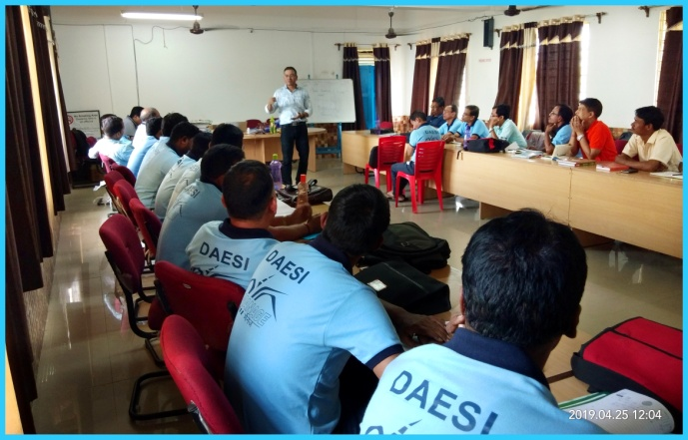

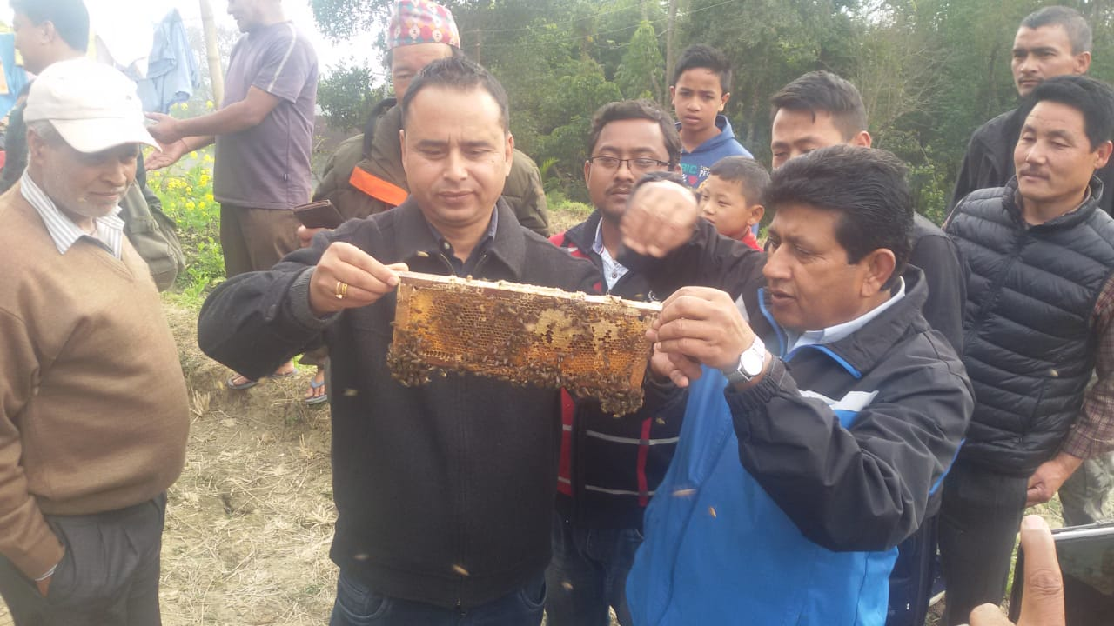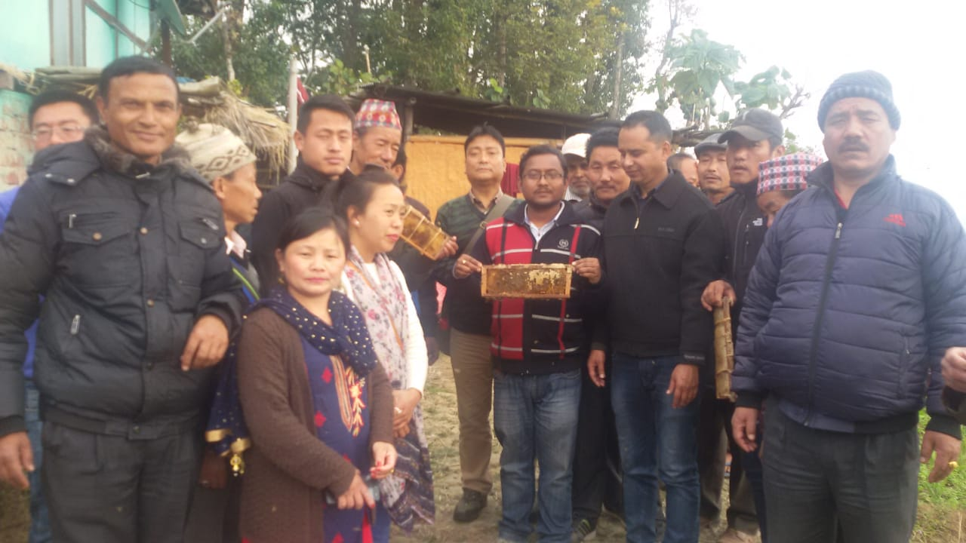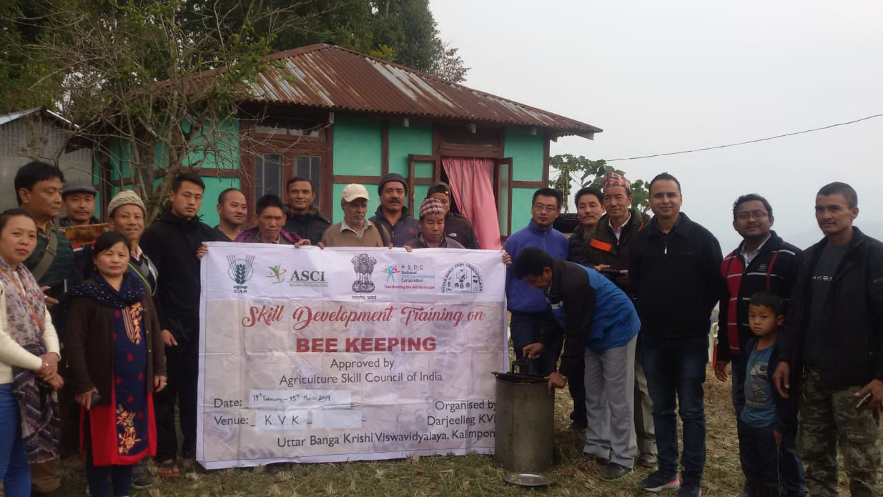

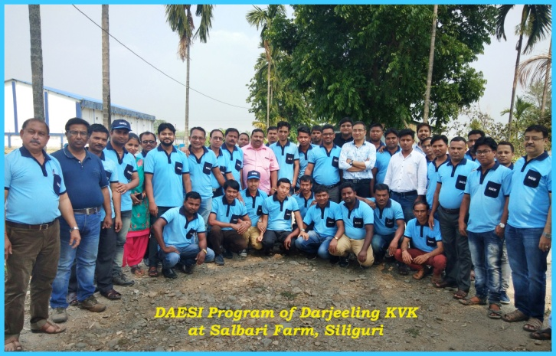

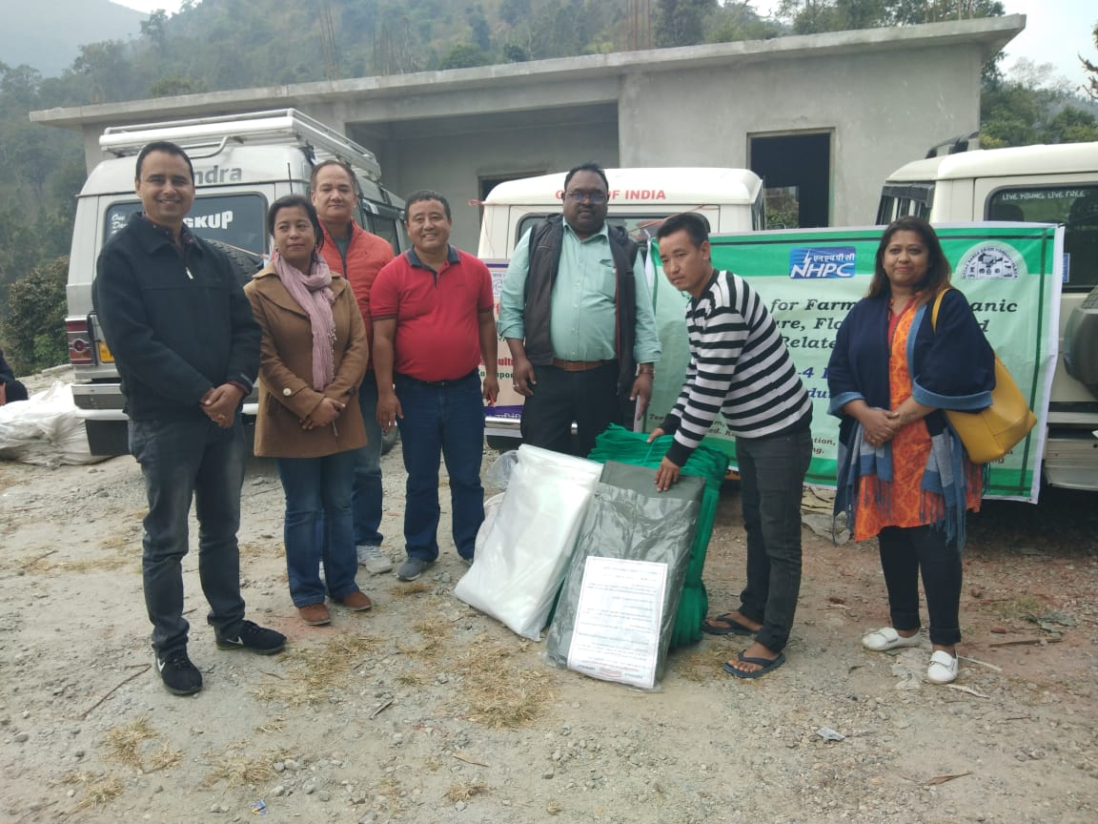

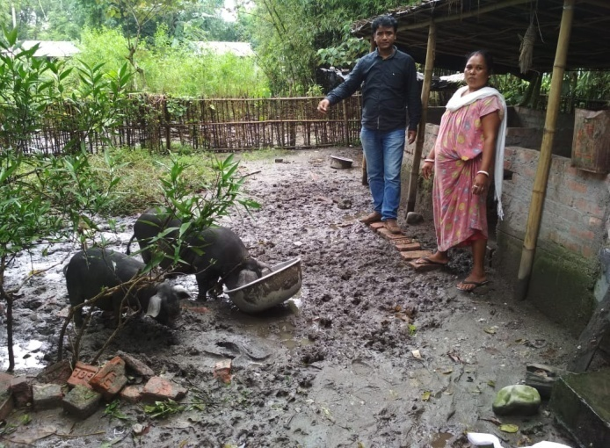 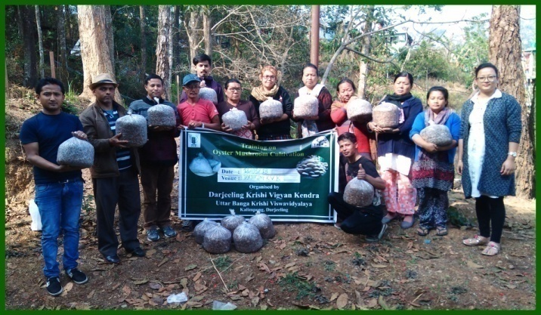

## H) Vocational training programmes for Rural Youth

## Details of training programmes for Rural Youth

|  |  |  |  |  |  |  |  |  |  |  |
| --- | --- | --- | --- | --- | --- | --- | --- | --- | --- | --- |
| Crop / Enterprise | Identified Thrust Area | Training title* | Duration (days) | No. of Participants | | | Self employed after training | | | Number of persons employed else where |
| Male | Female | Total | Type of units | Number  of units | Number of persons employed |  |
| Fertilizer and pesticide dealer | Para agriculture extension worker | DAESI | 365 | 39 | 1 | 40 | Dealers | 40 | 40 | -- |
|  |  |  |  |  |  |  |  |  |  |  |

*training title should specify the major technology /skill transferred

I) Sponsored Training Programmes

|  |  |  |  |  |  |  |  |  |  |  |  |  |  |  |  |  |  |
| --- | --- | --- | --- | --- | --- | --- | --- | --- | --- | --- | --- | --- | --- | --- | --- | --- | --- |
| Sl.No | Title | Thematic area | Month | Duration (days) | Client | No. of courses | No. of Participants | | | | | | | | | | Sponsoring Agency |
|  |  | PF/RY/EF | Male | | | Female | | | Total | | | |
|  | Others | SC | ST | Others | SC | ST | Others | SC | ST | Total |  |
|  |  |  |  |  |  |  |  |  |  |  |  |  |  |  |  |  |  |

3.4. A. Extension Activities (including activities of FLD programmes)

|  |  |  |  |  |  |  |  |  |  |  |  |
| --- | --- | --- | --- | --- | --- | --- | --- | --- | --- | --- | --- |
| Nature of Extension Activity | No. of activities | Farmers | | | | Extension Officials | | | Total | | |
| M | F | T | SC/ ST  (% of total) | Male | Female | Total | Male | Female | Total |
| Field Day | 1 | 9 | 0 | 9 |  | 0 | 0 | 0 | 9 | 0 | 9 |
| KisanMela | 2 | 8500 | 3250 | 11750 | 28 |  |  | 0 | 8500 | 3250 | 11750 |
| KisanGhosthi | 0 | 0 | 0 | 0 |  | 0 | 0 | 0 | 0 | 0 | 0 |
| Exhibition | 1 | 550 | 350 | 900 | 35 |  |  | 0 | 550 | 350 | 900 |
| Film Show | 15 | 251 | 135 | 386 | 27.2 | 1 | 2 | 3 | 252 | 137 | 389 |
| Method Demonstrations | 0 | 0 | 0 | 0 |  | 0 | 0 | 0 | 0 | 0 | 0 |
| Farmers Seminar | 2 | 50 | 32 | 82 | 15.85 |  |  | 0 | 50 | 32 | 82 |
| Workshop | 4 | 87 | 59 | 146 | 20.54 | 50 | 15 | 65 | 137 | 74 | 211 |
| Group meetings | 1 | 17 | 8 | 25 | 16 | 0 | 0 | 0 | 17 | 8 | 25 |
| Lectures delivered as resource persons | 8 | 119 | 207 | 326 | 22 | 19 | 17 | 36 | 138 | 224 | 362 |
| Advisory Services | 0 | 0 | 0 | 0 |  | 0 | 0 | 0 | 0 | 0 | 0 |
| Scientific visit to farmers field | 83 | 303 | 180 | 483 | 25.87 | 2 | 4 | 6 | 305 | 184 | 489 |
| Farmers visit to KVK | 79 | 334 | 165 | 499 | 32.86 | 3 | 1 | 4 | 337 | 166 | 503 |
| Diagnostic visits | 0 | 0 | 0 | 0 |  | 0 | 0 | 0 | 0 | 0 | 0 |
| Exposure visits | 0 | 0 | 0 | 0 |  | 0 | 0 | 0 | 0 | 0 | 0 |
| Ex-trainees Sammelan | 0 | 0 | 0 | 0 |  | 0 | 0 | 0 | 0 | 0 | 0 |
| Soil health Camp | 2 | 31 | 7 | 38 | 13.15 | 0 | 0 | 0 | 31 | 7 | 38 |
| Animal Health Camp | 1 | 34 | 13 | 47 | 17 | 3 | 1 | 4 | 37 | 14 | 51 |
| Agri mobile clinic | 0 | 0 | 0 | 0 |  | 0 | 0 | 0 | 0 | 0 | 0 |
| Soil test campaigns | 0 | 0 | 0 | 0 |  | 0 | 0 | 0 | 0 | 0 | 0 |
| Farm Science Club Conveners meet | 0 | 0 | 0 | 0 |  | 0 | 0 | 0 | 0 | 0 | 0 |
| Self Help Group Conveners meetings | 0 | 0 | 0 | 0 |  | 0 | 0 | 0 | 0 | 0 | 0 |
| Mahila Mandals Conveners meetings | 0 | 0 | 0 | 0 |  | 0 | 0 | 0 | 0 | 0 | 0 |
| Celebration of important days (specify) | 1 | 0 | 68 | 68 | 5.8 | 0 | 2 | 2 | 0 | 70 | 70 |
| Sankalp Se Siddhi |  |  |  |  |  |  |  |  |  |  |  |
| Swatchta Hi Sewa |  |  |  |  |  |  |  |  |  |  |  |
| Mahila Kisan Divas |  |  |  |  |  |  |  |  |  |  |  |
| Any Other (Farmers Scientist Interaction) | 1 | 38 | 2 | 40 | 15 | 4 | 0 | 4 | 42 | 2 | 44 |
| **Total** | **201** | **10323** | **4476** | **14799** |  | **82** | **42** | **124** | **10405** | **4518** | **14923** |

B. Other Extension activities

|  |  |
| --- | --- |
| ***Nature of Extension Activity*** | ***No. of activities*** |
|
| Newspaper coverage | 12 |
| Radio talks | 2 |
| TV talks | 0 |
| Popular articles | 4 |
| Extension Literature | 9 |
| Other, if any | - |

**3.5 a. Production and supply of Technological products : NA**

***Village seed***

|  |  |  |  |  |  |  |  |  |
| --- | --- | --- | --- | --- | --- | --- | --- | --- |
| Crop | Variety | Quantity of seed  (q) | Value  (Rs) | No. of farmers involved in village seed production | Number of farmers  to whom seed provided | | | |
|  |  |  |  |  | SC | ST | Other | Total |
|  |  |  |  |  |  |  |  |  |
| Total |  |  |  |  |  |  |  |  |

# *KVK farm*

# *KVK farm*

|  |  |  |  |  |  |  |  |  |  |  |  |
| --- | --- | --- | --- | --- | --- | --- | --- | --- | --- | --- | --- |
| Crop | **Variety** | **Quantity of seed**  **(q)** | **Value**  **(Rs)** | **Number of farmers**  **to whom seed provided** | | | | | | | |
| **SC** | | **ST** | | **Other** | | **Total** | |
|  |  |  |  | M | F | M | F | M | F | M | F |
| Maize | Kaveri | 150 Kg | 1950/- | 5 | 3 | 3 | 1 | 3 | -- | **11** | **4** |
| Turmeric | Paheli | 200 Kg | 10000/- | 4 | 6 | 3 | 3 | 2 | 2 | **9** | **11** |
| Ginger | Gorubathahey | 100 Kg | 6000/- | 1 | 1 | -- | -- | 2 | 1 | **3** | **2** |
| Potato | Kanchan & Jalandhar | 160 Kg | 14950/- | 1 | 1 | 1 | 1 | 2 | 2 | **4** | **4** |
| Grand Total |  | 610 Kg | 32900/- | 11 | 11 | 07 | 05 | 09 | 05 | **27** | **21** |

# Production of planting materials by the KVKs

|  |  |  |  |  |  |  |  |  |  |  |  |
| --- | --- | --- | --- | --- | --- | --- | --- | --- | --- | --- | --- |
| Crop | **Variety** | **No. of planting materials** | **Value**  **(Rs)** | **Number of farmers**  **to whom planting material provided** | | | | | | | |
| **SC** | | **ST** | | **Other** | | **Total** | |
|  |  |  |  | M | F | M | F | M | F | M | F |
| **Vegetable seedlings** |  |  |  |  |  |  |  |  |  |  |  |
| 1. Tomato | Jessica | 3000 nos. | 3000/- | 5 | 5 | -- | 3 | 4 | 3 | **9** | **11** |
| 1. Rai Sag | Lava | 2500 nos. | 3750/- | 5 | 2 | 3 | 4 | 3 | 4 | **11** | **10** |
| 1. Palki | Local | 2500 nos. | 2500/- | 4 | 3 | 5 | 3 | 3 | 3 | **12** | **9** |
| 1. Cabbage | Rare Ball | 2200 nos. | 2200/- | 3 | -- | 1 | 1 | 2 | 3 | **6** | **4** |
| 1. Cauliflower | White Flash | 2600 nos. | 2600/- | 6 | 4 | 3 | 4 | 4 | 5 | **13** | **13** |
| **Fruits** |  |  |  |  |  |  |  |  |  |  |  |
| 1. Strawberry | Festival | 6200 nos. | 31000/- | 4 | 5 | 3 | -- | 6 | 3 | **13** | **8** |
| **Others** |  |  |  |  |  |  |  |  |  |  |  |
| 1. Maize | Kaveri | 345 Kg | 27600/- |  |  |  |  |  |  |  |  |
| Ornamental plants |  |  |  |  |  |  |  |  |  |  |  |
| Medicinal and Aromatic |  |  |  |  |  |  |  |  |  |  |  |
| **Plantation** |  |  |  |  |  |  |  |  |  |  |  |
| 1. Broomstick |  | 7000 nos. | 35000/- |  |  |  |  |  |  |  |  |
| **Spices** |  |  |  |  |  |  |  |  |  |  |  |
| 1. Turmeric | Paheli | 550 kg. | 27500/- |  |  |  |  |  |  |  |  |
| 1. Ginger | Gorubathahey | 200 kg | 12000/- |  |  |  |  |  |  |  |  |
| **Tuber** |  |  |  |  |  |  |  |  |  |  |  |
| 1. Potato | Kanchan & Jalandhar | 920 kg | 11960/- |  |  |  |  |  |  |  |  |
| Elephant yams |  |  |  |  |  |  |  |  |  |  |  |
| Fodder crop saplings |  |  |  |  |  |  |  |  |  |  |  |
| Forest Species |  |  |  |  |  |  |  |  |  |  |  |
| Others, pl. specify |  |  |  |  |  |  |  |  |  |  |  |
| Total |  |  | **1,59,110/-** | **27** | **19** | **15** | **15** | **22** | **21** | **64** | **55** |

**Production of Bio-Products :NIL**

|  |  |  |  |  |  |  |
| --- | --- | --- | --- | --- | --- | --- |
| Name of product | Quantity | Value (Rs.) | No. of Farmers benefitted | | | |
| Kg |
|  |  |  | SC | ST | Other | Total |
| Bio-fertilizers |  |  |  |  |  |  |
| Bio-pesticide |  |  |  |  |  |  |
| Bio-fungicide |  |  |  |  |  |  |
| Bio-agents |  |  |  |  |  |  |
| Others, please specify. |  |  |  |  |  |  |
| Total |  |  |  |  |  |  |

# Production of livestock materials : NIL

|  |  |  |  |  |  |  |  |
| --- | --- | --- | --- | --- | --- | --- | --- |
| Particulars of Live stock | Name of the breed | Number | Value (Rs.) | No. of Farmers benefitted | | | |
|  |  |  |  | SC | ST | Other | Total |
| Dairy animals |  |  |  |  | | | |
| Cows |  |  |  |  | | | |
| Buffaloes |  |  |  |  | | | |
| Calves |  |  |  |  | | | |
| Others (Pl. specify) |  |  |  |  | | | |
| Small ruminants |  |  |  |  | | | |
| Sheep |  |  |  |  | | | |
| Goat |  |  |  |  | | | |
| Other, please specify |  |  |  |  | | | |
| Poultry |  |  |  |  | | | |
| Broilers |  |  |  |  | | | |
| Layers |  |  |  |  | | | |
| Duals (broiler and layer) |  |  |  |  | | | |
| Japanese Quail |  |  |  |  | | | |
| Turkey |  |  |  |  | | | |
| Emu |  |  |  |  | | | |
| Ducks |  |  |  |  | | | |
| Others (Pl. specify) |  |  |  |  | | | |
| Piggery |  |  |  |  | | | |
| Piglet |  |  |  |  | | | |
| Hog |  |  |  |  | | | |
| Others (Pl. specify) |  |  |  |  | | | |
| Fisheries |  |  |  |  | | | |
| Indian carp |  |  |  |  | | | |
| Exotic carp |  |  |  |  | | | |
| Mixed carp |  |  |  |  | | | |
| Fish fingerlings |  |  |  |  | | | |
| Spawn |  |  |  |  | | | |
| Others (Pl. specify) |  |  |  |  | | | |
| Grand Total |  |  |  |  | | | |

**3.5. b. Seed Hub Programme - *“Creation of Seed Hubs for Increasing Indigenous Production of Pulses in India”***

i) Name of Seed Hub Centre: NA

|  |  |
| --- | --- |
| Name of Nodal Officer : |  |
| Address : |  |
| e-mail : |  |
| Phone No. :  Mobile : |  |

ii) Quality Seed Production Reports : NIL

|  |  |  |  |  |  |  |
| --- | --- | --- | --- | --- | --- | --- |
| Season | Crop | Variety | Production (q) | | | |
| Target | Area sown (ha) | Production | Category of Seed  (F/S, C/S) |
| Kharif 2018 |  |  |  |  |  |  |
|  |  |  |  |  |  |  |
| Rabi 2018-19 |  |  |  |  |  |  |
|  |  |  |  |  |  |  |
| Summer/Spring 2019 |  |  |  |  |  |  |

iii) Financial Progress : NA

|  |  |  |  |  |
| --- | --- | --- | --- | --- |
| Fund received  (2016-17, 2017-18 and 2018-19) | Expenditure (Rs. in lakhs) | | Unspent balance  (Rs. in lakhs) | Remarks |
| Infrastructure | Revolving fund |
| 2016-17 | NIL | NIL | NIL | -- |
| 2017-18 | NIL | NIL | NIL | -- |
| 2018-19 | NIL | NIL | NIL | -- |

iv) Infrastructure Development : NA

|  |  |
| --- | --- |
| Item | Progress |
| Seed processing unit |  |
| Seed storage structure |

3.6. (A) Literature Developed/ Published (with full title, author & reference)

|  |  |  |  |  |
| --- | --- | --- | --- | --- |
| Item | Title | Author’s name | Number | Circulation |
| Research paper | Adoption of improved mandarin production technologies among mandarin growers of Darjeeling hills. | **Roy Rakesh,** Kharga B.D. and Moktan M.W. (2018). | *Agriculture Update,***13**(4):404-412 |  |
|  | Performance of dairy animals in commercial dairy farms in Karnataka. | Sathisha M.C., Tiwari Rupasi and **Roy Rakesh** (2018). | *Indian Journal of Dairy Science*,**71**(6): 620-624 |  |
|  | Adoption of good dairy farming practices among commercial dairy owners of Karnataka. | Sathisha M.C., Tiwari Rupasi and **Roy Rakesh** (2018). | *International Journal of Livestock Research,***8**(12):49-59 |  |
|  | Commercial dairy farmers preference towards livestock extension services in Karnataka. | Sathisha M.C., TiwariRupasi and **Roy Rakesh** (2018). | *Indian Journal of Extension Education*, **54**(3): 101-110 |  |
|  | Patterns of pre-weaning piglet mortality and economic losses in field condition. | **Roy R,** Mondal T. and Moktan M.W. (2018). | *African Journal of Agricultural Research,* **13**(25): 1291-1296 |  |
|  | Animal husbandry practices in hill farming situation: Gender role analysis, | **Roy Rakesh,** Mondal Tista and Moktan MW (2018). | *International Journal of Current Microbiology and Applied Sciences,***7**(6): 3136-3141 |  |
|  | Darjeeling mandarin orange: Reasons for its decline and perceived constraints. | **Roy Rakesh,** Kharga BD and Moktan MW (2018). | *International Journal of Current Microbiology and Applied Sciences,* **7**(9):14-20 |  |
|  | Assessment of socio-economic status of contract and non-contract goat farmers of Odisha: A Comparative Study. | Sahoo CK, Tiwari R and **Roy Rakesh** (2018) | *International Journal of Livestock Research,***8**(10):348-356 |  |
|  | Forecasting of green chilli prices in West Bengal by holt-winter methods using expert system. | Manna Subrata, Dhakre D.S. and **Roy Rakesh** (2018). | *International Research Journal of Agricultural Economics and Statistics,* **9**(1):207-211 |  |
|  | Factors affecting knowledge and adoption of preventive and control measures of diseases among goat owners under field condition. | **Roy Rakesh** and Tiwari Rupasi (2018). | *Indian Journal of Extension Education,* **54**(4):11-17 |  |
|  | An on - farm trial to evaluate the performance of  improved rice varieties in Darjeeling district of West Bengal | **Pranab Barma**, Sujit Sarkar, Sarkar RK, Moktan MW, Ali S, Rahaman  FH and Burman RR | Journal of Entomology and Zoology Studies 2018; 6(6): 78-81  ISSN: 2349-6800 |  |
|  | Relationship of whitefly population build up with  the spread of yellow mosaic virus on soybean | NayanKishorAdhikary, **Pranab Barma**, JayantaTarafdar and GautamSaha | Journal of Entomology and Zoology Studies 2018; 6(5): 348-352 ISSN: 2349-6800 |  |
| Seminar/conference/ symposia papers | Knowledge and adoption behaviour of tribal integrated farmers about improved livestock technologies in hill farming situation. | **Roy Rakesh**, Goswami A. and Tiwari Rupasi (2018). | Paper presented at National Seminar organized by Indian Society of Extension Education on “Integrated Farming System for Enhancing Farmers’ Income and Nutritional Security” held during Dec., 5-7, 2018 at WBUAFS, Kolkata, pp: 235 |  |
|  | Economic contribution and determinants of pig production under backyard farming system in Terai and Hill regions of West Bengal. | **Roy Rakesh** and Goswami A.(2018) | Paper presented at International Symposium organized by Indian Meat Science Association on ‘Technological innovations in muscle food processing for nutritional security, quality and safety’ held during Nov., 22-24, 2018at WBUAFS, Kolkata |  |
|  | Patterns of pre-weaning kid mortality and economic losses under field condition. | **Roy Rakesh,** Mondal Tista and Moktan MW(2018) | Paper presented at International Conference on ‘Agriculture and Allied Science: The Productivity, Food Security and Ecology’ held at BCKV, Kalyani during 13th-14th August, 2018. Vol II:219 |  |
|  | Integrated farming system prospective in Sub-Himalayan region for enhancing tribal farmers’ income. | **Roy Rakesh**, Goswami A. and Tarafder HK (2018) | Paper presented at National Seminar organized by Indian Society of Extension Education on “Integrated Farming System for Enhancing Farmers’ Income and Nutritional Security” held during Dec. 5-7, 2018 at WBUAFS, Kolkata, pp: 134-135 |  |
| Books |  |  |  |  |
| Bulletins |  |  |  |  |
| News letter |  |  |  |  |
| Popular Articles |  |  |  |  |
| Book Chapter |  |  |  |  |
| Extension Pamphlets/ literature |  |  |  |  |
| Technical reports |  |  |  |  |
| Electronic Publication (CD/DVD etc) |  |  |  |  |
| TOTAL |  |  |  |  |

N.B.: Please enclose a copy of each. In case of literature prepared in local language please indicate the title in English

(B) Details of HRD programmes undergone by KVK personnel:

|  |  |  |  |  |  |
| --- | --- | --- | --- | --- | --- |
| Sl. No. | Name of programme | Name of course | Name of KVK personnel and designation | Date and Duration | Organized by |
| 1. | HRD TRAINING PROGRAMME | HRM SYSTEM FOR KVKS OF UBKV | SNEHLATA LAMA | 1 DAY | DIRECTOR OF EXTENSION EDUCATION |
| 2. | HRD programme for the employees of KVKs | Entrepreneurship development & Motivation and leadership program | Akriti Pradhan  Pranab Barma  Ranajit Panda  Subrata Manna  Basudeo Kharga  Akash Deep Thapa  Sandeep Thapa  Dinesh Diyali  Harish Chettri | 1 Day | DIRECTOR OF EXTENSION EDUCATION |
| 3. | CAFT | ICT in Agriculture | Pranab Barma  Subrata Manna | 21 Days | DEE, BAU, Sabore |
| 4. | Short Course | Entrepreneurship Development through Agro food processing centres | Basu Deo Kharga | 12-22/12/2019  10 Days | CIAE, Regional Centre, Coimbatore |
| Akash Deep Thapa |
| 5 | CAFT | ICT in Agriculture | Ranajit Panda | 21 Days | DEE, BAU, Sabore |

3.7. Success stories/Case studies, if any (two or three pages write-up on 1-2 best case(s) with suitable action photographs)

3.9. a. Give details of indigenous technology practiced by the farmers in the KVK operational area which can be considered for technology development (in detail with suitable photographs)

|  |  |  |  |
| --- | --- | --- | --- |
| **S. No.** | **Crop / Enterprise** | **ITK Practiced** | **Purpose of ITK** |
| 01. | Flowers /ferns | Spraying of solution prepared from 250gm of tobacco leaves soaked in 3 litres of water for atlest 1 hour. | Controls aphid |
|  |  |  |  |
|  |  |  |  |
|  |  |  |  |
|  |  |  |  |
|  |  |  |  |

b. Give details of organic farming practiced by the farmer

|  |  |  |  |  |  |
| --- | --- | --- | --- | --- | --- |
| **Sl. No.** | **Crop / Enterprise** | **Area (ha)/ No. covered** | **Production** | **No. of farmers involved** | **Market available (Y/N)** |
| 01. | Vegetables | 6.4 | Cauliflower-12-15t/ha-  Brocolli-10t/ha  Cabbage -12t/ha | 7 | No saperate market for organic vegetables. |

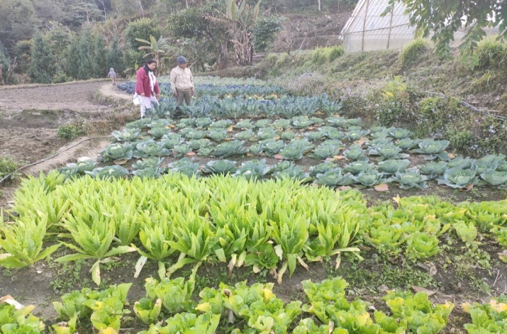

3.10. Indicate the specific training need analysis tools/methodology followed by KVKs

|  |  |  |
| --- | --- | --- |
| Sl. No. | Brief details of the tool/ methodology followed | Purpose for which the tool was followed |
| -- | -- | -- |

3.11. a. Details of equipment available in Soil and Water Testing Laboratory

|  |  |  |
| --- | --- | --- |
| Sl. No | Name of the Equipment | Qty. |
| 1. | Spectrophotometer | 1 |
| 2. | Flame Photometer | 1 |
| 3. | PH Meter | 1 |
| 4. | Conductivity bridge | 1 |
| 5. | Physical balance | 1 |
| 6. | Chemical balance | 1 |
| 7. | Digestion unit | 1 |
| 8. | Kjeldhal Distillation set | 2 |
| 9. | Mechanical shaker | 1 |
| 10. | Refrigerator | 1 |
| 11. | Hot air oven | 1 |
| 12. | Hot plate | 1 |
| 13. | Grinder | 1 |
| 14. | Water distillation unit (double) | 1 |
| 15. | Chemical and Glass wares | 50 |
| 16. | Soxlet Apparatus (Big &Small) | 2 |
| 17. | Laboratory set up | 1 |
| 18. | Soil and plant sample processing and storage facility | 2 |
| Total | | 17 |

3.11.b. Details of samples analyzed so far :

|  |  |  |  |  |  |
| --- | --- | --- | --- | --- | --- |
| Number of soil samples analyzed | | | No. of Farmers | No. of Villages | Amount realized  (in Rs.) |
| Through mini soil testing kit/labs | Through soil testing laboratory | Total |
| -- | -- | -- | -- | -- | -- |

3.11.c. Details on World Soil Day

|  |  |  |  |  |  |  |
| --- | --- | --- | --- | --- | --- | --- |
| Sl.  No. | Activity | No. of Participants | No. of VIPs | Name (s) of VIP(s) | Number of Soil Health Cards distributed | No. of farmers benefitted |
|  |  |  |  |  |  |  |
|  |  |  |  |  |  |  |

3.12. Activities of rain water harvesting structure and micro irrigation system

|  |  |  |  |  |
| --- | --- | --- | --- | --- |
| **No of training programme** | **No of demonstrations** | **No of plant material produced** | **Visit by the farmers** | **Visit by the officials** |
| --- | -- | -- | -- | -- |

3.13. Technology week celebration

|  |  |  |  |
| --- | --- | --- | --- |
| Type of activities | No. of activities | Number of participants | Related crop/livestock technology |
| -- | -- | -- | -- |

3.14. RAWE/ FET programme - is KVK involved? Yes

|  |  |
| --- | --- |
| No of student trained | No of days stayed |
| 1. SATKAR THAPA | 7 WEEKS |
| 1. JUBAID REHMAN CHERUPARAMBIL | 7WEEKS |

|  |  |
| --- | --- |
| ARS trainees trained | No of days stayed |
| -- | -- |

3.15. List of VIP visitors (Minister/ MP/MLA/DM/VC/Zila Sabhadipati/Other Head of Organization/Foreigners)

|  |  |  |
| --- | --- | --- |
| Date | Name of the person | Purpose of visit |
|  |  |  |
|  |  |  |
|  |  |  |
|  |  |  |
|  |  |  |
|  |  |  |
|  |  |  |
|  |  |  |
|  |  |  |
|  |  |  |

1. IMPACT
   1. Impact of KVK activities (Not to be restricted for reporting period).

|  |  |  |  |  |
| --- | --- | --- | --- | --- |
| Name of specific technology/skill transferred | No. of participants | % of adoption | Change in income (Rs.) | |
| Before (Rs./Unit) | After (Rs./Unit) |
| Adding value in local fruits & vegetables | 15 | 13.33 | - | 3500- 5000 |
| Vermi composting | 4 | 50 | 5000-6000 | 10,000- 12,000 |
| Kitchen Gardening | 25 | 80 | 1500- 2500 | 5000-7000 |
| Commercial cultivation of gladiolus variety American Variety | 10 | 90 | 18,000/- | 33,750/- |
| Disease management in ginger with hot water treatment and application of bio agent | 14 | 42 | 36150 | 57200 |
| Nutritional management of Darjeeling Management | 300 | 40 | 22000(per tree) | 3000(per tree) |

NB: Should be based on actual study, questionnaire/group discussion etc. with ex-participants

4.2. Cases of large scale adoption

(Please furnish detailed information for each case)

|  |  |
| --- | --- |
| **Horizontal spread of technologies** | |
| **Technology** | **Horizontal spread** |
| Hampshire pig under backyard farming system | Hampshire pig is highly preferred by the farmers for farrowing. Hampshire pig has higher litter size and higher growth rate under backyard farming system in hill farming situation. |
| Backyard poultry farming with improved poultry breed | Scientific poultry farming under backyard systemwith improved poultry birds is a common practices under hill farming system due to its higher production performance and higher return. |
| Trapping of Fruit flies | The Kendra had demonstrated a technology on trapping of fruit flies in Darjeeling Orange at SantookVillage, Duptin village, and Bong Busty and the farmers are following this technique in the Orchards. With this techniques, there may not be 100% destruction of flies but with continuous application of this technology the natural population of insects will be reduced to a great extent resulting in less incidence of fruit drop. |
| Management of blight disease of Large Cardamom | Sri. B BThapa of Sangsey was trained on management of blight disease of Large Cardamom using 1% Bordeaux mixture.Now he applied this technology in his field and has observed reduction of blight disease up to 40% thereby increase his annual production up to 27% and increases in income up to 67%.He is recommending and teaching the technique to other farmers of his village. |
| Seed treatment of Ginger | Sri. PradipPradan of Makaldara, Bhalukhop was trained on seed treatment of Ginger using hot water at 510C for 10 minutes. Now he is using this technique and the disease incidence in his field has reduced from 60% to 15%. He is recommending and teaching the technique to other farmers of his village. |
| Nutritional Management of Darjeeling Mandarin | With the application of the balance fertilizer the number of fruits per tree increased by 59 %. The demonstration was conducted in the field of 10 farmers which was adopted by 30 more farmers of the locality. |

Give information in the same format as in case studies

4.3. Details of impact analysis of KVK activities carried out during the reporting period

|  |  |  |  |
| --- | --- | --- | --- |
| **Sl. No.** | **Brief details of technology** | **Impact of the technology in subjective terms** | **Impact of the technology in objective terms** |
| 1. | Productive Performance of Hampshire pig | Spreading of this technology or spreading of this pig breed in large scale for farrowing of piglet has increase in income of the pig farmers who were only engaged in fattening of pig with local pig breed. | This technology has enhanced the income of the pig farmers and thereby increases in socio economic condition of the pig farmer. |
| 2. | Grading up of local poultry by RIR cock | Spreading of this RIR cock for grading up of local poultry has enhance the egg production and growth rate of the local poultry bird with local disease incidence rate | Increased egg and meat production has enhanced income in backyard poultry farming and thereby higher return and higher protein consumption by the poultry farmers. |
| 3. | Supplementation of Iron to check piglet anaemia | Iron Supplementation to check piglet anaemia have reduce mortality due to piglet anaemia | Reduced mortality had enhanced higher return from pig farming and thereby higher socio-economic condition of the pig farmers. |
| 4. | Mineral Mixture | Providing mineral mixture to the dairy animals has increased the milk production in lactating cattle and higher conception rate. | Higher milk production, higher conception rate gives higher return to the dairy farmers. This has enhanced the socio-economic condition of the dairy farmers. |
| 5 | Varietal Assessment of potato under Hill Agro-climatic conditions | Increase in the size of tubers by59%,60% and 70%of Kufri Himalini, Kufri Kanchan,and Kufri Sailija compared to the local variety | Increase in the yield of tubers by 19%,36%,and 31% of Kufri Himalini, Kufri Kanchan,and Kufri Sailija compared to the local variety |

4.4. Details of innovations recorded by the KVK :NIL

|  |  |
| --- | --- |
| Thematic area |  |
| Name of the Innovation |  |
| Details of Innovator |  |
| Back ground of innovation |  |
| Technology details |  |
| Practical utility of innovation |  |

4.5. Details of entrepreneurship development

|  |  |
| --- | --- |
| Entrepreneurship development under Horticulture | |
| Name of the enterprise | Organic seed Production of Vegetable crops . |
| Name & complete address of the entrepreneur | Hem Kumar Tamang  Village-Purba Samalbong  Samalbong GP |
| Role of KVK with quantitative data support: | Mr Tamang was into traditional farming since his childhood but his interest in Seedling production of vegetables grew when he was given training on topic Seedling production conducted off campus sponsored by Rotary club at Samalbong GP on January 2018 regarding.His keen interest has made him entrepreneur them . |
| Timeline of the entrepreneurship development | 1.5 Years. |
| Technical Components of the Enterprise | Seedling Production Unit (30/15 ft). |
| Status of entrepreneur before and after the enterprise | Mr Tamang being traditional farmer had a very irratic source of income but after the establishment of the unit he has now a regular source of income and also he has become a resource person or a adviser for the farmers of the locality. |
| Present working condition of enterprise in terms of raw materials availability, labour availability, consumer preference, marketing the product etc. ( Economic viability of the enterprise): | He produces seedling of Tomato, Cabbage, Capsicum , Cauliflower and Brocolli 1000/-seedling each at 15 days interval .  He also provides employment to 1 worker daily for maintenance of his business.  His produce are sold locally in the market as well as |
| Horizontal spread of enterprise | After his establishment of the seedling production unit Six more farmers of the nearby villages have started their unit. |

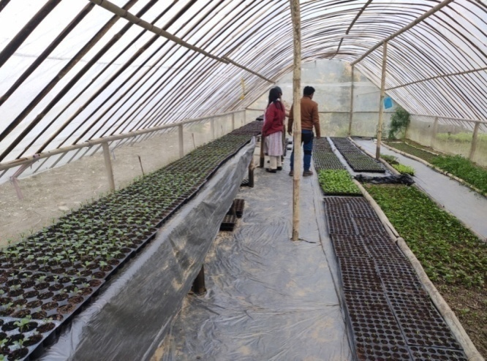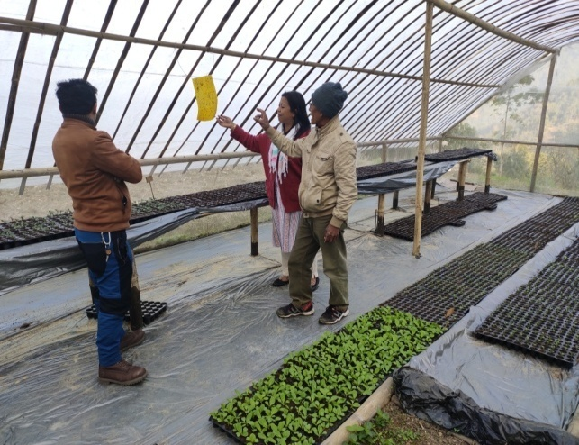

4.6. Any other initiative taken by the KVK

5. LINKAGES

5.1. Functional linkage with different organizations

|  |  |
| --- | --- |
| **Name of organization** | **Nature of linkage** |
| State Agriculture Dept., Govt. of West Bengal | Training |
| Regional Research Station (Hill Zone), Uttar Banga Krishi Viswavidyalaya, Kalimpong |
| Dept. of Animal Recourses Development, Govt. of West Bengal |
| Sasastra Seema Bal (SSB), Siliguri Frontier |
| Regional Station, Indian Agricultural Research Institute, Kalimpong |
| Regional Research Station (Hill Zone), Uttar Banga Krishi Viswavidyalaya, Kalimpong | Demonstration |
| State Agriculture Dept., Govt. of West Bengal |
| Regional Research Station (Hill Zone), Uttar Banga Krishi Viswavidyalaya, Kalimpong | Joint Survey |
| State Agriculture Dept., Govt. of West Bengal |
| State Agriculture Dept., Govt. of West Bengal | Technical Support |
| Regional Research Station (Hill Zone), Uttar Banga Krishi Viswavidyalaya, Kalimpong |
| Dept. of Animal Recourses Development, Govt. of West Bengal |
| Spices Board, Kalimpong, Govt. of India |
| Regional Station, Indian Agricultural Research Institute, Kalimpong |

5.2. List of special programmes undertaken during 2018-19 by the KVK, which have been financed by ATMA/ Central Govt/ State Govt./NABARD/NHM/NFDB/Other Agencies **(information of previous years should not be provided)**

a) Programmes for infrastructure development

|  |  |  |  |  |
| --- | --- | --- | --- | --- |
| Name of the programme/ scheme | Purpose of programme | Date/ Month of initiation | Funding agency | Amount (Rs.) |
|  |  |  |  |  |

(b) Programme for other activities (training, FLD,OFT, Mela, Exhibition etc.)

|  |  |  |  |  |
| --- | --- | --- | --- | --- |
| Name of the programme/ scheme | Purpose of programme | Date/ Month of initiation | Funding agency | Amount (Rs.) |
|  |  |  |  |  |

1. PERFORMANCE OF INFRASTRUCTURE IN KVK

6.1. Performance of demonstration units (other than instructional farm)

|  |  |  |  |  |  |  |  |  |  |
| --- | --- | --- | --- | --- | --- | --- | --- | --- | --- |
| Sl. No. | Name of demo Unit | Year of estt. | Area(Sq.mt) | Details of production | | | Amount (Rs.) | | Remarks |
| Variety/breed | Produce | Qty. | Cost of inputs | Gross income |
| 1. |  |  |  |  |  |  |  |  |  |
| 2. |  |  |  |  |  |  |  |  |  |
| 3. |  |  |  |  |  |  |  |  |  |
| 4. |  |  |  |  |  |  |  |  |  |
| 5. |  |  |  |  |  |  |  |  |  |
| 6. |  |  |  |  |  |  |  |  |  |
| 7. |  |  |  |  |  |  |  |  |  |
|  | Total |  |  |  |  |  |  |  |  |

6.2. Performance of Instructional Farm (Crops)

|  |  |  |  |  |  |  |  |  |  |
| --- | --- | --- | --- | --- | --- | --- | --- | --- | --- |
| **Name**  **Of the crop** | **Date of sowing** | **Date of harvest** | **Area (ha)** | **Details of production** | | | **Amount (Rs.)** | | **Remarks** |
|  |  | **Variety** | **Type of Produce** | **Qty.(q)** | **Cost of**  **inputs** | **Gross income** |
|  |  |  |  |  |  |  |  |  |  |
|  |  |  |  |  |  |  |  |  |  |
|  |  |  |  |  |  |  |  |  |  |
|  |  |  |  |  |  |  |  |  |  |
|  |  |  |  |  |  |  |  |  |  |
|  |  |  |  |  |  |  |  |  |  |
|  |  |  |  |  |  |  |  |  |  |
|  |  |  |  |  |  |  |  |  |  |
|  |  |  |  |  |  |  |  |  |  |

* 1. Performance of Production Units (bio-agents / bio pesticides/ bio fertilizers etc.,)

|  |  |  |  |  |  |
| --- | --- | --- | --- | --- | --- |
| Sl.  No. | Name of the Product | Qty. (Kg) | Amount (Rs.) | | Remarks |
| Cost of inputs | Gross income |
| 1. |  |  |  |  |  |
|  |  |  |  |  |  |

* 1. Performance of instructional farm (livestock and fisheries production)

|  |  |  |  |  |  |  |  |
| --- | --- | --- | --- | --- | --- | --- | --- |
| Sl.  No | Name  of the animal / bird / aquatics | Details of production | | | Amount (Rs.) | | Remarks |
| Breed | Type of Produce | Qty. | Cost of inputs | Gross income |
| 1. |  |  |  |  |  |  |  |
| 2. |  |  |  |  |  |  |  |
| 3. |  |  |  |  |  |  |  |

* 1. Utilization of hostel facilities

Accommodation available (No. of beds)

|  |  |  |  |
| --- | --- | --- | --- |
| Months | No. of trainees stayed | Trainee days  (days stayed) | Reason for short fall (if any) |
| January 2019 |  |  |  |
| February 2019 |  |  |  |
| March 2019 |  |  |  |
| April 2019 |  |  |  |
| May 2019 |  |  |  |
| June 2019 |  |  |  |
| July 2019 |  |  |  |
| August 2019 |  |  |  |
| September 2019 |  |  |  |
| October 2019 |  |  |  |
| November 2019 |  |  |  |
| December 2019 |  |  |  |
| Total : |  |  |  |

(For whole of the year)

* 1. Utilization of staff quarters

Whether staff quarters has been completed: Yes

No. of staffquarters: 6

Date of completion: 2009

Occupancy details:

|  |  |  |  |  |  |  |
| --- | --- | --- | --- | --- | --- | --- |
| **Months** | **Q I** | **QII** | **Q III** | **QIV** | **Q V** | **QVI** |
| March 2019 | B1 |  |  |  |  |  |
| March 2019 |  | B2 |  |  |  |  |
| March 2019 |  |  | C1 |  |  |  |
| March 2019 |  |  |  | C2 |  |  |
| Vacant |  |  |  |  | B3 |  |
| Vacant |  |  |  |  |  | A1 |

1. FINANCIAL PERFORMANCE

7.1. Details of KVK Bank accounts

|  |  |  |  |
| --- | --- | --- | --- |
| Bank account | Name of the bank | Location | Account Number |
| Darjeeling KVK | SBI | Kalimpong | 11283931150 |
| Darjeeling KVK | Bank of India | Kalimpong | 429310110000033 |

* 1. Utilization of funds under CFLD on Oilseed *(Rs. In Lakhs)*

|  |  |  |  |  |  |
| --- | --- | --- | --- | --- | --- |
| Item | Released by ICAR | | Expenditure | | Unspent balance as on - |
| Kharif | Rabi | Kharif | Rabi |
| Soybean | 75,000 |  | 74,935 |  | 65 |
| Rapeseed & Mustard | 1,20,000 |  | 1,19,875 |  | 125 |
| Field Pea |  |  |  |  |  |
|  |  |  |  |  |  |

7.3. Utilization of funds under CFLD on Pulses *(Rs. In Lakhs)*

|  |  |  |  |  |  |
| --- | --- | --- | --- | --- | --- |
| Item | Released by ICAR | | Expenditure | | Unspent balance as on 1st April 2019 |
| Kharif | Rabi | Kharif | Rabi |
| Green gram | 90,000 |  | 89,930 |  | 70 |
| Black gram | 90,000 |  | 89,915 |  | 85 |
| Field Pea |  | 90,000 |  | 89,980 | 20 |

7.4. Utilization of KVK funds during the year 2018-19 (Not audited)

|  |  |  |  |  |
| --- | --- | --- | --- | --- |
| Sl.  No. | Particulars | Sanctioned | Released | Expenditure |
| A. Recurring Contingencies | | | | |
| 1 | Pay & Allowances | 1,05,00,000 | 1,05,00,000 | 1,11,14,941 |
| 2 | Traveling allowances | 1,20,000 | 80,000 | 79,953 |
| 3 | Contingencies | | | |
| *A* | Stationary, telephone, postage and other expenditure on office running, publication of newsletter | 4,44,000 | 4,44,000 | 4,39,914 |
| *B* | POL, repair of vehicle, tractor and equipment |
| *C* | Training of farmer (meals/ refreshment of trainer) | 3,30,000 | 3,30,000 | 3,29,860 |
| *D* | Training materials (need based materials and equipment for conducting the training) |
| *E* | Training of exention functionaries |
| *F* | Training of Rural Youth |
| *G* | Front line demonstration | 2,20,000 | 2,20,000 | 2,19,935 |
| *H* | On farm testing (On need based, location specific and newly generated information in the major production system of the area) | 1,10,000 | 1,10,000 | 1,09,884 |
| *I* | HRD | 30,000 | 30,000 | 29,814 |
| *J* | Swachhta Expenditure |  |  |  |
| TOTAL (A) | | **1,17,50,000** | **1,17,10,000** | **1,23,23,719** |
| B. Non-Recurring Contingencies | | | | |
| 1 | Vehicle | 8,00,000 | NIL | NIL |
| 2 |  |  |  |  |
| 3 |  |  |  |  |
| 4 |  |  |  |  |
| TOTAL (B) | |  |  |  |
| C. REVOLVING FUND | |  |  |  |
| GRAND TOTAL (A+B+C) | | **1,25,50,000** | **1,17,10,000** | **1,23,23,719** |

7.5. Status of revolving fund (Rs. in lakh) for last three years

|  |  |  |  |  |
| --- | --- | --- | --- | --- |
| Year | Opening balance as on 1st April | Income during the year | Expenditure during the year | Net balance in hand as on 1st April of each year (Kind + cash) |
| 2015-16 | 4,16,841 | 17,24,056 | 16,37,151 | 5,03,745 |
| 2016-17 | 5,03,745 | 2,11,967 | 2,78,520 | 4,37,192 |
| 2017-18 | 4,37,192 | 11,96,326 | 10,65,400 | 5,68,118 |
| 2018-19 | 5,68,118 | 19,53,452 | 19,44,552 | 5,77,018 |

* 1. (i) Number of SHGs formed by KVKs

(ii) Association of KVKs with SHGs formed by other organizations indicating the area of SHG activities

(iii) Details of marketing channels created for the SHGs

* 1. Joint activity carried out with line departments and ATMA

|  |  |  |  |  |  |
| --- | --- | --- | --- | --- | --- |
| Name of activity | Number of activity | Season | With line department | With ATMA | With both |
|  |  |  |  |  |  |
|  |  |  |  |  |  |
|  |  |  |  |  |  |

8. Other information

8.1. Prevalent diseases in Crops : NIL

|  |  |  |  |  |  |
| --- | --- | --- | --- | --- | --- |
| Name of the disease | Crop | Date of outbreak | Area affected (in ha) | % Commodity loss | Preventive measures taken for area (in ha) |
|  |  |  |  |  |  |
|  |  |  |  |  |  |

8.2. Prevalent diseases in Livestock/Fishery : NA

|  |  |  |  |  |  |
| --- | --- | --- | --- | --- | --- |
| Name of the disease | Species affected | Date of outbreak | Number of death/ Morbidity rate (%) | Number of animals vaccinated | Preventive measures taken in pond (in ha) |
|  |  |  |  |  |  |

9.1. Nehru Yuva Kendra (NYK) Training

|  |  |  |  |  |  |
| --- | --- | --- | --- | --- | --- |
| Title of the training programme | Period | | No. of the participant | | Amount of Fund Received (Rs) |
| From | To | M | F |
|  |  |  |  |  |  |
|  |  |  |  |  |  |

9.2. PPV & FR Sensitization training Programme

|  |  |  |  |  |
| --- | --- | --- | --- | --- |
| Date of organizing the programme | Resource Person | No. of participants | Registration (crop wise) | |
| Name of crop | No. of registration |
|  |  |  |  |  |

9.3. *mKisan* Portal (National Farmers’ Portal/ SMS Portal)

|  |  |  |
| --- | --- | --- |
| Type of message | No. of messages | No. of farmers covered |
| Crop |  |  |
| Livestock |  |  |
| Fishery |  |  |
| Weather |  |  |
| Marketing |  |  |
| Awareness |  |  |
| Training information |  |  |
| Other |  |  |
| **Total** |  |  |

9.4. *KVK* Portal and Mobile App

|  |  |  |
| --- | --- | --- |
| Sl. No. | Particulars | Description |
| 1. | No. of visitors visited the portal |  |
| 2. | No. of farmers registered in the portal |  |
| 3. | Mobile Apps developed by KVK |  |
| 4. | Name of the App |  |
| 5. | Language of the App |  |
| 6. | Meant for crop/ livestock/ fishery/ others |  |
| 7. | No. of times downloaded |  |

9.5. a. Observation of Swachh Bharat Programme

|  |  |
| --- | --- |
| Date/ Duration of Observation | Activities undertaken |
|
|  |  |

b. Details of Swachhta activities with expenditure

|  |  |  |
| --- | --- | --- |
| **Activities** | **Number** | **Expenditure (in Rs.)** |
| 1. Digitization of office records/ e-office |  |  |
| 1. Basic maintenance |  |  |
| 1. Sanitation and SBM |  |  |
| 1. Cleaning and beautification of surrounding areas |  |  |
| 1. Vermicomposting/   Composting of biodegradable waste management & other activities on generate of wealth for waste |  |  |
| 1. Used water for agriculture/ horticulture application |  |  |
| 1. Swachhta Awareness at local level |  |  |
| 1. Swachhta Workshops |  |  |
| 1. Swachhta Pledge |  |  |
| 1. Display and Banner |  |  |
| 1. Foster healthy competition |  |  |
| 1. Involvement of print and electronic media |  |  |
| 1. Involving the farmers, farm women and village youth in the adopted villages (no of adopted village) |  |  |
| 1. No of Staff members involved in the activities |  |  |
| 1. No of VIP/VVIPs involved in the activities |  |  |
| 16. Any other specific activity (in details) |  |  |
| **Total** |  |  |

9.6. Observation of National Science day

|  |  |
| --- | --- |
| Date of Observation | Activities undertaken |
|
|  |  |

9.7. Programme with Seema Suraksha Bal/ BSF

|  |  |  |
| --- | --- | --- |
| Title of Programme | Date | No. of participants |
|  |  |  |

9.8. Agriculture Knowledge in rural school

|  |  |  |  |
| --- | --- | --- | --- |
| Name and address of school | Date of visit to school | Areas covered | Teaching aids used |
| Chandramaya HS School | 31/05/2018 | 95 | Audio visual aid  And Leaflets |
| Pranami Balika Vidya Mandir | 07/12/2018 | 110 | Audio visual aid  And Leaflets |

Give good quality 1-2 photograph(s)

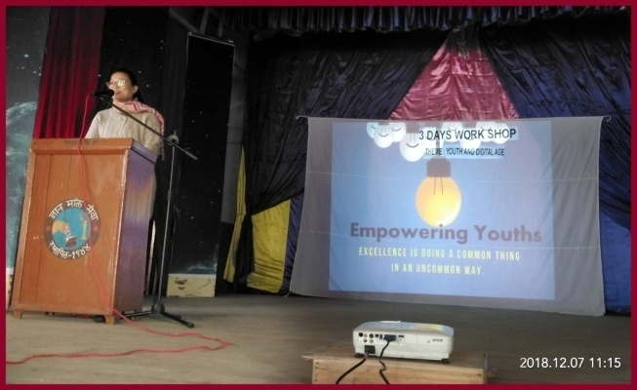

9.9. Details of ‘*Pre-Rabi Campaign’* Programme

|  |  |  |  |  |  |  |  |  |  |  |  |  |
| --- | --- | --- | --- | --- | --- | --- | --- | --- | --- | --- | --- | --- |
| Date of programme | No. of Union Ministers attended the programme | No. of  Hon’ble MPs (Loksabha/ Rajyasabha) participated | No. of State Govt. Ministers | Participants (No.) | | | | | | | Coverage by Door Darshan (Yes/No) | Coverage by other channels (Number) |
| MLAs Attended the programme | Chairman ZilaPanchayat | Distt. Collector/ DM | Bank Officials | Farmers | Govt. Officials, PRI members etc. | Total |
|  |  |  |  |  |  |  |  |  |  |  |  |  |

9.10. Details of Swachhta Hi Sewa programme organized

|  |  |  |  |  |  |
| --- | --- | --- | --- | --- | --- |
| Sl.  No. | Activity | No. of villages Involved | No. of Participants | No. of VIPs | Name (s) of VIP(s) |
|  |  |  |  |  |  |

9.11. Details of Mahila Kisan Divas programme organized

|  |  |  |  |  |  |
| --- | --- | --- | --- | --- | --- |
| Sl.  No. | Activity | No. of villages Involved | No. of Participants | No. of VIPs | Name (s) of VIP(s) |
| 01 | Role Play on importance of Nutrition and food security  Essay writing on role of women in Agriculture  Experience sharing by progressive farm women  Distribution of seeds for kitchen garden  Felicitation of progressive farmers  Debate and brain storming session on “role of women in economic development of nation” | 3 | 35 | 1 | Mrs. Roma Moktan  Principal of Pranami Valika Vidya mandir  Member of Red Cross Society  Member of Citizen right forum  Third judge in Lok Adalot |

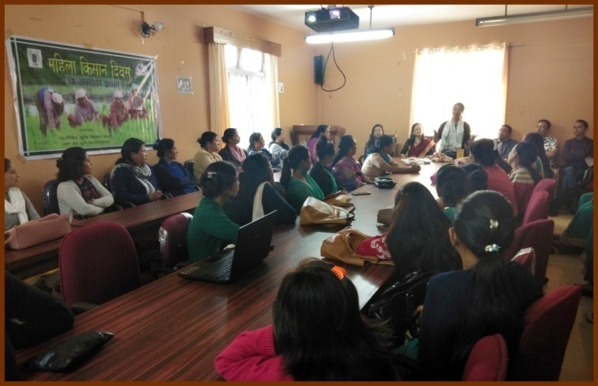 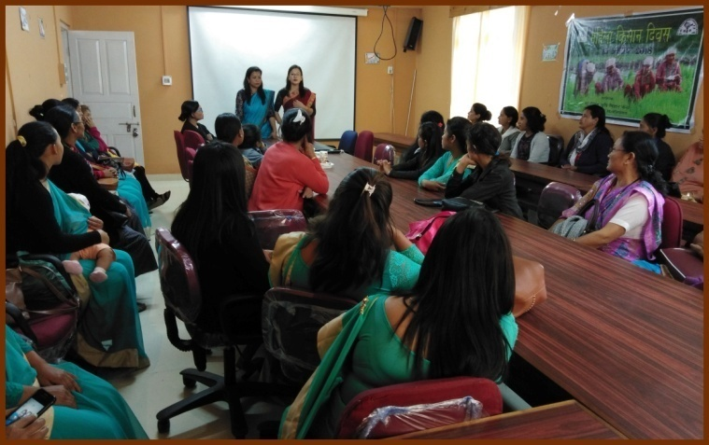

9.12. No. of Progressive/ Innovative/ Lead farmer identified (category wise)

|  |  |  |  |
| --- | --- | --- | --- |
| Sl.  No. | Name of Farmer | Address of the farmer with contact no. | Innovation/ Leading in enterprise |
| 1 | Arun Chettri | Bong Busty  7908022935 | Floriculture |
| 2 | Kamala Sharma | Bong Busty  9733384481 | Vermi Compost and Floriculture |
| 3 | Gobinda Acharya | Sakyong | Vegetables and Floriculture |
| 4 | Yogendra Kharga | Bong Busty  9002929342 | Integrated Farming |
| 5 | Bhima Bhattarai | Kagey | Tulsi Ark Enterprise |
| 6 | Krishna Bhattarai | Gyandong  7602052744 | Tulsi Tea |
| 7 | Sajib Joshi | Nim busty  9083390504 | Integrated Farming |
| 8 | Premkit Simik Lepcha | Bidyang  9733323348 | Piggery |
| 9 | Priya Munda | Hatighisa  9563981960 | Piggery |
| 10 | Saran Thapa | Changa Busty  7364998390 | IFS |
| 11 | Rama Devi Poudyal | Lower Echhey  8116508490 | Value Addition |
| 12 | Mahendra Chettri | 14th Mile, Kalimpong  9832503929 | Mushroom Cultivation |

9.13. Revenue generation

| Sl.No. | Name of Head | Income(Rs.) | Sponsoring agency |
| --- | --- | --- | --- |
| 1. | Training | 7,79,958 | ATMA |
| 2. | Training | 4,31,439 | NHPC |
| 3. | Training | 4,00,000 | SAMETI |
| 4 | Training | 2,20,000 | National Innovation Fund |
| 5 | Sale proceed | 1,81,305 | Farm produce |

9.14. Resource Generation: NIL

|  |  |  |  |  |  |
| --- | --- | --- | --- | --- | --- |
| Sl.No. | Name of the programme | Purpose of the programme | Sources of fund | Amount  (Rs. lakhs) | Infrastructure created |
| -- | -- | -- | -- | **--** | **--** |

9.15. Performance of Automatic Weather Station in KVK

|  |  |  |
| --- | --- | --- |
| Date of establishment | Source of funding i.e. IMD/ICAR/Others (pl. specify) | Present status of functioning |
| -- | -- | -- |

9.16. Contingent crop planning : NA

|  |  |  |  |  |  |
| --- | --- | --- | --- | --- | --- |
| Name of the state | Name of district/KVK | Thematic area | Number of programmes organized | Number of Farmers contacted | A brief about contingent plan executed by the KVK |
| -- | -- | -- | -- | -- | -- |

10. Report on Cereal Systems Initiative for South Asia (CSISA) : NA

1. Year:
2. Introduction / General Information:

|  |  |  |  |  |  |  |
| --- | --- | --- | --- | --- | --- | --- |
|  | Title | Objective | Treatment details | Date of sowing | Replication | Result with photographs |
| Experiment 1 |  |  |  |  |  |  |
| Experiment 2 |  |  |  |  |  |  |
| Experiment 3 |  |  |  |  |  |  |
| … |  |  |  |  |  |  |
| .. |  |  |  |  |  |  |
| Others (If any) |  |  |  |  |  |  |

11. Details of TSP

1. Achievements of physical output under TSP during 2018-19 : NIL

|  |  |
| --- | --- |
| **Programmes** | **Physical achievements** |
| Asset creation (Number; Sprayer, ridge maker, pump set, weeder etc.) |  |
| On-farm trials (Number) |  |
| Frontline demonstrations (Number) |  |
| Farmers training (in lakh) |  |
| Extension personnel training (in lakh) |  |
| Participants in extension activities (in lakh) |  |
| Seed production (in tonnes) |  |
| Planting material production (in lakh) |  |
| Livestock strains and fingerlings production (in lakh) |  |
| Soil, water, plant, manures samples testing (in lakh) |  |
| Provision of mobile agro – advisory to farmers (in lakh) |  |
| No. of other programmes (Swachha Bharat Abhiyaan, Agriculture knowledge in rural school, Planting material distribution, Vaccination camp etc.) |  |

1. Fund received under TSP in 2018-19 (Rs. In lakh): NIL
2. Achievements of physical outcome under TSP during 2017-18

|  |  |  |  |
| --- | --- | --- | --- |
| Sl. No. | Description | Unit | Achievements |
|
| 1 | Change in family income | % | -- |
| 2 | Change in family consumption level | % | -- |
| 3 | Change in availability of agricultural implements/ tools etc. | No. per household | -- |

1. Location and Beneficiary Details during 2018-19

|  |  |  |  |  |  |  |
| --- | --- | --- | --- | --- | --- | --- |
| ***District*** | ***Sub-district*** | ***No. of Village covered*** | ***Name of village(s)***  ***covered*** | ***ST population benefitted***  ***(No.)*** | | |
| M | F | T |
|  |  |  |  |  |  |  |

12. Progress report of NICRA KVK (Technology Demonstration component) during the period

(Applicable for KVKs identified under NICRA) : NA

Natural Resource Management

|  |  |  |  |  |  |  |  |  |  |  |  |  |  |  |
| --- | --- | --- | --- | --- | --- | --- | --- | --- | --- | --- | --- | --- | --- | --- |
| Name of intervention undertaken | Numbers under taken | No of units | Area (ha) | No of farmers covered / benefitted | | | | | | | | | | Remarks |
|  |  |  |  | SC | | ST | | | Other | | Total | | |  |
|  |  |  |  | M | F | | M | F | M | F | M | F | T |  |
| -- | -- | -- | -- | -- | -- | | -- | -- | -- | -- | -- | -- | -- |  |

Crop Management

|  |  |  |  |  |  |  |  |  |  |  |  |  |
| --- | --- | --- | --- | --- | --- | --- | --- | --- | --- | --- | --- | --- |
| Name of intervention undertaken | Area (ha) | No of farmers covered / benefitted | | | | | | | | | | Remarks |
|  |  | SC | | ST | | | Other | | Total | | |  |
|  |  | M | F | | M | F | M | F | M | F | T |  |
|  |  |  |  | |  |  |  |  |  |  |  |  |

Livestock and fisheries

|  |  |  |  |  |  |  |  |  |  |  |  |  |  |  |
| --- | --- | --- | --- | --- | --- | --- | --- | --- | --- | --- | --- | --- | --- | --- |
| Name of intervention undertaken | Number of animals covered | No of units | Area (ha) | No of farmers covered / benefitted | | | | | | | | | | Remarks |
| SC | | ST | | | Other | | Total | | |  |
| M | F | | M | F | M | F | M | F | T |  |
|  |  |  |  |  |  | |  |  |  |  |  |  |  |  |

Institutional interventions

|  |  |  |  |  |  |  |  |  |  |  |  |  |  |
| --- | --- | --- | --- | --- | --- | --- | --- | --- | --- | --- | --- | --- | --- |
| Name of intervention undertaken | No of units | Area (ha) | No of farmers covered / benefitted | | | | | | | | | | Remarks |
|  |  |  | SC | | ST | | | Other | | Total | | |  |
|  |  |  | M | F | | M | F | M | F | M | F | T |  |
|  |  |  |  |  | |  |  |  |  |  |  |  |  |

Capacity building

|  |  |  |  |  |  |  |  |  |  |  |  |
| --- | --- | --- | --- | --- | --- | --- | --- | --- | --- | --- | --- |
| Thematic area | No of Courses | No of beneficiaries | | | | | | | | | |
|  |  | SC | ST | | | Other | | | Total | | |
|  |  | M | F | M | F | | M | F | M | F | T |
|  |  |  |  |  |  | |  |  |  |  |  |

Extension activities

|  |  |  |  |  |  |  |  |  |  |  |  |
| --- | --- | --- | --- | --- | --- | --- | --- | --- | --- | --- | --- |
| Thematic area | No of activities | No of beneficiaries | | | | | | | | | |
|  |  | SC | ST | | | Other | | | Total | | |
|  |  | M | F | M | F | | M | F | M | F | T |
|  |  |  |  |  |  | |  |  |  |  |  |

Detailed report should be provided in the circulated Performa

13. Awards/Recognition received by the KVK : NIL

|  |  |  |  |  |  |
| --- | --- | --- | --- | --- | --- |
| Sl. No. | Name of the Award | Year | Conferring Authority | Amount | Purpose |
| -- | -- | -- | -- | -- | -- |

Award received by Farmers from the KVK district : NIL

|  |  |  |  |  |  |  |
| --- | --- | --- | --- | --- | --- | --- |
| Sl. No. | Name of the Award | Name of the Farmer | Year | Conferring Authority | Amount | Purpose |
| -- | -- | -- | -- | -- | -- | -- |

14. Any significant achievement of the KVK with facts and figures as well as quality photograph

15. Number of commodity based organizations/ farmers’ cooperative society/ FPO formed/ associated with during last one year (Details of the group/society may be indicated) : NIL

|  |  |  |  |  |  |  |  |  |
| --- | --- | --- | --- | --- | --- | --- | --- | --- |
| Sl. No. | Name of the organization/ Society | Trust Deed No.& date | Date of Trust Registration        Address | Proposed Activity | Commodity Identified | No. of Members | Financial position  (Rupees in lakh) | Success indicator |
| -- | -- | -- | -- | -- | -- | -- | -- | -- |

1. Integrated Farming System (IFS) : NA

Details of KVK Demo. Unit

|  |  |  |  |  |  |  |  |
| --- | --- | --- | --- | --- | --- | --- | --- |
| Sl.  No. | Module details (Component-wise) | Area under IFS (ha) | Production (Commodity-wise) | Cost of production in Rs. (Component-wise) | Value realized in Rs. (Commodity-wise) | No. of farmer adopted practicing IFS | % Change in adoption during the year |
| -- | -- | -- | -- | -- | -- | -- | -- |

1. Technologies for Doubling Farmers' Income

|  |  |  |  |  |  |
| --- | --- | --- | --- | --- | --- |
| Sl. No. | Name of the Technology | Brief Details of Technology (3- 5 bullet points) | Net Return to the farmer (Rs.) per ha per year due to adoption of the technology | No. of farmers adopted the technology in the district | One high resolution ‘Photo’ in ‘jpg’ format for each technology |
| 1 | Mushroom Cultivation | Oyster Mushroom | 35000 to 40000 annum / unit | 10 | Fig. A |
| 2 | Vermi Compost preparation | *Eisenia fetida* | 12000 to 15000 annum / unit | 8 | Fig B |

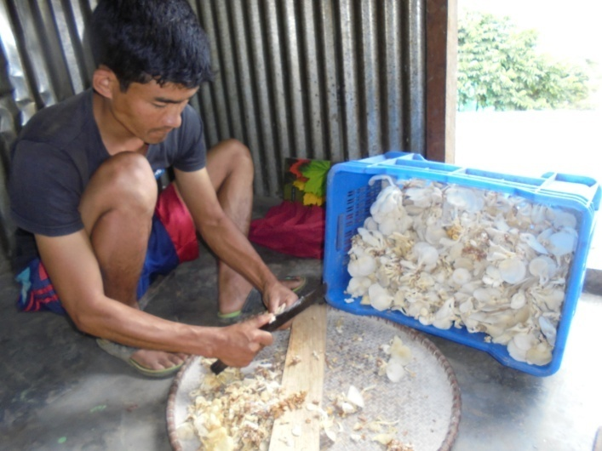 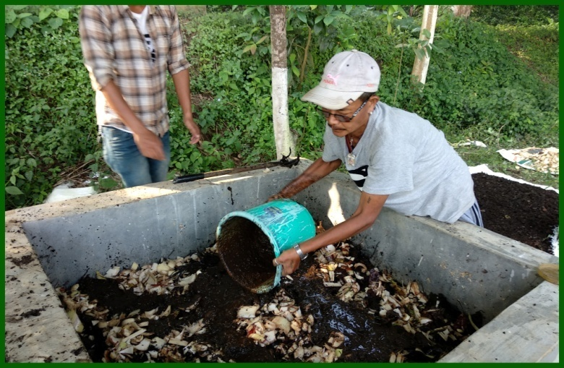

Fig. A Fig. B

1. Report on Digital Farming Initiatives in Agriculture/ Digital Ag. Extension Service

|  |  |  |  |  |  |
| --- | --- | --- | --- | --- | --- |
|  | Database prepared/ covered for | | KVK level Committee | | Various activity conducted for farmers |
| Phase | Total no. of villages | Total no. of farmers | Date of formation | Name of members |
| I (up-to 15.03.2018) |  |  |  |  |  |
| II (up-to 24.04.218) |  |  |  |
| Total |  |  |  |

1. Information on Visit of Ministers to KVKs, if any

| Date of Visit | Name of Hon’ble Minister | Name of Ministry | Salient points in his/ her observation  (2-3 bulleted points) |
| --- | --- | --- | --- |
|  |  |  |  |

1. a) Information on **ASCI** Skill Development Training Programme, if undertaken during 2017-18 and 2018-19

|  |  |  |  |  |  |  |  |
| --- | --- | --- | --- | --- | --- | --- | --- |
| Year | Name of the Job role | Name of the certified Trainer of KVK for the Job role | Date of start of training | Date of completion of training | No. of participants | Whether uploaded to SDMS Portal (Y/N) | Fund utilized for the training (Rs.) |
| 2016-17 | Broiler Farm Worker | Dr. Rakesh Roy | 21/02/2017 | 25/03/2017 | 17 | Y |  |
|  | Bee Keeping | Dr. Pranab Barma | 01/03/2017 | 30/03/2017 | 12 | Y |  |
| 2017-18 |  |  |  |  |  |  |  |
|  |  |  |  |  |  |  |  |
| 2018-19 | Small Poultry Farmer | Dr. Rakesh Roy | 17/02/2019 | 18/03/2019 | 16 | Y |  |
|  | Bee Keeping | Dr. Pranab Barma | 19/02/2019 | 15/03/2019 | 20 | Y | 1,41,200/- |

b) Information on Skill Development Training Programme (**Other than ASCI or less than 200 hrs**., if any) if undertaken during 2018-19

|  |  |  |  |  |  |  |  |  |  |  |  |  |
| --- | --- | --- | --- | --- | --- | --- | --- | --- | --- | --- | --- | --- |
| Thematic area of training | Title of the training | Duration (in hrs.) | No. of participants | | | | | | | | | Fund utilized for the training (Rs.) |
|  |  |  | SC | | ST | | Other | | Total | | |  |
|  |  |  | M | F | M | F | M | F | M | F | T |  |
|  |  |  |  |  |  |  |  |  |  |  |  |  |

1. Information on NARI Project (if applicable) : NA

|  |  |  |  |  |  |  |
| --- | --- | --- | --- | --- | --- | --- |
| **Name of Nodal Officer** | **No. of OFT on specified aspects** | **Title(s) of OFT** | **No. of FLD on specified aspects** | **No. of capacity development programme on specified aspects** | **Total no. of farm women/ girls involved in the project** | **Details of Issues related to gender mainstreaming addressed through the project** |
|  |  |  |  |  |  |  |

1. Information on Krishi Kalyan Abhiyan Phase- I/ Phase-II/ Phase-III, if applicable

***Krishi Kalyan Abhiyan- I and II***

1. **Training**

|  |  |  |  |  |  |  |  |  |  |  |  |
| --- | --- | --- | --- | --- | --- | --- | --- | --- | --- | --- | --- |
| ***Name of programme*** | ***No. of programmes*** | ***No. of farmers benefitted*** | | | | | | | | | ***No. of officials attended the programme*** |
| ***SC*** | | ***ST*** | | ***Others*** | | ***Total*** | | |
| ***M*** | ***F*** | ***M*** | ***F*** | ***M*** | ***F*** | ***M*** | ***F*** | ***T*** |
| **KKA-I** |  |  |  |  |  |  |  |  |  |  |  |
| **KKA-II** |  |  |  |  |  |  |  |  |  |  |  |

1. **Distribution of seed/ planting materials/ input/ others : NA**

| Name of programme | No. of Programme | Total quantity distributed | | | | No. of farmers benefited | | | | | | | | | No. of other officials (except KVK)  attended the programme |
| --- | --- | --- | --- | --- | --- | --- | --- | --- | --- | --- | --- | --- | --- | --- | --- |
| Seed (q) | Planting material (lakh) | Input (kg) | Other (kg/ No.) | SC | | ST | | Others | | Total | | |
| M | F | M | F | M | F | M | F | T |
| KKA-I | -- | -- | -- | -- | -- | -- | -- | -- | -- | -- | -- | -- | -- | -- |  |
| KKA-II | -- | -- | -- | -- | -- | -- | -- | -- | -- | -- | -- | -- | -- | -- |  |

1. **Livestock and Fishery related activities**

| ***Name of programme*** | ***No. of Programme*** | ***Activities performed*** | | | | ***No. of farmers benefited*** | | | | | | | | | ***No. of other officials (except KVK)***  ***attended the programme*** |
| --- | --- | --- | --- | --- | --- | --- | --- | --- | --- | --- | --- | --- | --- | --- | --- |
| ***No. of animals vaccinated*** | ***No. of animals dewormed*** | ***Feed/ nutrient supplements provided (kg)*** | ***Any other (Distribution of animals/ birds/ fingerlings)***  ***[No.]*** | ***SC*** | | ***ST*** | | ***Others*** | | ***Total*** | | |
| ***M*** | ***F*** | ***M*** | ***F*** | ***M*** | ***F*** | ***M*** | ***F*** | ***T*** |
| **KKA-I** |  |  |  |  |  |  |  |  |  |  |  |  |  |  |  |
| **KKA-II** |  |  |  |  |  |  |  |  |  |  |  |  |  |  |  |

1. **Other activities**

| ***Name of programme*** | ***Activities*** | ***No. of farmers benefited*** | | | | | | | | | ***No. of other officials (except KVK)***  ***attended the programme*** |
| --- | --- | --- | --- | --- | --- | --- | --- | --- | --- | --- | --- |
| ***SC*** | | ***ST*** | | ***Others*** | | ***Total*** | | |
| ***M*** | ***F*** | ***M*** | ***F*** | ***M*** | ***F*** | ***M*** | ***F*** | T |
| KKA-I | Soil Health Card Distributed |  |  |  |  |  |  |  |  |  |  |
| NADEP  Pit established |  |  |  |  |  |  |  |  |  |  |
| Farm implements distributed |  |  |  |  |  |  |  |  |  |  |
| Others, if any |  |  |  |  |  |  |  |  |  |  |
| KKA-II | Soil Health Card Distributed |  |  |  |  |  |  |  |  |  |  |
| NADEP  Pit established |  |  |  |  |  |  |  |  |  |  |
| Farm implements distributed |  |  |  |  |  |  |  |  |  |  |
| Others, if any |  |  |  |  |  |  |  |  |  |  |

***Krishi Kalyan Abhiyan- III : NA***

|  |  |  |  |  |  |  |  |  |  |  |  |
| --- | --- | --- | --- | --- | --- | --- | --- | --- | --- | --- | --- |
| ***No. of villages covered*** | ***No. of animal inseminated*** | ***No. of farmers benefitted*** | | | | | | | | | ***Any other, if any***  ***(pl. specify)*** |
| ***SC*** | | ***ST*** | | ***Others*** | | ***Total*** | | |
| ***M*** | ***F*** | ***M*** | ***F*** | ***M*** | ***F*** | ***M*** | ***F*** | T |  |
| ***--*** | ***--*** | ***--*** | ***--*** | ***--*** | ***--*** | ***--*** | ***--*** | ***--*** | ***--*** | ***--*** | ***--*** |

1. Any other programme organized by KVK, not covered above

|  |  |  |  |  |  |
| --- | --- | --- | --- | --- | --- |
| ***Sl.***  ***No.*** | ***Name of the programme*** | ***Date of the programme*** | ***Venue*** | ***Purpose*** | ***No. of participants*** |
| 1. | Celebration of National Nutrition Week | 06/09/18 | Lower Ecchay Busty | To create awareness and knowledge on importance of balance diet. To identify local sources of high nutritional value vegetables, cereals and fruits. Preparation of low cost foods. | 68 |
| 2. | Observation of International Breast Feeding Week | 05/08/18 | Thapa Gaon | To sensitize pregnant and lactating mothers and anganwadi workers on importance and benefits of breast feeding, nutritional content of breast milk. | 30 |
| 3 | Celebration of Mahila Kisan DIwas | 16/10/18 | KVK | To strengthen and motivate women into agriculture. Felicitate progressive farm women for their contribution and role in agriculture | 32 |
| 4 | Awareness program on Nutrition, Health and Hygiene & importance of kitchen gardening for rural school | 31/05/18 | Chandramaya HS school | To encourage students in establishing kitchen garden for food and nutritional security | 95 |
| 5 | Workshop on square meter vegetable garden | 12-13 /09/2018 | Darjeeling KVK | Make the farmers aware about the construction and production Technique in Square Meter Vegetable Garden | 19 |

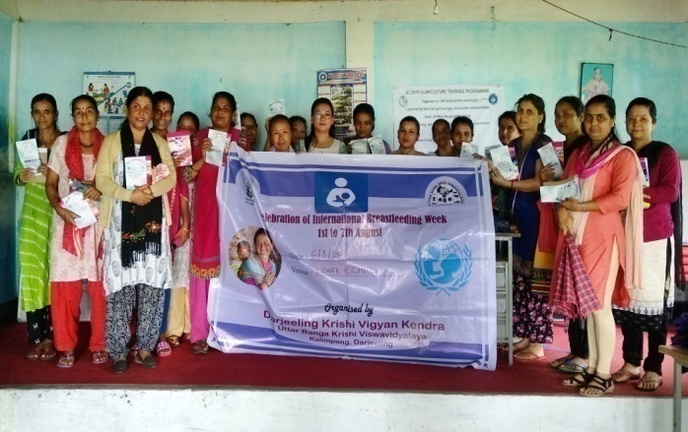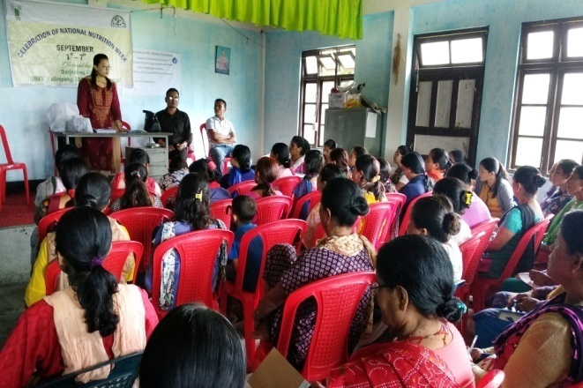

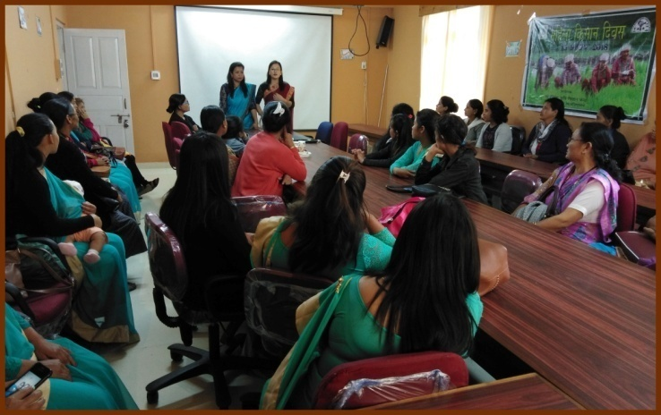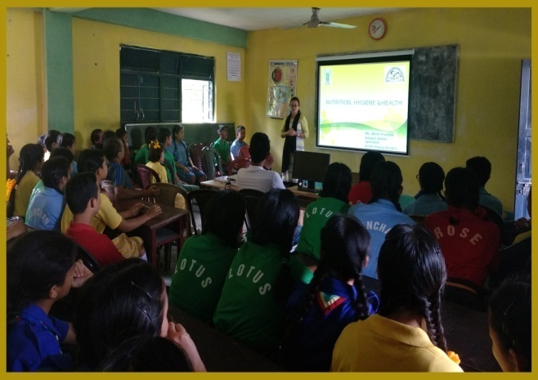

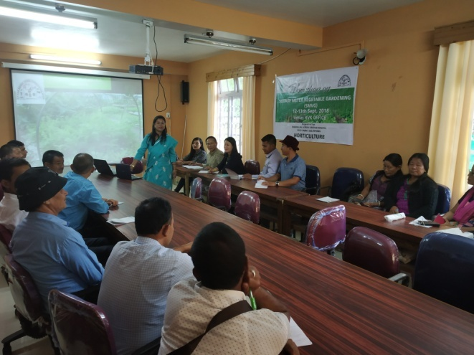 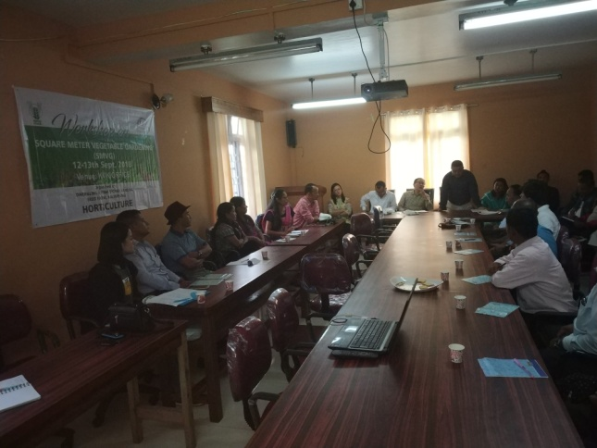

1. Good quality action photographs of overall achievements of KVK during the year (best 10)

***